


Laboratory Manual
CPEG1611: Applications of Information and Communication Technologies Lab
Name: Reg No: Section:

Department of Electrical and Computer Engineering Capital University of Science and Technology Islamabad, Pakistan

© Copy Rights, Department of Electrical & Computer Engineering, CUST Islamabad All Rights Reserved

S.  No | List of Experiments
1 | Exploring Computer Hardware and Software in Practice
2 | Creating and Editing Professional Documents in Microsoft Word
3 | Building Spreadsheets, Formulas, and Charts in Microsoft Excel
4 | Analyzing Data with Advanced Excel Functions
5 | Designing Effective Presentations in Microsoft Power Point
6 | Drawing Block Diagrams and Flowcharts in Microsoft Visio
7 | Writing Pseudocode and Designing Flowcharts for Problem Solving
8 | Setting Up Visual C++ and Running Your First Program
9 | Making Decisions in Code with Relational operators and Logical operators
10 | Familiarization with Network Simulator Tools
11 | Designing and Querying a Database in Microsoft Access
12 | Protecting Systems with Antivirus, Firewalls, and Encryption
13 | Open-ended Lab I
14 | Open-ended Lab II

Lab Safety Rules
- Be sure that all equipment is properly working before using them for laboratory exercises. Any defective equipment must be reported immediately to the Lab Engineer or Lab Technical Staff.
- Students should keep a safe distance from the circuit breakers, electric circuits or any moving parts during the experiment.
- Avoid any part of your body to be connected to the energized circuit and ground.
- Switch off the equipment and disconnect the power supplies from the circuit before leaving the laboratory.
- Make sure that the last connection to be made in your circuit is the power supply and first thing to be disconnected is also the power supply.
- Equipment should not be removed, transferred to any location without permission from the laboratory staff.

Experiment No 1

Exploring Computer Hardware and Software in Practice

Objective:
- Understand the basic hardware components of computer.
- Overview of different types of computers.
- Overview of different software i.e. application and system software.
- Learn to create folders, search files/folders, write and send emails, and navigate the CUST student portal.

Computer
A computer is a machine that can store and process information. In others terms, a computer is a digital electronic machine that can be programmed to carry out sequences of arithmetic or logical operations automatically. Computers are composed of several hardware and software components. This lab presents an overview of hardware components of computer and software components.
Computer Hardware
Computer hardware is the collection of physical parts of a computer system. This includes the computer case, monitor, keyboard, and mouse. It also includes all the parts inside the computer case, such as the hard disk drive, motherboard, video card, and many others. Computer hardware is what you can physically touch.
Examples of Hardware:
- Input devices – keyboard, mouse, scanner, microphone, webcam
- Output devices – printer, monitor, speaker, projector
- Secondary storage devices – Hard disk, CD, DVD, USB flash drive
- Internal components – CPU, motherboard, RAM, ROM, sound card, video card, NIC, modem
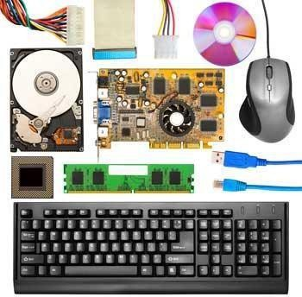
Figure 1-1. Hardware components of a computer

CPU (Central Processing Unit)
The CPU is the brain of the computer. It handles all instructions it receives from hardware and software running on the computer.
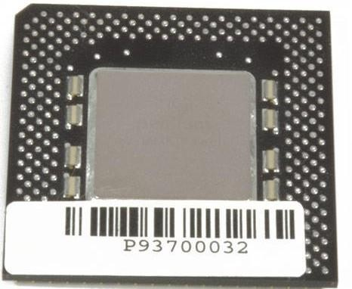
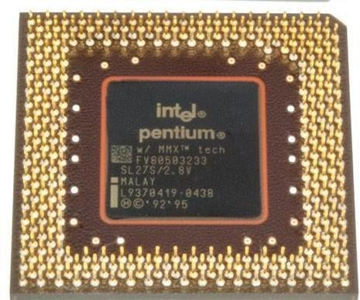
Figure 1-2. Central Processing Unit
The primary components of the CPU are:
- ALU (Arithmetic Logic Unit) – performs mathematical, logical, and decision operations
- CU (Control Unit) – directs all of the processor's operations
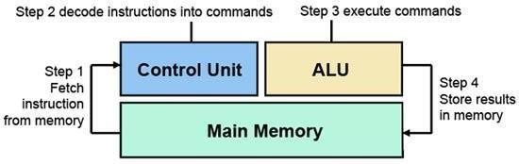
Figure 1-3. Machine Cycle

RAM (Random Access Memory)
RAM is the main memory of a computer that allows information to be stored and retrieved. It is volatile memory, meaning data is lost when power is turned off.
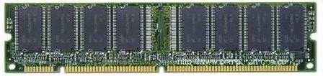
Figure 1-4. RAM
ROM (Read Only Memory)
ROM is a memory device that stores information permanently. We can only read the programs and data stored on it but cannot write on it.
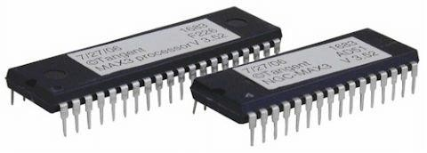
Figure 1-5. ROM
Motherboard
The motherboard is a printed circuit board that is the foundation of a computer. It allocates power and allows communication to the CPU, RAM, and all other computer hardware components.
Other Components:
- Fan/Heat Sink – keeps the computer cool
- Modem – connects a computer to a broadband network
- NIC (Network Interface Card) – enables a computer to connect to a network
- Sound Card – audio output device
- Video Card – creates a picture on a display
Types of Computers
Based on size and capacity, computers are categorized into:
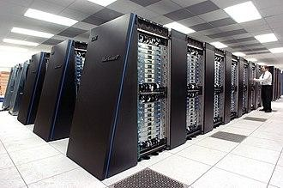
- Supercomputers – high-performance computers used for scientific and engineering applications (weather forecasting, climate research, quantum mechanics)
- Mainframe computers – high-performance computers used for large information processing jobs (bulk data processing, transaction processing)
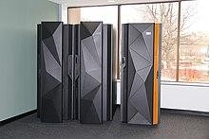
Figure 1-6. Mainframe computers
- Minicomputers – mid-range computers (now referred to as small or midsize servers)
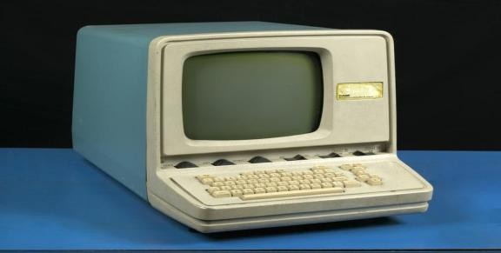
Figure 1-7. Minicomputer
- Personal computers (PCs) / Microcomputers – small computers designed for use by a single user:

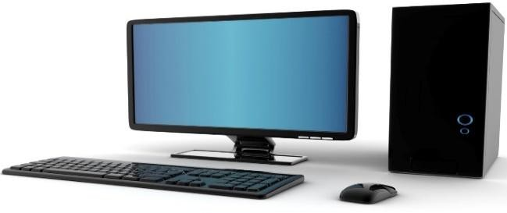
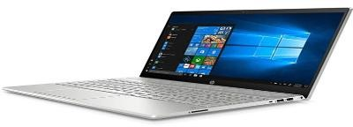

Figure 1-8. Desktop Figure 1-9. Laptop

- Computer Software
Software is a set of instructions, data or programs used to operate computers and execute specific tasks.
Types of Software:

- System Software – coordinates the activities and functions of hardware and software. Examples: MS-Windows, Ubuntu, Mac OS, Linux
Figure 2-1. System Software Examples

- Application Software – performs specific functions for a user. Examples: MS Word, VLC Media Player, Web Browsers (Google Chrome, Mozilla Firefox, Microsoft Edge)
Figure 2-2. Application Software

CREATING AND SEARCHING FOLDERS IN WINDOWS
Creating a New Folder:
- Right-click on the desktop or in File Explorer.
- Select New > Folder.
- Type a name for the folder and press Enter.
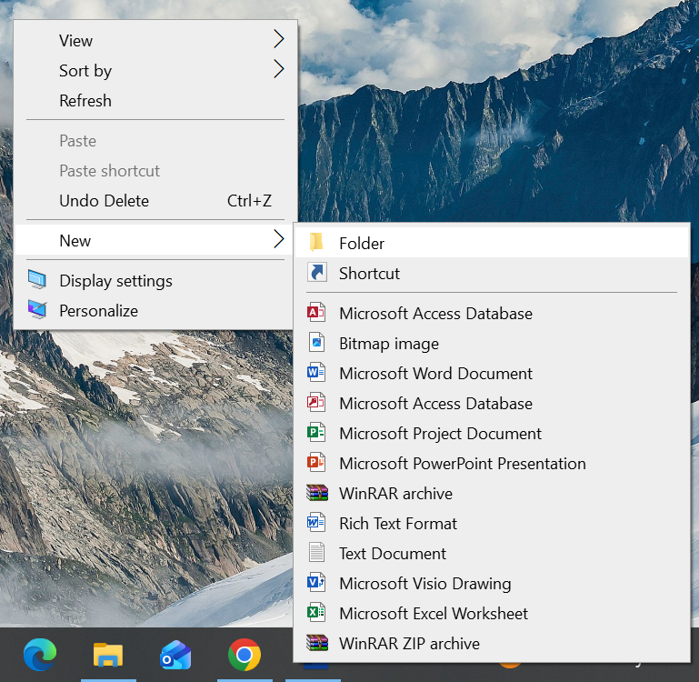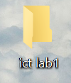
Figure 2-3. Creating folder

Searching for a File or Folder:
- Open the Start menu and type a search term in the search field.
- Double-click the file to open it.

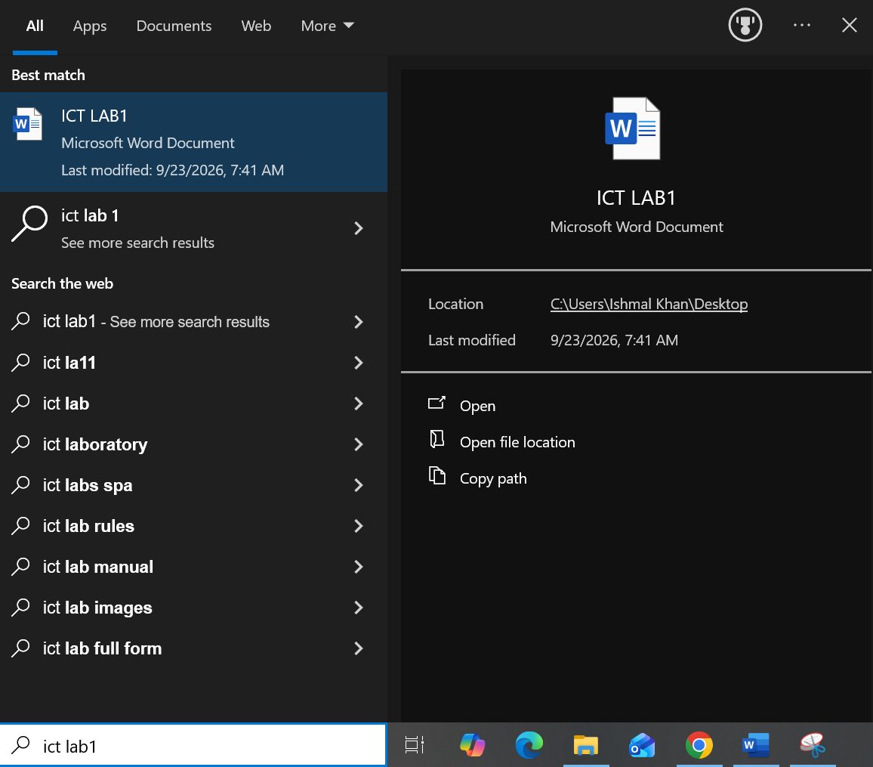
Figure 2-4. Searching the file

How to write an Email?
- Open your email client (e.g., Outlook, Gmail).
- Click Compose or New Email.
- Enter the recipient's email address in the To field.
- Write a subject line.
- Type your message in the body.
- Attach any files if needed (click Attach).
- Click Send.

CUST Portal
Access of CUST Portal
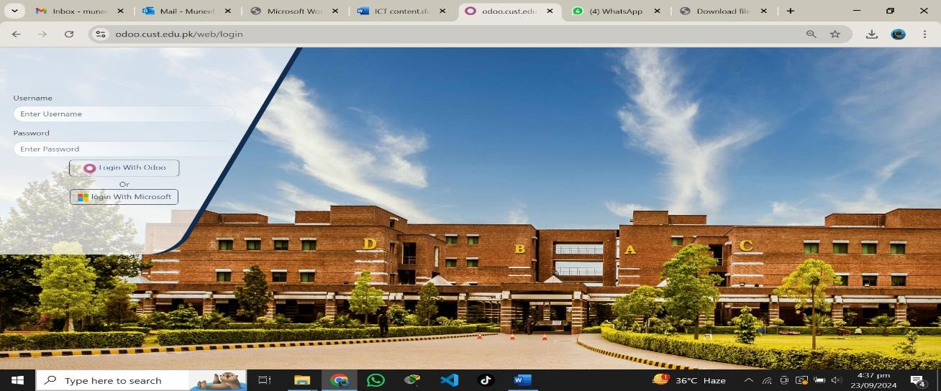

Figure 2-5. CUST Portal
Student Services
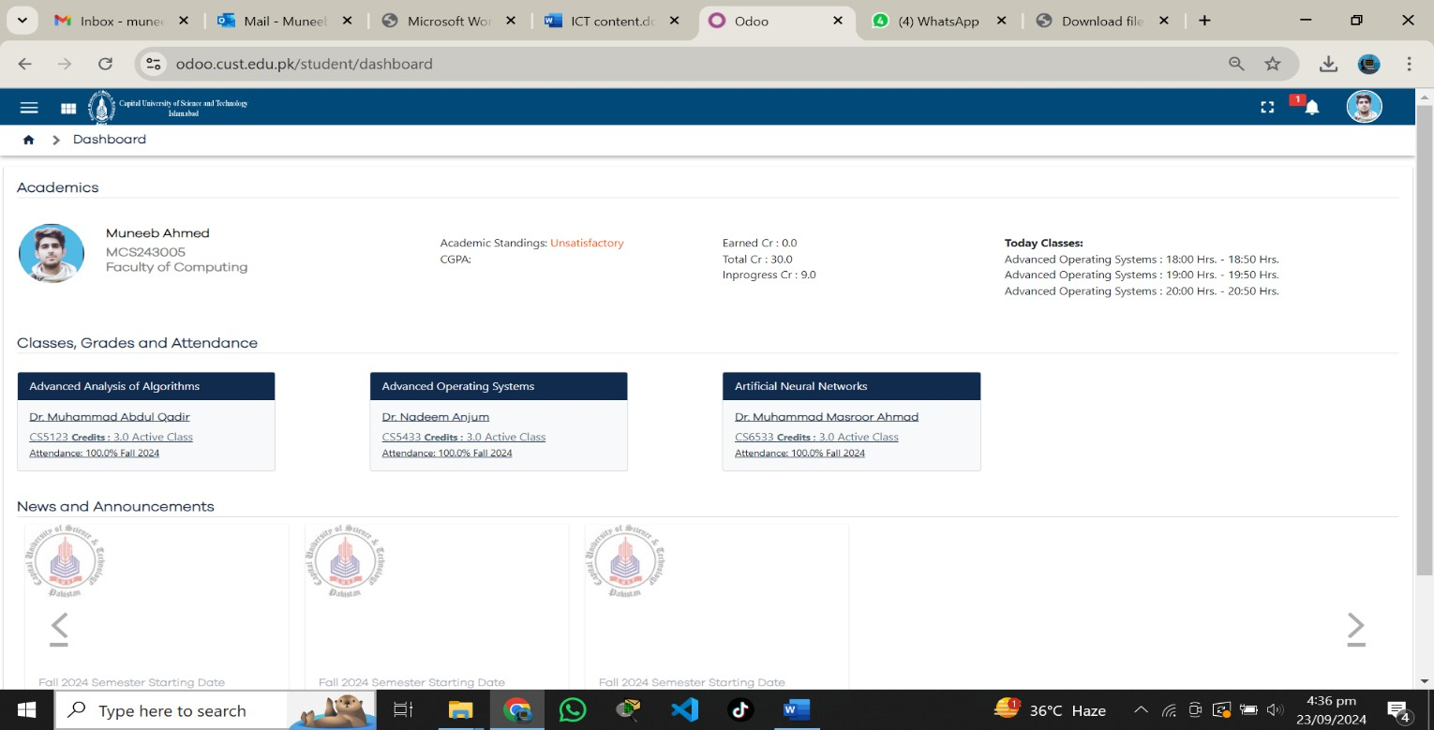

Figure 2-6. Student Portal

Access of Lectures
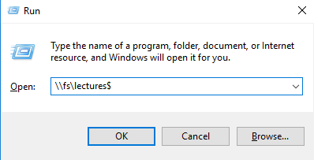
Figure 2-7. Access of Lectures
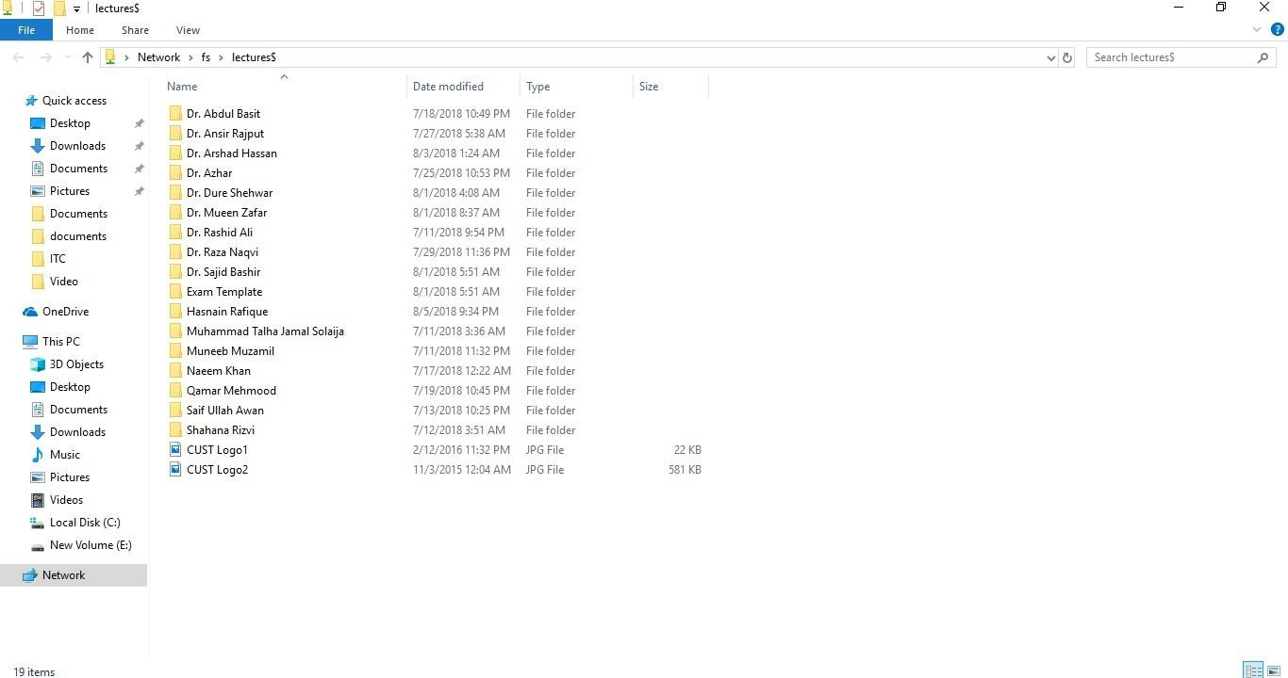
Figure 2-8. Lectures Folder

Cognitive Questions
Q1. Sort the following 10 items into two lists — Hardware and Software — and for one item from each list, explain in one sentence why it belongs there: Mouse, Microsoft Word, Windows 11, RAM, Google Chrome, Keyboard, Antivirus program, Motherboard, Printer, WhatsApp.

Cognitive Activity
Obtained Marks | /10

Lab Activity
Task 1: Creating and Searching Folders
Instructions: Follow the steps below and write down the commands or steps you used.
- Create a new folder on the Desktop named "ICT_Lab1_YourRegNo".
- Inside this folder, create three subfolders named "Documents", "Images", and "Presentations".
- Create a new text file named "myfile.txt" inside the "Documents" folder.
- Use the Windows search feature to search for "myfile.txt".

Task 2: Writing and Sending an Email
Instructions: Compose an email to your instructor with the following details:
- To: [instructor's email address]
- Subject: ICT Lab 1 - Your Name - Your Reg No
- Body: Introduce yourself, mention your department and section, and state one thing you learned in today's lab.

Lab Exercise and Summary
Summary should cover Introduction, Procedure, Data Analysis and Evaluation.

Student’s Signature: Date:
Psychomotor Activity 1 — Experimental Setup
S.No | Criteria | Performance | Description | Marks
1 | System/Software Setup (4) | Level 4 | Correctly identifies and prepares the computer to view hardware components and system/application software as required. | 4
1 | System/Software Setup (4) | Level 3 | Identifies most hardware/software elements with minor errors or assistance. | 3
1 | System/Software Setup (4) | Level 2 | Partially identifies hardware/software elements and requires considerable assistance. | 2
1 | System/Software Setup (4) | Level 1 | Shows limited ability to identify hardware/software and requires substantial assistance. | 1
2 | Document Setup (4) | Level 4 | Correctly creates/opens the document used to prepare the Gaming PC specification (or hardware/software identification) exercise. | 4
2 | Document Setup (4) | Level 3 | Document setup is mostly correct with minor errors or omissions. | 3
2 | Document Setup (4) | Level 2 | Setup is partially completed and requires assistance. | 2
2 | Document Setup (4) | Level 1 | Major errors or omissions are present in the setup. | 1
3 | Parameter Setup (2) | Level 2 | Correctly records required specifications (component names, categories, computer/software type). | 2
3 | Parameter Setup (2) | Level 1 | Records most required specifications with minor errors. | 1
 | Total Obtained |  |  | /10

If a student is absent:
Criteria | Description | Marks
Absent | Student is absent from the laboratory activity. | 0

Psychomotor Activity 2 — Implementation + Results
S.No | Criteria | Performance | Description | Marks
1 | Implementation (4) | Level 4 | Correctly identifies and classifies hardware components and software types independently, following the lab content. | 4
1 | Implementation (4) | Level 3 | Identifies most hardware/software elements with minor errors or assistance. | 3
1 | Implementation (4) | Level 2 | Partially identifies hardware/software elements and requires considerable assistance. | 2
1 | Implementation (4) | Level 1 | Shows limited ability to identify hardware/software and requires substantial assistance. | 1
2 | Execution/Operation (2) | Level 2 | Correctly navigates the computer (e.g., System Properties/Device Manager, CUST Portal) to verify hardware/software information as required. | 2
2 | Execution/Operation (2) | Level 1 | Performs basic navigation/verification with minor errors or assistance. | 1
3 | Results/Output (4) | Level 4 | Produces a correct, complete classification of hardware components and software types, and a well-formed specification document. | 4
3 | Results/Output (4) | Level 3 | Produces a mostly correct classification/document with minor errors. | 3
3 | Results/Output (4) | Level 2 | Produces a partially correct classification/document with noticeable errors or omissions. | 2
3 | Results/Output (4) | Level 1 | Classification/document is largely incomplete or incorrect. | 1
 | Total Obtained |  |  | /10

If a student is absent:
Criteria | Description | Marks
Absent | Student is absent from the laboratory activity. | 0

Affective Activity — Lab Report + Viva Voce
S.No | Criteria | Performance | Description | Marks
1 | Lab Report  Completeness & Organization  (4) | Level 4 | Report is complete, well-organized, and demonstrates responsible completion of the hardware/software identification exercise. | 4
1 | Lab Report  Completeness & Organization  (4) | Level 3 | Report is complete with minor omissions or organizational issues. | 3
1 | Lab Report  Completeness & Organization  (4) | Level 2 | Report is partially complete with several omissions. | 2
1 | Lab Report  Completeness & Organization  (4) | Level 1 | Report has major omissions or poor organization. | 1
2 | Work/Results & Conclusion (2) | Level 2 | Completed classification and conclusion are correctly presented and discussed. | 2
2 | Work/Results & Conclusion (2) | Level 1 | Presented with minor errors or omissions. | 1
3 | Viva Voce (4) | Level 4 | Clearly explains hardware components, computer types, and software categories, demonstrating strong understanding. | 4
3 | Viva Voce (4) | Level 3 | Explains most concepts correctly with minor difficulty. | 3
3 | Viva Voce (4) | Level 2 | Explains basic aspects with some prompting. | 2
3 | Viva Voce (4) | Level 1 | Demonstrates limited understanding, requires substantial prompting. | 1
3 | Total Obtained |  |  | /10

The student has not submitted the report and has not appeared in the Viva Voce.
Criteria | Description | Marks
Lab Report and Results Not Submitted | Student has not submitted the report and results file. | 0
Absent in Viva Voce | Student is absent from the viva voce. | 0

Instructor’s Signature: Date: _________

Experiment No 2

Creating and Editing Professional Documents in Microsoft Word

Objective:
- Learn how to create and edit documents in MS Word.
- Understand and apply formatting, styles, tables, illustrations, captions, and table of contents.
- Develop practical skills to produce professional-looking documents

Introduction
MS Word enables you to write letters, reports, memos and much, much more quickly and efficiently. It will also enable you to print the documents out and store them for future reference, modifying or altering them as you wish.

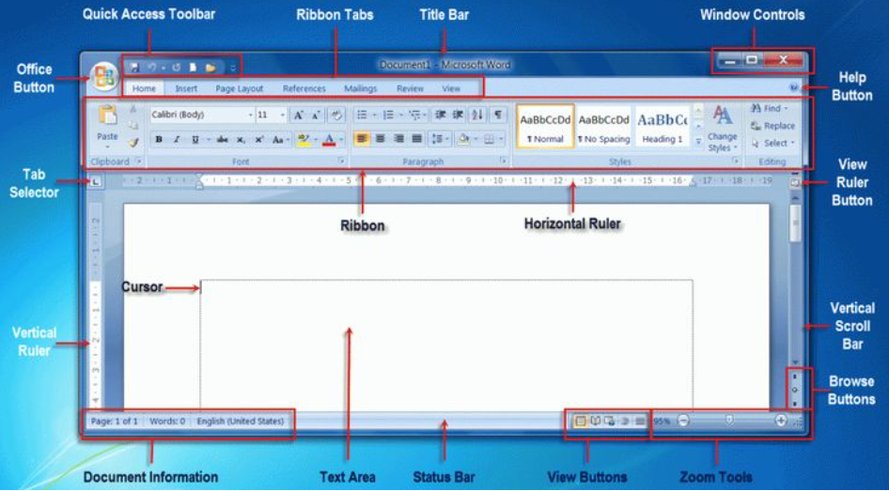
Figure 1. MS Word

Homework before Lab
- MS Office Installation
Download the MS office setup from the https://www.microsoft.com/en-us/microsoft-365/download-office. Try to install it at home. Open MS word from the start menu and try to do the following task.
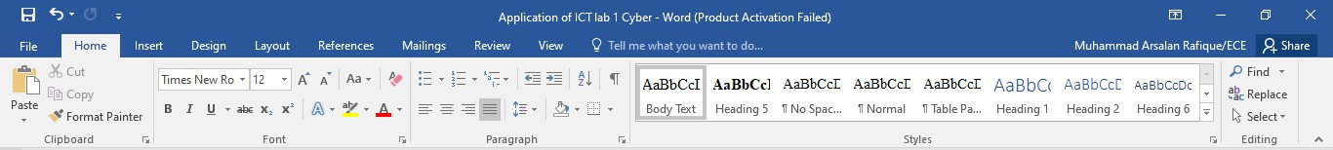
Figure 2-1. MS Word Help System
Click on the File then look for Question Mark or F1 to go to Microsoft Office Help. The Office Help is really good. After opening the help try to search the shortcut key for following tasks in MS Word 2016 or any version available.
  - Create a new document of the same type as the current or most recent document
  - Open a document
  - Close a document
  - Save a document

- Procedure & Tools
  - Tools
    - Desktop Computer
    - Microsoft Windows operating system, XP or any latest Edition
    - Microsoft Word 2016 / any latest version

Setting-up Microsoft Word

Search Microsoft Word: Click on the Search box > Type "Microsoft Word" > Press Enter.

Templates: Templates are a collection of styles and formatting settings that save time when creating a new document.
  - Go to File menu and click New.
  - Select Sample templates to use built-in templates.
  - Select Executive Report and click Create.
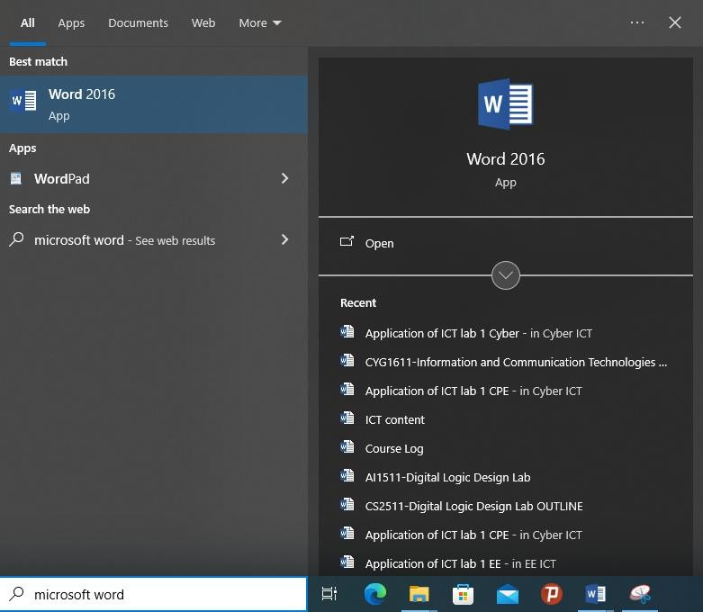

Figure 2-2. Start Menu to Start MS Word

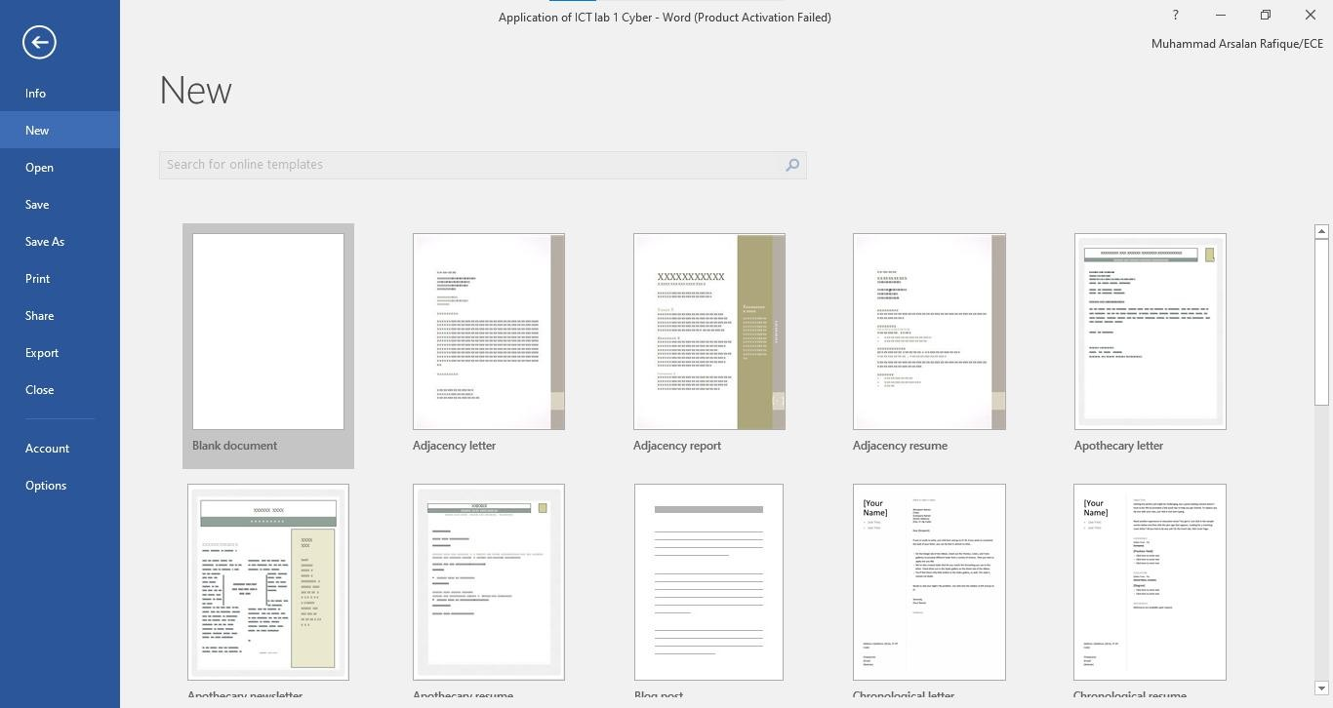
Figure 2-3. MS Word Open New Document
Select ‘Executive Report’ ‘and click ‘Create’.
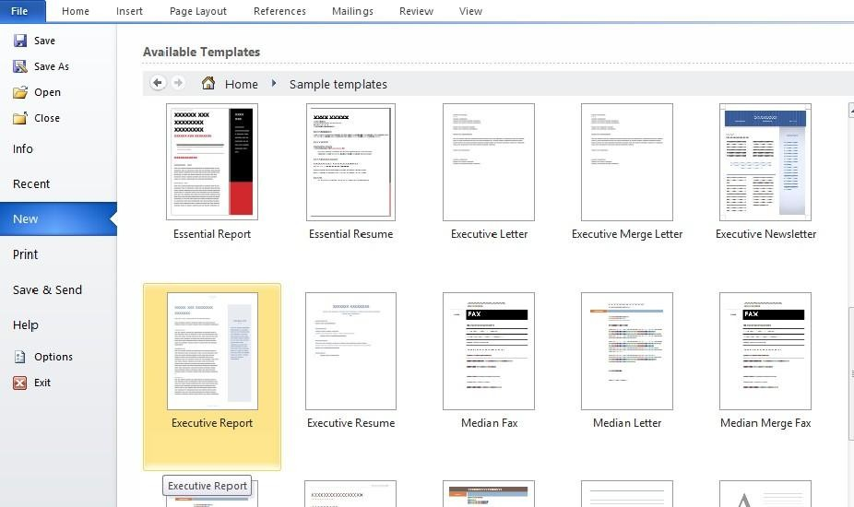
Figure 2-4. Executive Report

Insert Cover Page
Pages group is in the far left of the insert tab. You can insert from the three categories for pages which are; Cover Page, Blank Page, and Page Break. These features are useful if you are creating a professional or long document.
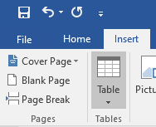
Figure 2-5. Insert Cover Page
Cover Page is the title page of the document. Word provides a number of preformed cover pages to give your document a professional look.
Cover page Exercise: Creating a Cover Page
Click the Insert tab to make it the active tab. Refer to figure 2-5
To open the Built-in Cover Page Gallery, click the down arrow to the right of Cover Page and choose any Cover page.
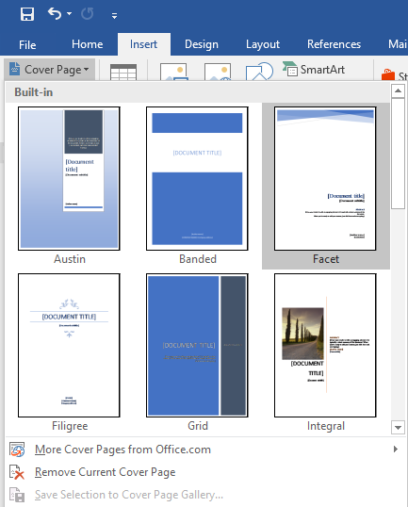
Figure 2-6. Built-in Cover Page

- Scroll down and click the desired cover for the document from the Cover Page Gallery. Use the scroll bar or scroll arrow to see all the cover page choices.
- A Cover page will be added to your document.
Style Group
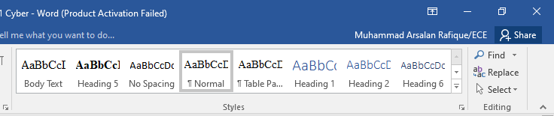
Figure 2-7. Styles Group
The fourth group on the Home ribbon is the Style group. Styles are a collection of Formatting options that you can apply to text. When you use styles to format your document, you can quickly and easily apply a set of formatting choices consistently throughout your document.
A style is a set of formatting characteristics, such as font name, size, color, paragraph alignment and spacing. Some styles even include borders and shading. For example, instead of taking three separate steps to format your heading as 16-point, bold, Cambria, you can achieve the sameresult in one step by applying the built-in Heading 1 style. You do not need to remember the characteristics of the Heading 1 style. For each heading in your document, you just click in the heading (you don’t even need to select all the text), and then click Heading 1 in the gallery of styles.
Tables
Word provides tables option for placing data in a more formal way.
- Click on table in insert tab.
- To add Rows and Columns, select top to bottom for rows & left to right for columns
- Click to apply when happy with the selection.
- Click on the box to enter text.
- Observe the new tab opened "Table Tools". You can use this tool to apply further formatting to your created table.

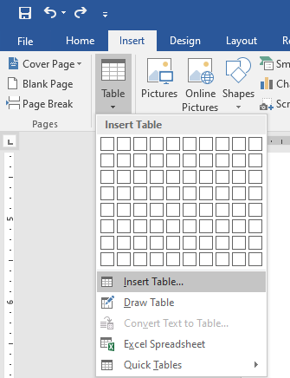

Figure 2-8. Insert Table
Illustrations
Using Illustrations you can add pictures of all types and styles to your document. Followed is detail Description on how to add illustrations.
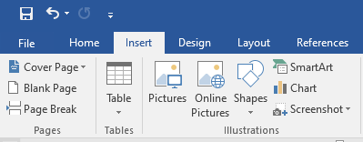
Figure 2-9. Illustrations
Insert Caption
- Right click on the image and select ‘Insert Caption’.
- Write the caption of the figure and click ‘OK’

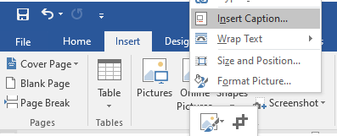

Figure 2-10. Insert caption on picture
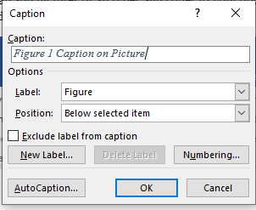
Figure 2-11. Caption
Table of Contents
While writing long documents consisting of several main and sub headings it becomes a difficult task to read and find relevant text. Microsoft Word helps deal with issue by assembling a table of contents (TOC) for you, listing headings each with appropriate page number. It also takes care of counting pages, and even updates the TOC for you if the document’s page numbers change. When you create a TOC, Word searches your document for headings to include, recognizing them by the Styles applied.
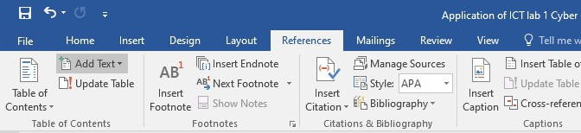
Figure 2-12. Insert Table of Contents

Activity 01:

How to add Table of Contents
- Apply heading styles to your chosen headings.
- Move the insertion point to the place where you want the Table of Contents to appear.
- Click the References tab on the Ribbon and then click the Table of Contents button found in the Table of Contents group.
- Click the Table of Contents style you want to use.
- To customize your TOC, click the Table of Contents button and select Insert Table of Contents Field.
- Click the Update Table button in the Table of Contents group of the References tab.
- Click OK to update the table.
- Save your file after you update the tables.
- To delete a TOC, select the entire table and press Delete.
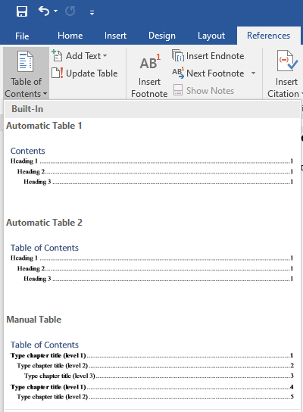
Figure 2-13. Table of Content formats

Table of Figures Activity 02:
How to add Table of Figures
- Apply caption to your figures.
- Move the insertion point to the place where you want the Table of figures to appear.
- Click the References tab on the Ribbon and go to Captions section.
- Click on ‘Insert table of figures’.
- Choose your desired style and click ‘OK’.
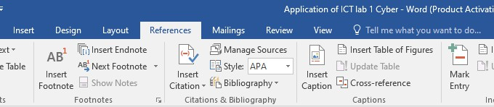
Figure 2-14. Insert Table of Figures
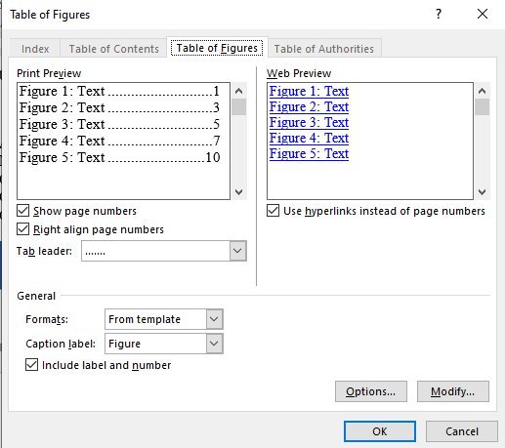
Figure 2-15. Table of Figures

Activity 03:
Payroll Report:
Create a payroll report on MS Word use text boxes, shapes, alignment options and format the report according to the figure given below.
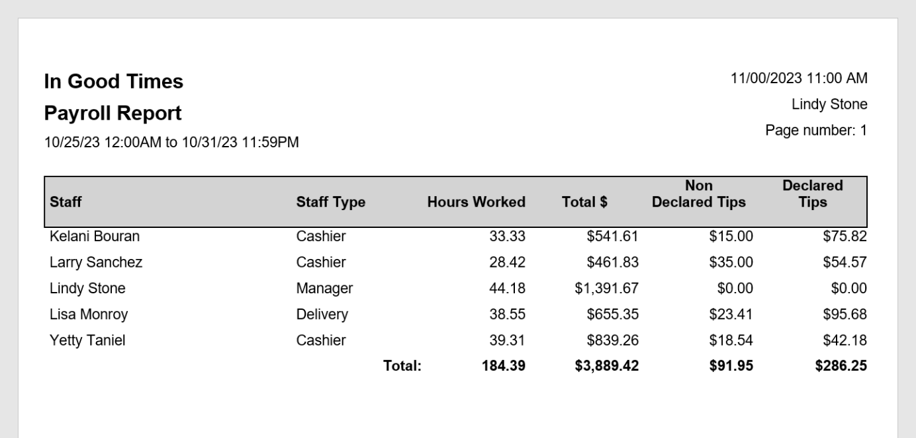
Figure 2-16. Payroll Report

Cognitive Questions
Q1. Match each MS Word feature to what it's used for: Table of Contents, Caption, Style/Theme, Page Break. Descriptions to match:
(a) automatically lists all headings with their page numbers,
(b) adds a numbered label under a picture or table,
(c) applies consistent fonts and colors across the whole document in one click,
(d) starts a new page without pressing Enter repeatedly. (5)

Q2. You've written a 10-page report with a heading for each section, but there's no Table of Contents yet. Name the MS Word feature that can generate a clickable table of contents automatically without retyping anything, and explain in 2–3 sentences why the section titles need to be formatted using Heading Styles (not just made bold and bigger) for this to work. (5)

Cognitive Activity
Obtained Marks | /10

Lab Exercise and Summary
Summary should cover Introduction, Procedure, Data Analysis and Evaluation.

Student’s Signature: Date:

Psychomotor Activity 1 — Experimental Setup
S.No | Criteria | Performance | Description | Marks
1 | MS Word Setup (4) | Level 4 | Opens and configures MS Word correctly and independently. | 4
1 | MS Word Setup (4) | Level 3 | Configures MS Word with minor errors or assistance. | 3
1 | MS Word Setup (4) | Level 2 | Completes the setup with considerable assistance. | 2
1 | MS Word Setup (4) | Level 1 | Setup is incomplete and requires substantial assistance. | 1
2 | File/Template Setup (4) | Level 4 | Correctly creates/selects the required document, template, and file structure. | 4
2 | File/Template Setup (4) | Level 3 | File/template setup is mostly correct with minor errors or omissions. | 3
2 | File/Template Setup (4) | Level 2 | Setup is partially completed and requires assistance. | 2
2 | File/Template Setup (4) | Level 1 | Major errors or omissions are present in the setup. | 1
3 | Parameter Setup (2) | Level 2 | Correctly enters all required formatting, styles, and document properties. | 2
3 | Parameter Setup (2) | Level 1 | Enters most required formatting and styles with minor errors. | 1
 | Total Obtained |  |  | /10

If a student is absent:
Criteria | Description | Marks
Absent | Student is absent from the laboratory activity. | 0

Psychomotor Activity 2 — Implementation + Results
S.No | Criteria | Performance | Description | Marks
1 | Implementation (4) | Level 4 | Implements the experiment correctly and independently using MS Word features (styles, TOC, illustrations, captions). | 4
1 | Implementation (4) | Level 3 | Implements the experiment with minor errors or assistance. | 3
1 | Implementation (4) | Level 2 | Partially implements the experiment and requires considerable assistance. | 2
1 | Implementation (4) | Level 1 | Implementation is largely incomplete and requires substantial assistance. | 1
2 | Execution/Formatting (2) | Level 2 | Executes all MS Word tasks correctly and appropriately handles basic formatting errors. | 2
2 | Execution/Formatting (2) | Level 1 | Executes tasks with minor errors or assistance. | 1
3 | Results/Output (4) | Level 4 | Obtains correct results and presents the required document with proper formatting, TOC, table of figures, and captions clearly. | 4
3 | Results/Output (4) | Level 3 | Obtains mostly correct results with minor errors in output or presentation. | 3
3 | Results/Output (4) | Level 2 | Obtains partially correct results with noticeable errors or omissions. | 2
3 | Results/Output (4) | Level 1 | Results are largely incomplete or require substantial correction. | 1
 | Total Obtained |  |  | /10
If a student is absent:
Criteria | Description | Marks
Absent | Student is absent from the laboratory activity. | 0
Affective Activity — Lab Report + Viva Voce
S.No | Criteria | Performance | Description | Marks
1 | Lab Report Completeness & Organization (4) | Level 4 | Report is complete, well-organized, and systematically formatted. Includes title, objective, methodology, screenshots/results, discussion, and conclusion. Demonstrates responsibility for the assigned work. | 4
 |  | Level 3 | Report is complete with minor omissions or organizational issues. Most sections present; some may be brief or slightly disorganized. | 3
 |  | Level 2 | Report is partially complete with several omissions. Key sections missing or very brief; screenshots unclear or missing. | 2
 |  | Level 1 | Report has major omissions or poor organization. Most sections missing or incomplete; shows limited responsibility. | 1
2 | Results, Discussion & Conclusion (2) | Level 2 | Results are accurately presented with clear discussion and conclusion. Explains what was learned and how errors were resolved. | 2
 |  | Level 1 | Results presented with minor errors or limited discussion. Conclusion is superficial or disconnected from learning objectives. | 1
3 | Viva Voce (4) | Level 4 | Clearly explains the assigned work, implementation, and results. Demonstrates individual responsibility, strong understanding, and effective communication. Answers confidently and correctly. | 4
 |  | Level 3 | Explains most aspects correctly with minor difficulty. Demonstrates good individual participation and understanding. | 3
 |  | Level 2 | Explains basic aspects with some prompting. Demonstrates basic participation and limited understanding. | 2
 |  | Level 1 | Demonstrates limited understanding or involvement. Requires substantial prompting to explain the work. | 1
Total Obtained |  |  |  | /10

The student has not submitted the report and has not appeared in the Viva Voce.
Criteria | Description | Marks
Lab Report and Results Not Submitted | Student has not submitted the report and results file. | 0
Absent in Viva Voce | Student is absent from the viva voce. | 0

Instructor’s Signature: Date: _________

Experiment No 3

Building Spreadsheets, Formulas, and Charts in Microsoft Excel

Objective:
- How to write documents in Excel and the use of editing options available in Excel.

Walkthrough task for MS Excel:
Interface:
The first figure shows the typical Excel sheet with the important parts of the programs interface labeled. Please become familiar with these.
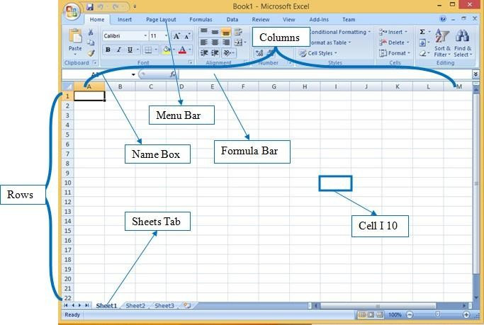
Figure 3-1. Excel Layout

Activity 01:-
We will be doing our tasks on the following example data.
Table 3.1. Data table for activity 1
Name | ITP | English | Total | Percentage
Ali | 75 | 77
Bilal | 63 | 70
Sara | 74 | 66
Aleena | 62 | 75
- Copy and paste this data into a newly created Excel File.
- Now left align the Name column while apply right alignment for the rest of the columns.
- Now, use the data of ITP and English to calculate the total marks. To do this use ‘function’,

the built in formula in Excel.
- By using sum calculate the sum of marks of a student.
- Percentage Formula:
There are some situations where you need to find some percent of a particular number, marks, price or the percentage of salary to incremented annually for employees. For all such tasks you need a percentage formula. We would apply a percentage formula for finding out the percentage of a student’s marks.
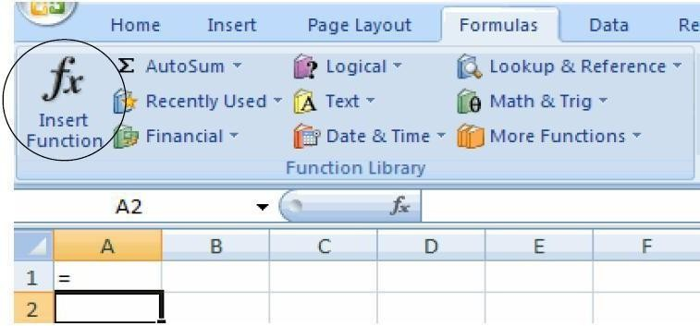
Figure 3-2. Insert function in Excel
To do so you need to do the following:
  - Select the cell where you want to apply the formula
  - Put = (equal sign) in that cell
  - Apply the percentage formula as shown in figure
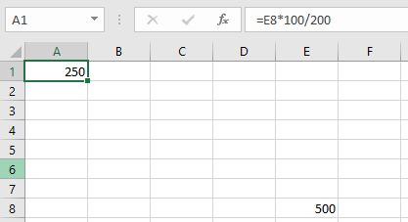
Figure 3-3. Percentage Formula
When you would apply the formula, you would get the required percentage as shown in figure
30. Percentage is shown in Highlighted column.

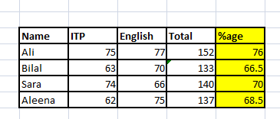
Figure 3-4. Percentage Formula

Activity 2:
Create a GPA calculator according to the instructions given below

- Make a table for 4 semesters with their course and credit hours written.
- Then after writing the GPA manually grade should be rendered in another column.
- After that use the formula to calculate SGPA.
- And after calculating all SGPA of every semester calculate the CGPA of the student.

SOLUTION GUIDANCE:
- Your table could look like:
SEMESTER 1
course | credit hours | marks | Grade | Grade point | Quality points
ICT | 2 | 89
English | 3 | 72
Physics | 3 | 76
Maths | 3 | 82
Islamiat | 1 | 56
Total

- Use the following grading system:
Marks | Grade | Grade Point
85–100 | A | 4
80–84 | A- | 3.67
75–79 | B+ | 3.33
70–74 | B | 3
65–69 | B- | 2.67
60–64 | C+ | 2.33
55–59 | C | 2
50–54 | C- | 1.67
45–49 | D | 1
Below 45 | F | 0

    - Now comes the important Excel formula to calculate Grade:
If marks are in C5, enter this formula in D5:
=IF(C5>=85,"A",IF(C5>=80,"A",IF(C5>=75,"B+",IF(C5>=70,"B",IF(C5>=65,"B",IF(C5>=60,"C+",IF(C5>=55,"C",IF(C5>=50,"C-",IF(C5>=45,"D","F")))))))))

    - To calculate Grade points:
If marks are in C5, enter this formula in E5:
=IF(C5>=85,4,IF(C5>=80,3.67,IF(C5>=75,3.33,IF(C5>=70,3,IF(C5>=65,2.67,IF(C5>=60,2.33,IF(C5>=55,2,IF(C5>=50,1.67,IF(C5>=45,1,0)))))))))

    - Calculate Quality points: Quality Points = Credit Hours × Grade Point
    - Calculate Total Credit Hours & Calculate Total Quality points
    - Calculate SGPA = Total Quality Points ÷ Total Credit Hour
    - Then make Semester 2, 3 and 4:
You can use exactly the same structure for all four semesters.
For example:
Course | Credit Hours | Marks | Grade | Grade Point | Quality Points
Each semester will have its own SGPA.
    - Finally calculate CGPA
CGPA = Total Quality Points of all semesters ÷ Total Credit Hours of all semesters
Suppose after completing four semesters, you get:
Semester | Total CH | Total QP | SGPA
1 | 12 | 40 | 3.33
2 | 15 | 48.5 | 3.23
3 | 16 | 55.2 | 3.45
4 | 15 | 54 | 3.6
TOTAL | 58 | 197.7
CGPA | 3.408621

Cognitive Questions
Q1. You are building a class marksheet in Excel. You write the formula =C2/D2*100 in cell E2 to calculate the percentage, then use the Fill Handle to copy it down to E3, E4, E5... For most students the percentage is correct, but a few rows show #DIV/0! errors because D (Total Marks) was left blank for the mid-term column only. Explain what a relative cell reference is, why copying the formula changes C2/D2 into C3/D3 automatically, and how you would fix the #DIV/0! error without retyping every formula. (5)

Q2. You need to report the total marks, the average marks, and the highest mark obtained by 40 students in one Excel sheet. Explain which built-in functions you would use for each of these three values, and why using these functions is more reliable than adding up the numbers on a calculator and typing the answer in manually. (5)

Cognitive Activity
Obtained Marks | /10

Lab Exercise and Summary
Summary should cover Introduction, Procedure, Data Analysis and Evaluation.

Student’s Signature: Date:

Psychomotor Activity 1 — Experimental Setup
S.No | Criteria | Performance | Description | Marks
1 | MS Excel Setup (4) | Level 4 | Opens and configures MS Excel correctly and independently. | 4
1 | MS Excel Setup (4) | Level 3 | Configures MS Excel with minor errors or assistance. | 3
1 | MS Excel Setup (4) | Level 2 | Completes the setup with considerable assistance. | 2
1 | MS Excel Setup (4) | Level 1 | Setup is incomplete and requires substantial assistance. | 1
2 | Worksheet/Workbook Setup (4) | Level 4 | Correctly creates/selects the required worksheet, workbook, and column/row structure for the task. | 4
2 | Worksheet/Workbook Setup (4) | Level 3 | Worksheet/workbook setup is mostly correct with minor errors or omissions. | 3
2 | Worksheet/Workbook Setup (4) | Level 2 | Setup is partially completed and requires assistance. | 2
2 | Worksheet/Workbook Setup (4) | Level 1 | Major errors or omissions are present in the setup. | 1
3 | Parameter Setup (2) | Level 2 | Correctly enters all required data, cell references, and formulas/functions. | 2
3 | Parameter Setup (2) | Level 1 | Enters most required data and formulas with minor errors. | 1
 | Total Obtained |  |  | /10

If a student is absent:
Criteria | Description | Marks
Absent | Student is absent from the laboratory activity. | 0

Psychomotor Activity 2 — Implementation + Results
S.No | Criteria | Performance | Description | Marks
1 | Implementation (4) | Level 4 | Implements the experiment correctly and independently using MS Excel formulas and functions. | 4
1 | Implementation (4) | Level 3 | Implements the experiment with minor errors or assistance. | 3
1 | Implementation (4) | Level 2 | Partially implements the experiment and requires considerable assistance. | 2
1 | Implementation (4) | Level 1 | Implementation is largely incomplete and requires substantial assistance. | 1
2 | Execution/Calculation (2) | Level 2 | Executes all formulas/functions correctly and appropriately handles basic errors (e.g., #DIV/0!, #REF!). | 2
2 | Execution/Calculation (2) | Level 1 | Executes formulas with minor errors or assistance. | 1
3 | Results/Output (4) | Level 4 | Obtains correct results and presents a properly formatted worksheet with accurate calculations. | 4
3 | Results/Output (4) | Level 3 | Obtains mostly correct results with minor errors in output or formatting. | 3
3 | Results/Output (4) | Level 2 | Obtains partially correct results with noticeable errors or omissions. | 2
3 | Results/Output (4) | Level 1 | Results are largely incomplete or require substantial correction. | 1
 | Total Obtained |  |  | /10

If a student is absent:
Criteria | Description | Marks
Absent | Student is absent from the laboratory activity. | 0

Affective Activity — Lab Report + Viva Voce
S.No | Criteria | Performance | Description | Marks
1 | Lab Report Completeness & Organization (4) | Level 4 | Report is complete, well-organized, and systematically formatted. Includes title, objective, methodology, screenshots/results, discussion, and conclusion. Demonstrates responsibility for the assigned work. | 4
 |  | Level 3 | Report is complete with minor omissions or organizational issues. Most sections present; some may be brief or slightly disorganized. | 3
 |  | Level 2 | Report is partially complete with several omissions. Key sections missing or very brief; screenshots unclear or missing. | 2
 |  | Level 1 | Report has major omissions or poor organization. Most sections missing or incomplete; shows limited responsibility. | 1
2 | Results, Discussion & Conclusion (2) | Level 2 | Results are accurately presented with clear discussion and conclusion. Explains what was learned and how errors were resolved. | 2
 |  | Level 1 | Results presented with minor errors or limited discussion. Conclusion is superficial or disconnected from learning objectives. | 1
3 | Viva Voce (4) | Level 4 | Clearly explains the assigned work, implementation, and results. Demonstrates individual responsibility, strong understanding, and effective communication. Answers confidently and correctly. | 4
 |  | Level 3 | Explains most aspects correctly with minor difficulty. Demonstrates good individual participation and understanding. | 3
 |  | Level 2 | Explains basic aspects with some prompting. Demonstrates basic participation and limited understanding. | 2
 |  | Level 1 | Demonstrates limited understanding or involvement. Requires substantial prompting to explain the work. | 1
Total Obtained |  |  |  | /10

The student has not submitted the report and has not appeared in the Viva Voce.
Criteria | Description | Marks
Lab Report and Results Not Submitted | Student has not submitted the report and results file. | 0
Absent in Viva Voce | Student is absent from the viva voce. | 0

Instructor’s Signature: Date: _________

Experiment No 4

Microsoft Excel Advance

Objective:
- Understand different formulas of excel and implementing them into real world examples.

Activity 1:
Create a Checkbox list in Excel
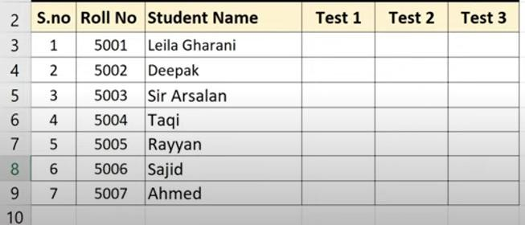
Figure 4-1. Sample Data File
  - Turn on the developer mode
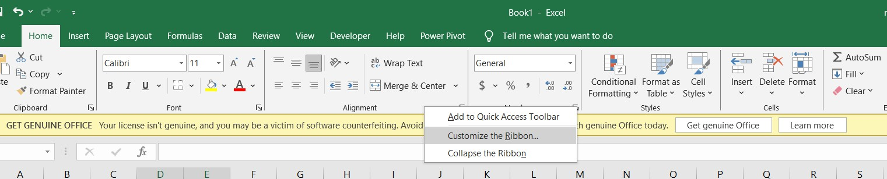
Figure 4-2. Customize the Ribbon to add Developer Mode Tab
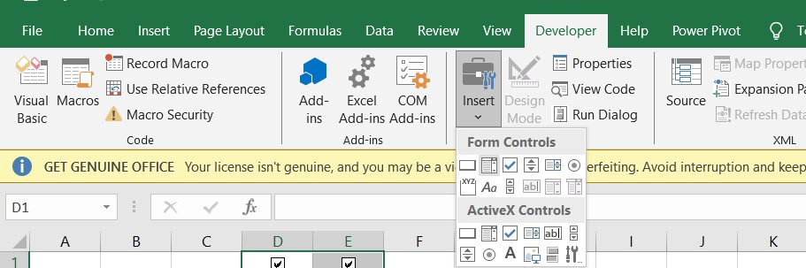
  - Click on Insert Tab in Developer Tab to add a check box

1. Find duplicate values in Excel
Figure 4-3. Click on Insert Tab

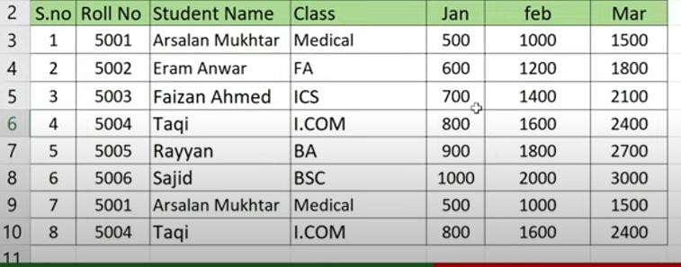
Figure 4-4. Data set with duplicate values
  - Select Cell and go to Conditional Formatting Cell
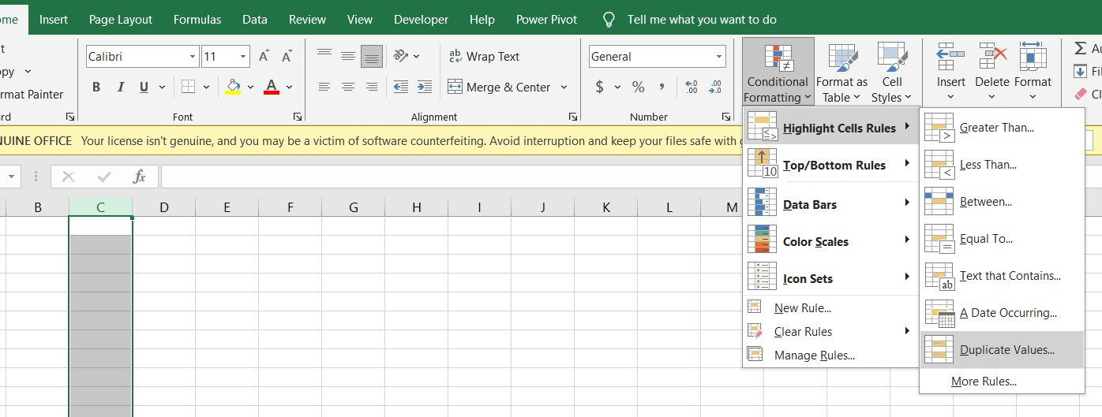
Figure 4-5. Select Cell and go to Conditional Formatting Cell to select duplicate values

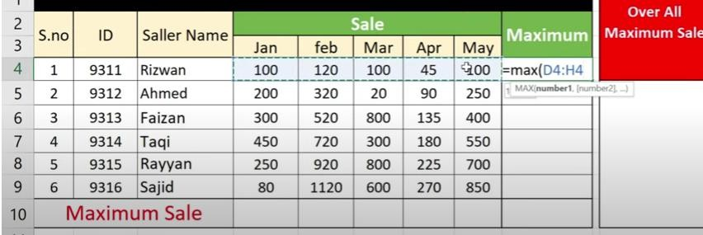
Calculate Maximum Sales
Figure 4-6. Data set to find maximum sales
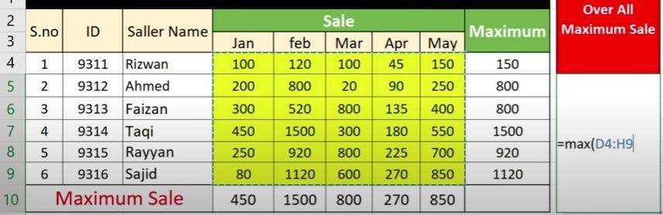
Figure 4-7. Data set to find overall maximum sales
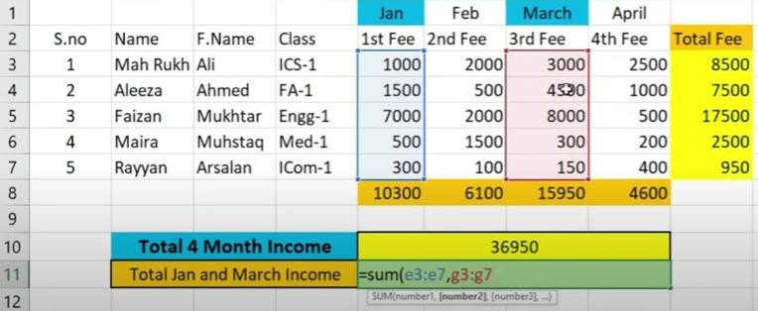
Figure 4-8. Data set to find fee submission amount

Change Text Direction
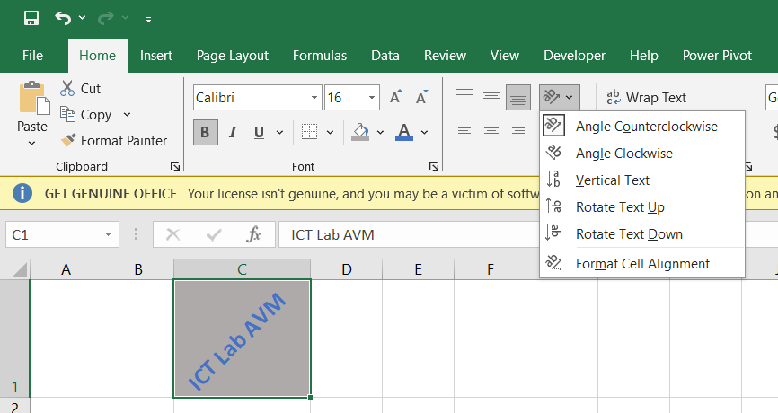
Figure 4-9. Change Text Direction in Excel

Activity 4:
Find Total Savings by Subtraction
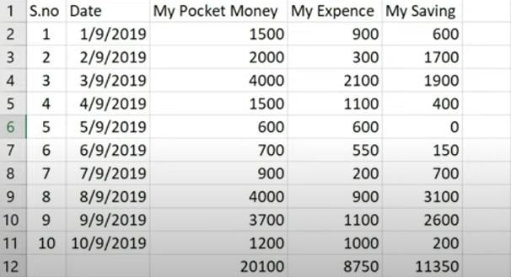
Figure 4-10. Data set to calculate saving amount

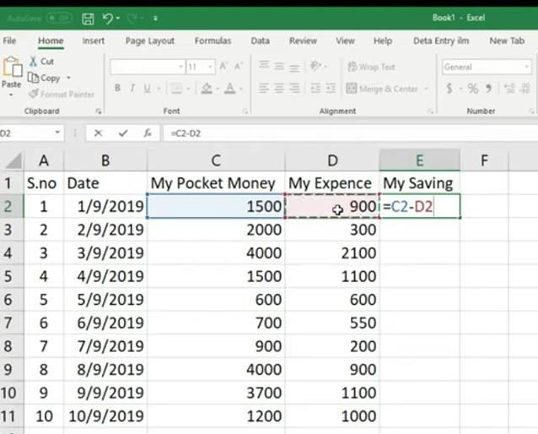
Figure 4-11. Formula implementation to calculate saving amount
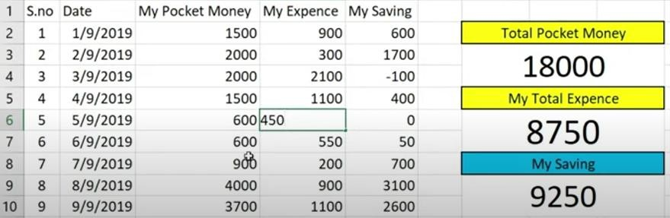
Figure 4-12. Required file at the end in given format

Find per Month Fee (Installments) by using Division
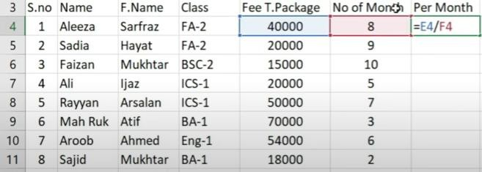
Figure 4-13. Data set and Formula implementation to calculate per month fee
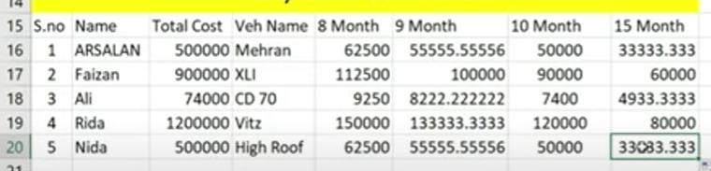
Figure 4-14. Data set to calculate per month installment for different durations

Production Calculation
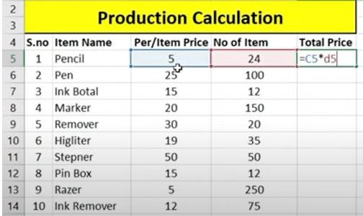
Figure 4-15. Data set and Formula implementation to calculate production cost
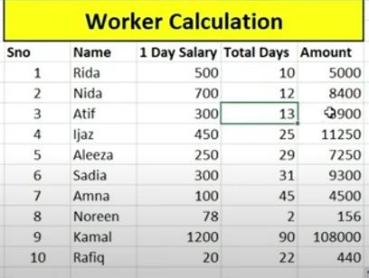
Figure 4-16. Data set and Formula implementation to calculate salary amount

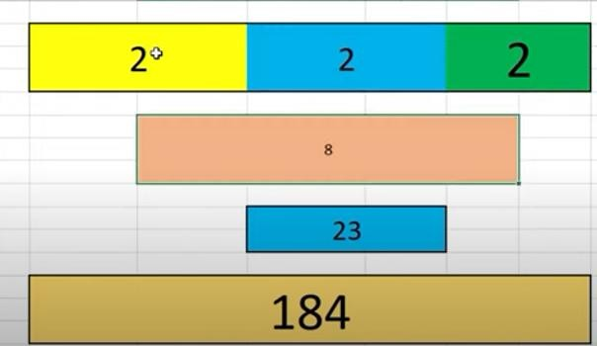
Merging and Multiplying Columns
Figure 4-17. Merging and Multiplying Columns

Activity 8:

Creating Charts
To create charts using the Insert Chart tab, follow the steps given below.
Step 1: Select the data.
Step 2: Click the Insert tab on the Ribbon.
Step 3: Click the Insert Column Chart on the Ribbon
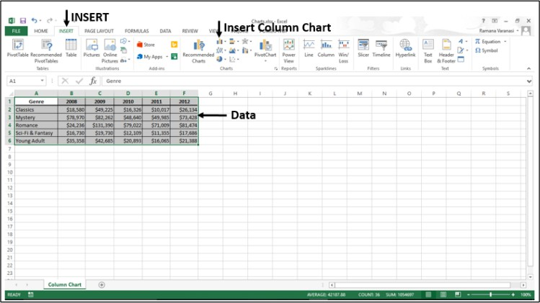
Figure 4-18. Insert charts

The 2-D column, 3-D Column chart options are displayed. Further, More Column Charts… Option is also displayed.
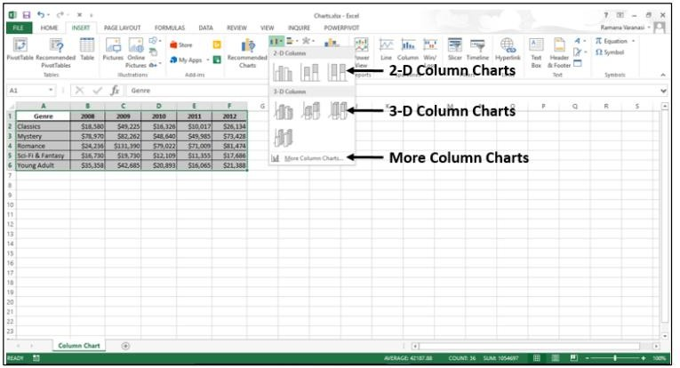
Figure 4-19. Insert charts (b)
Activity 9:
Create Salary Sheet
- One day Salary
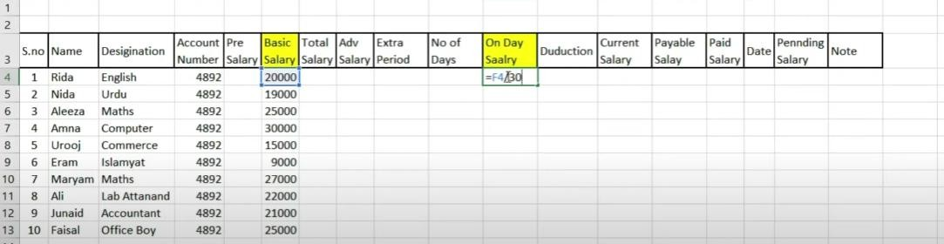
Figure 4-20. Data set and Formula implementation to calculate one day salary

Total Salary
Pre Salary + Basic

Current Salary
# of days * One Day – Adv

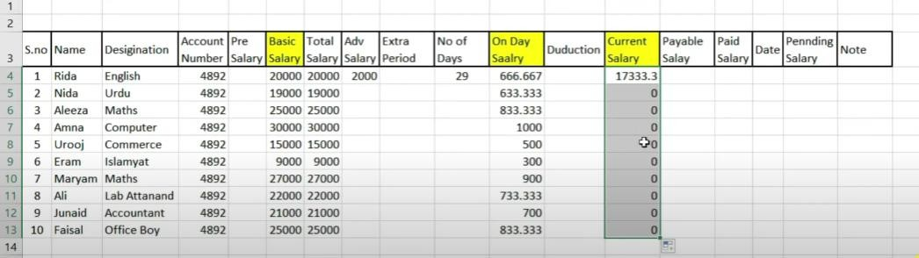
Figure 4-21. Calculate one day and current salary

Deduction
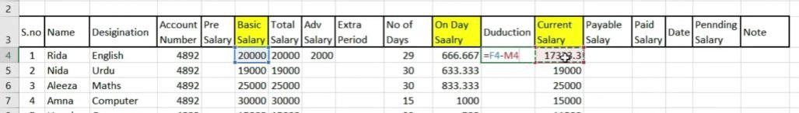
Figure 4-22. Calculate deduction amount

Payable Salary
Current + Pre Salary + Extra Period

Pending Salary
Payable- Paid
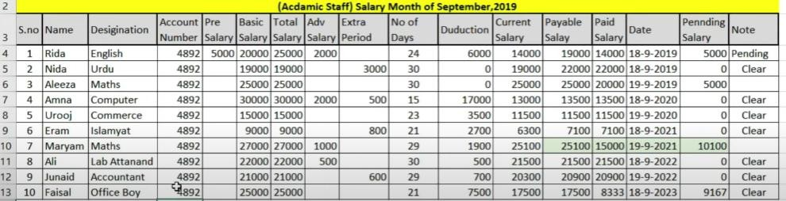
Figure 4-21. Academic staff salary sheet

Cognitive Questions
Q1. In the Payable Salary activity, an employee's Deduction should apply only if their Attendance is below 90%; otherwise the deduction should be 0. Explain how you would build this using an IF formula, and what would go wrong for the payroll if you instead subtracted a fixed deduction from every employee's salary regardless of attendance. (5)

Q2. You have a Total Salary column for 200 employees. Explain the difference between using the Fill Handle to copy one formula down the whole column versus typing the formula separately into all 200 cells, and describe one real mistake that becomes more likely when formulas are typed manually at that scale. (5)

Cognitive Activity
Obtained Marks | /10

Lab Exercise and Summary
Summary should cover Introduction, Procedure, Data Analysis and Evaluation.

Student’s Signature: Date:

Psychomotor Activity 1 — Experimental Setup
S.No | Criteria | Performance | Description | Marks
1 | MS Excel Setup (4) | Level 4 | Opens and configures MS Excel correctly and independently. | 4
1 | MS Excel Setup (4) | Level 3 | Configures MS Excel with minor errors or assistance. | 3
1 | MS Excel Setup (4) | Level 2 | Completes the setup with considerable assistance. | 2
1 | MS Excel Setup (4) | Level 1 | Setup is incomplete and requires substantial assistance. | 1
2 | Worksheet Setup (4) | Level 4 | Correctly creates/selects the required worksheet(s), columns, and payroll/production data structure. | 4
2 | Worksheet Setup (4) | Level 3 | Worksheet setup is mostly correct with minor errors or omissions. | 3
2 | Worksheet Setup (4) | Level 2 | Setup is partially completed and requires assistance. | 2
2 | Worksheet Setup (4) | Level 1 | Major errors or omissions are present in the setup. | 1
3 | Parameter Setup (2) | Level 2 | Correctly enters all required values, conditions (IF), and formula parameters. | 2
3 | Parameter Setup (2) | Level 1 | Enters most required values and conditions with minor errors. | 1
 | Total Obtained |  |  | /10

If a student is absent:
Criteria | Description | Marks
Absent | Student is absent from the laboratory activity. | 0

Psychomotor Activity 2 — Implementation + Results
S.No | Criteria | Performance | Description | Marks
1 | Implementation (4) | Level 4 | Implements the experiment correctly and independently using nested/conditional Excel formulas (IF, division, merging columns). | 4
1 | Implementation (4) | Level 3 | Implements the experiment with minor errors or assistance. | 3
1 | Implementation (4) | Level 2 | Partially implements the experiment and requires considerable assistance. | 2
1 | Implementation (4) | Level 1 | Implementation is largely incomplete and requires substantial assistance. | 1
2 | Execution/Calculation (2) | Level 2 | Executes all conditional formulas correctly and appropriately handles basic logic/formula errors. | 2
2 | Execution/Calculation (2) | Level 1 | Executes formulas with minor errors or assistance. | 1
3 | Results/Output (4) | Level 4 | Obtains correct results and presents accurate salary/production calculations clearly. | 4
3 | Results/Output (4) | Level 3 | Obtains mostly correct results with minor errors in output or formatting. | 3
3 | Results/Output (4) | Level 2 | Obtains partially correct results with noticeable errors or omissions. | 2
3 | Results/Output (4) | Level 1 | Results are largely incomplete or require substantial correction. | 1
 | Total Obtained |  |  | /10

If a student is absent:
Criteria | Description | Marks
Absent | Student is absent from the laboratory activity. | 0
Affective Activity — Lab Report + Viva Voce
S.No | Criteria | Performance | Description | Marks
1 | Lab Report  Completeness & Organization  (4) | Level 4 | Report is complete, well-organized, and demonstrates responsible completion of the hardware/software identification exercise. | 4
1 | Lab Report  Completeness & Organization  (4) | Level 3 | Report is complete with minor omissions or organizational issues. | 3
1 | Lab Report  Completeness & Organization  (4) | Level 2 | Report is partially complete with several omissions. | 2
1 | Lab Report  Completeness & Organization  (4) | Level 1 | Report has major omissions or poor organization. | 1
2 | Work/Results & Conclusion (2) | Level 2 | Completed classification and conclusion are correctly presented and discussed. | 2
2 | Work/Results & Conclusion (2) | Level 1 | Presented with minor errors or omissions. | 1
3 | Viva Voce (4) | Level 4 | Clearly different formulas of excel, demonstrating strong understanding. | 4
3 | Viva Voce (4) | Level 3 | Explains most concepts correctly with minor difficulty. | 3
3 | Viva Voce (4) | Level 2 | Explains basic aspects with some prompting. | 2
3 | Viva Voce (4) | Level 1 | Demonstrates limited understanding, requires substantial prompting. | 1
3 | Total Obtained |  |  | /10

The student has not submitted the report and has not appeared in the Viva Voce.
Criteria | Description | Marks
Lab Report and Results Not Submitted | Student has not submitted the report and results file. | 0
Absent in Viva Voce | Student is absent from the viva voce. | 0

Instructor’s Signature: Date: _________

Experiment No 5

Introduction to Microsoft Power Point

Objective:
- How to write documents in Power Point and the use of editing options available in Power Point.

Home Ribbon
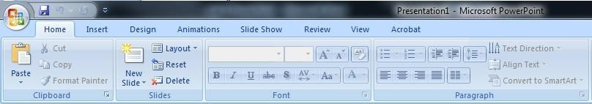
Figure 5-1. Home Ribbon

Activity 1:
Slides
  - New Slide:
- Click on home ribbon
- Click on new slide button
- New slide will be shown in your presentation
  - Layout:
Different slide layouts are used to manage the arrangement of content on the side.
Click the layout you want. The layout appears in the slide pane of the PowerPoint window.
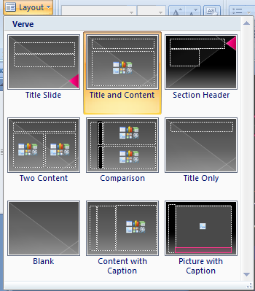
Figure 5-2. Layout

- Make two of the slides as tile slide, third and fourth one as size and content layout and last one should be blank.
- Write your name and registration number on first title slide.
- On second slide write topic as "Computers".
- Search text from internet and add some points about computers in the successive two slides and last slide should be having pictures of computers.
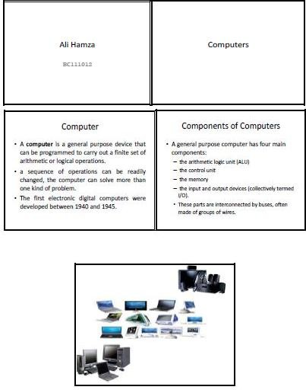

Figure 5-3. Output of Sample Slides
  - Themes
Applying theme to your slides:
A theme is a set of colors, fonts, and special effects. Themes provide attractive backgrounds for your PowerPoint slides.
    - To apply a theme to all of the slides in your presentation:

      - Choose the Design tab.
      - Click the More buttons in the Themes group.
      - Click the design as shown in arrow 3 of figure 5-5 you want.
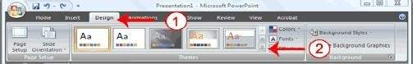
Figure 5-4. Design Tab in Power Point
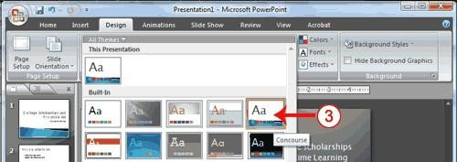
Figure 5-5. Design Tab to apply theme in Power Point
  - To apply a theme to selected slides
Click the Slides tab, located on the left side of the window.
- Hold down the Ctrl key and then click to select the slides to which you want to apply a theme.
- Choose the Design tab as shown in arrow 1 of figure 5-4.
- Click the More buttons in the Themes group as shown in arrow 2 of figure 5-4.
- Right-click the theme you want to apply. A menu appears.
- Click Apply to Selected Slides
- Change fonts to Arial, colors to origin and add Metro effects in Design Tab.
  - Background:
- You can add a dramatic effect to your theme by applying a background.
- Choose the Design tab.
- Click the Background Styles button.
- Click the background you want.

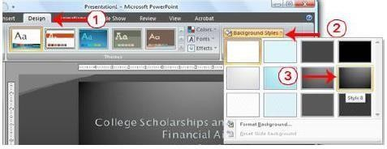
Figure 5-6. Apply Background Styles
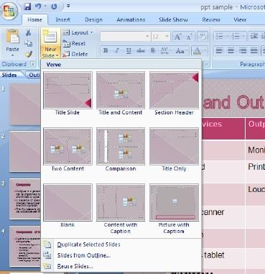
Figure 5-7. New Slide with Custom Design

After applying theme and background style 6, presentation would look similar to following slides:
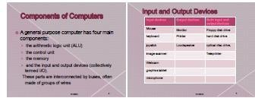
Figure 5-8. Output of Custom Design Slides
  - Animations
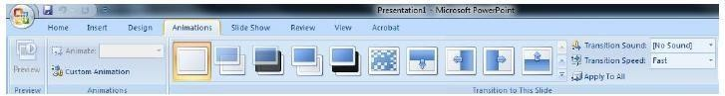
Figure 5-9. Animations Tab
- Preview:
This button previews the animated slides being set by using slide transitions of the presentation.
- Animations:
Animations control how objects move onto, off of, and around your slides. Transitions control how your presentation moves from one slide to the next
- Custom Animation:
You can animate the objects on your PowerPoint slides. PowerPoint provides four types of animations as shown in Figure 5-10.
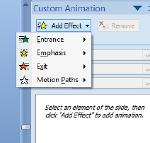
Figure 5-9. Custom Animations

- Entrance
An Entrance animation determines the manner in which an object appears on a slide; for example, an object can move onto a slide.
- Emphasis
An Emphasis animation does something to draw attention to an object; for example, the object can become larger.
- Exit
An Exit animation determines the manner in which an object leaves a slide; for example, an object can move off a slide.
- Motion Paths

A Motion Paths animation determines how an object moves around a slide; for example, an object can move from left to right.

  - To choose an effect:
    - Select the object you want to animate.
    - Choose the Animations tab.
    - Click the Custom Animation button. The Custom Animation pane appears.
    - Click the Add Effect button. A menu appears.
    - Choose the type of effect you want. A submenu appears.
    - Click the effect you want. PowerPoint applies the effect.

  - To modify an effect:
    - Click the down arrow next to the Start field on the Custom Animations pane and then select the start method you want.
    - Click the down arrow next to the Property field on the Custom Animations pane and the select the property you want. The Property field might be labelled Direction, Size, or some other property.
    - Click the down arrow next to the Speed field on the Custom Animations pane and then select the speed you want to apply to your animation.
    - Apply animation on text and images on all slides.
    - Choose Text animation from emphasis on all headings and Diamond from entrance for all other text bullet by bullet.
    - To preview the animation, click the Play button on the Custom Animations pane.
    - Explore all of them yourself and animate your text and slides. Slide show should display presentation in effective manner with animations on each slide.

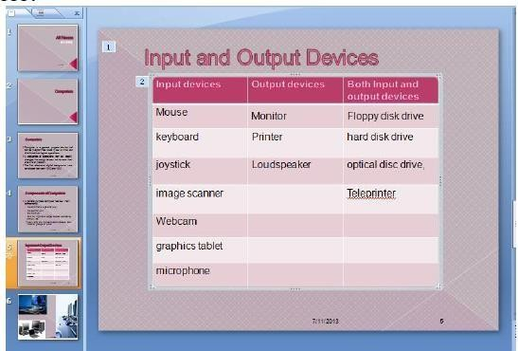
Figure 5-10. Applying Animation
  - Transition Sound
This button allows you to add some sound during slid transitions of your presentation. You can select various sounds from this option.
    - In the pane that contains the Outline and Slides tabs, click the Slides tab.
    - Select slide thumbnail of the slide that you want to add a sound to.
    - On the Transitions tab, in the Timing group, click the arrow next to Sound, and then do one of the following:
      - To add a sound from the list, select the sound that you want.
      - To add a sound not found on the list, select Other Sound, locate the sound file that you want to add, and then click OK.
      - Select transition sound for the presentation that must not be annoying for the audience.

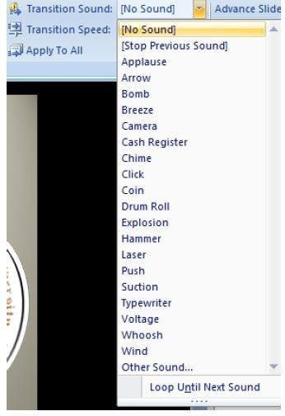
Figure 5-11. Transition Sound
  - Transition Speed
It sets the speed of the slide transition to be slow, medium or fast.
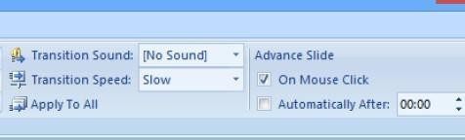
Figure 5-12. Managing Slide Transitions
All slides should advance one by one at mouse click or keyboard keys.
- Apply To all
This button applies all settings being chosen on all slides in the presentation.
- Advance Slide
To advance the slides to the next one, set the duration of the transition between the previous

slide and the current slide. For performing this task, do the following:
On the Transitions tab, in the Timing group, type or select the speed that you want: Mouse click. To advance the slide when you click the mouse, on the Transitions tab, in the Timing group, select the On Mouse Click check box. Automatically After
To advance the slide after a specified time, on the Transitions tab, in the Timing group, in the after box, enter the number of seconds that you want.

What is a Master Slide in PowerPoint?

Slide Master is a PowerPoint feature you can find in the View tab. It allows you to create master templates (or master slides). It’s a way to automatically add elements that you want to be repeated throughout your slides, like a font or a theme.
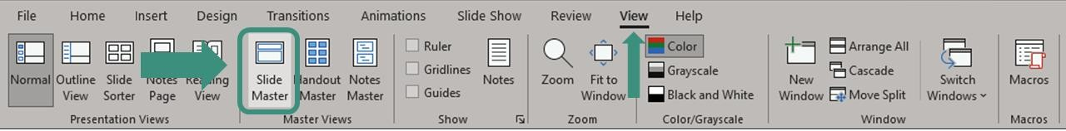
Figure 5-13. Slide Master View

Why is Master Slide used?

The Slide Master feature in PowerPoint is extremely useful for making your presentation design process more efficient. The main reason it’s used is because it helps you customize all of your PowerPoint elements at once.
That’s right, there is no reason to change slide by slide anymore. With master slides, you can change the typography, logo, and colors and even add your logo and watermark by changing these elements on one single slide. When you adjust one of the elements in the Master Slide, all of those elements will change in all the slides.
How to use slide master in PowerPoint?
To create your own Master template, you just need to go to the View tab > Slide Master. This will allow you to access the Slide Master view.
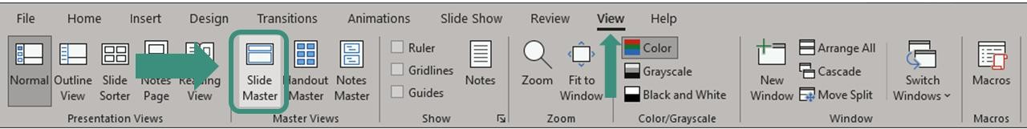

Figure 5-14. Open Slide Master View

How to create master slides in PowerPoint?
Follow these steps to learn how to create a presentation using master slides in PowerPoint:
- Work on your main Slide Master
Once you are on the Master View, it’s time to get to work! Go to the very first slide on the Slides Overview Pane on the left. This is your Master Slide. You’ll recognize it because it’ll have a number 1 at the side, and it’ll be a little bigger than the rest:
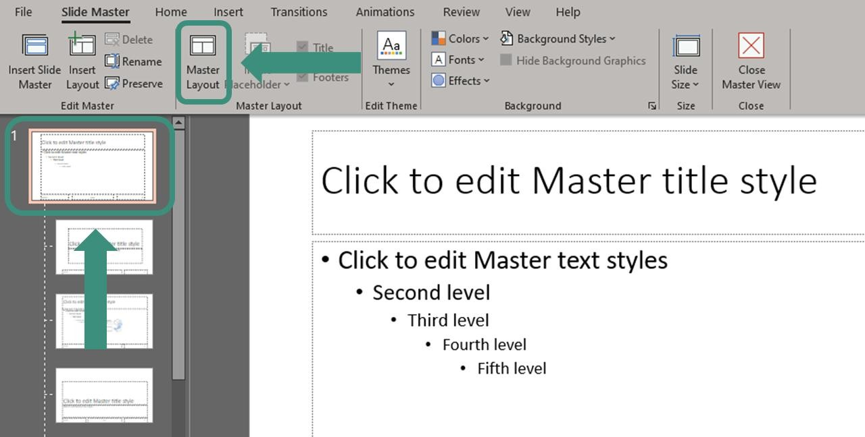
Figure 5-15. Master layout
Here is where you’ll work on the common elements all your slides will share. This is where you should customize your background, font style, and color. This is also the perfect opportunity to add an element you want to repeat throughout your slides, like a logo. Take into account that anything you do while in this mode will then be reflected in all the rest of your slides.

By clicking on the Master Layout option, you’ll also be able to customize which layout elements you want in your presentation slides.
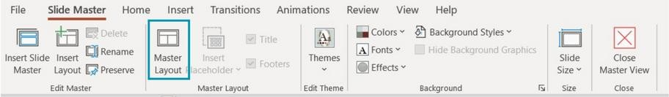
Figure 5-16. Master layout option
For example, you can choose to include the date, the slide number, and more.
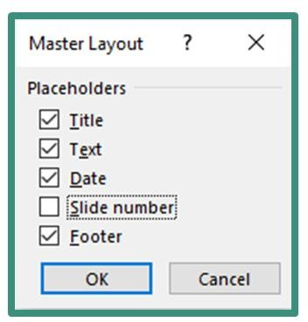
Figure 5-16. Master layout option add or delete
- Work on your Layout slides
Next, it’s time to move to the Layout slides. These are slides that appear below your Master Slide. In other words, these are your actual slides.

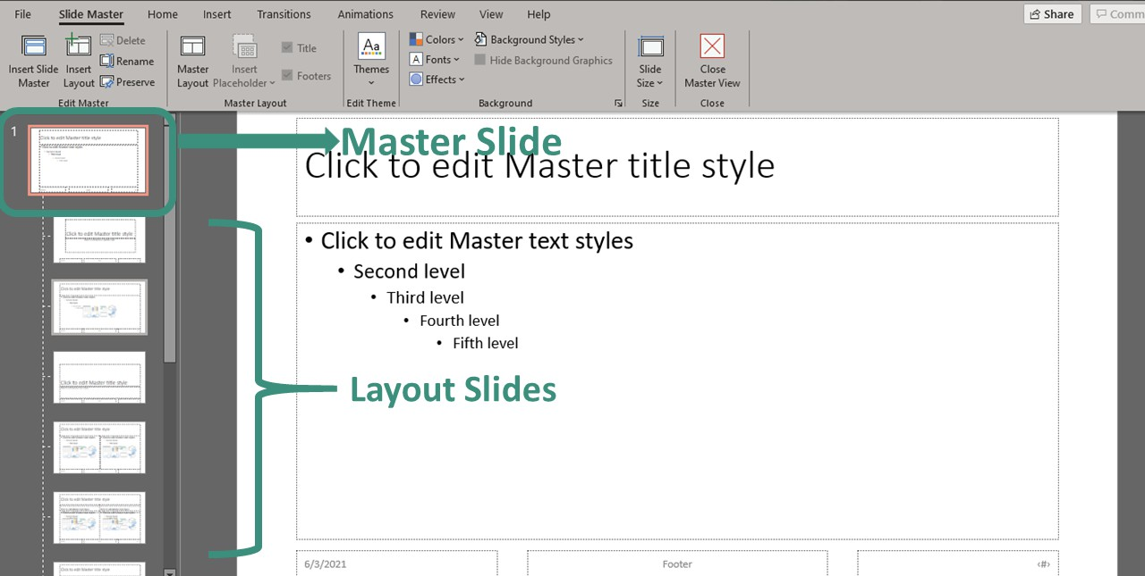

Figure 5-17. Master Slide and Layout Slides
You’ll notice that PowerPoint offers 11 different default layout settings for you to start to work with. You can edit and alter these layouts as much as you want. Consider that these are meant to make your life easier when designing your presentation. That’s why it’s important to think through what kind of layouts your presentation will need.

If you don’t find a layout that fits your needs, you can also create a master layout from scratch. Select any of your layouts and click the option Insert Layout in the Edit Master group.

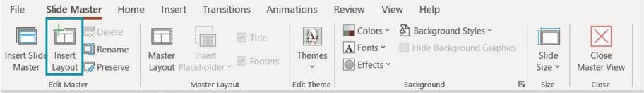
Figure 5-17. Create Your Master Layout from Scratch
It’ll create a new type of slide you can edit and customize as you see fit. Use the option Insert Placeholder to add different kinds of elements to our new layout.
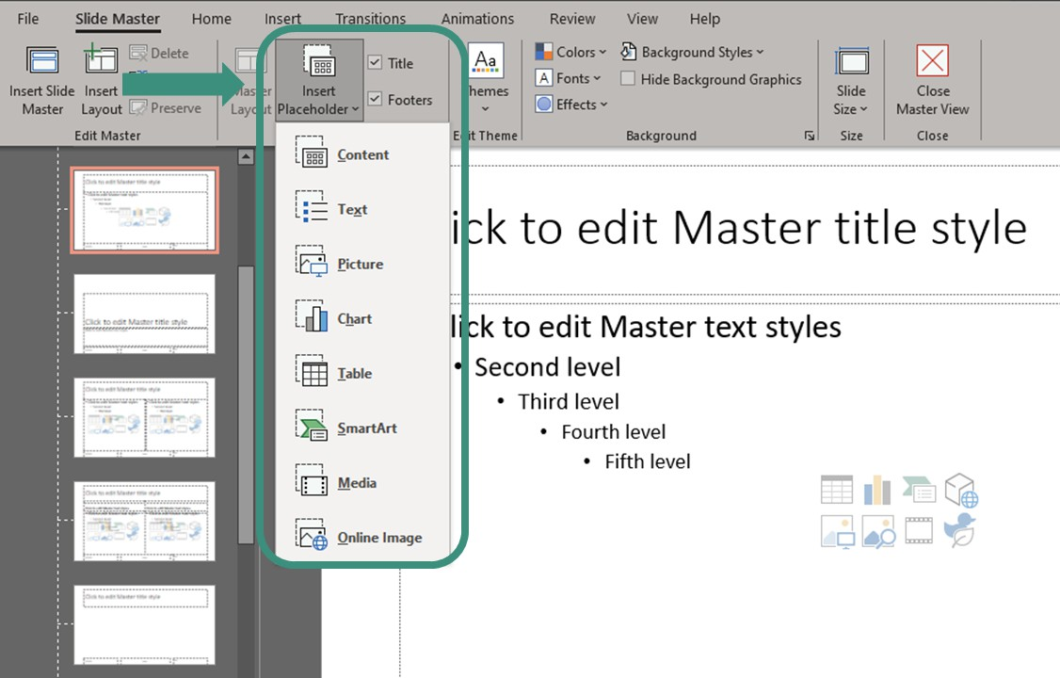
Figure 5-18. Insert Placeholder

Adding a new Slide Master if necessary
If you think just one “theme” is not enough for your presentation and want to use several different styles, or segments, in a single presentation, you can do it! You just need to add a second Slide Master. Select Insert Slide Master on the far left, and you’ll get a completely new Master slide in the same presentation.
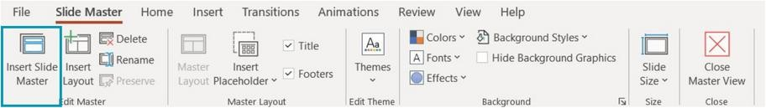
Figure 5-18. Insert Slide Master
You’ll be able to see your two different master slides, and the layout slides below each one:
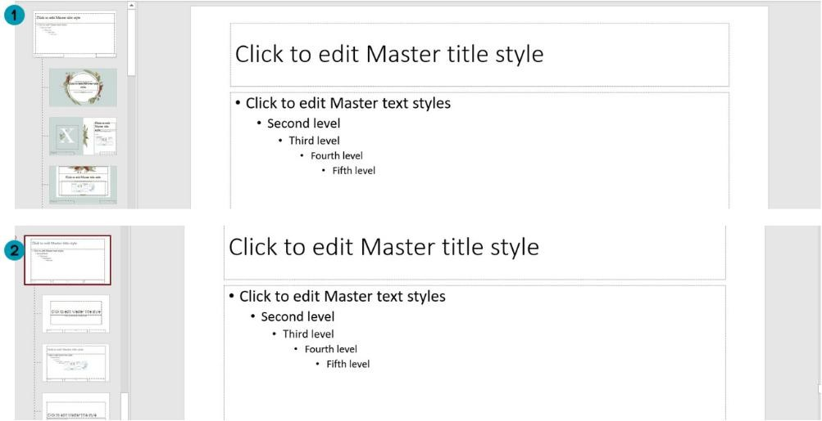
Figure 5-19. Two Different Master Slides

Once you’re happy with how your master template looks, remember to click the option Close Master View so you can see your changes.
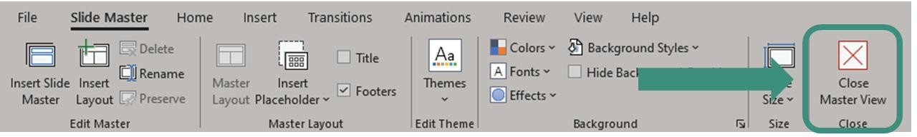
Figure 5-20. Close Master View How to edit master slide in PowerPoint?
If you’ve worked with a presentation that’s already using a master template, you can edit your slides through Master View. Especially if there are common elements you want to eliminate, add, or edit on more than one slide!
Access the Master Slide View
Just like for creating a master template, the first thing is to access the master view. Go to View tab
> Slide Master to see exactly all the design guidelines your presentation has at the moment.
Edit the Master Slide
If there’s a common element that you want to change, the Master Slide is the place to do it! It works great for adding and removing logos or changing the background or color scheme.
Edit Specific Layout Slides
If there’s a design element you want to change from a specific layout style, you can do so, too. Pick the slide layout you want to edit and customize as you see fit.
Remember that all the slides below the master slide will have these changes. So, if you are looking for a specific change in one of the slides, it’s better to avoid the Master Slide view and edit your slides as you normally would.

Activity 02:-
Prepare 20 slides on topic “Computer”. Your slides must have following effects:-
- Proper Layout
- Theme
- Background
- Animation
- Transition Sound
- Transition Speed
- Tables
And all other effects which you learn in this lab.

Cognitive Questions
Q1. Two students prepare a 10-slide project summary. Student A fills each slide with full paragraphs and reads them aloud word-for-word. Student B uses short bullet points, one supporting image per slide, and keeps the detailed explanation in the Speaker Notes. Explain why Student B's approach is generally more effective for an audience, and name two specific PowerPoint features that support this style. (5)

Q2. Explain the difference between a slide Transition and an Animation in PowerPoint. Then describe a situation where adding too many animations to a single slide would distract from the message rather than support it, and how you would decide when an animation is actually useful. (5)

Cognitive Activity
Obtained Marks | /10

Lab Exercise and Summary
Summary should cover Introduction, Procedure, Data Analysis and Evaluation.

Student’s Signature: Date:

Psychomotor Activity 1 — Experimental Setup
S.No | Criteria | Performance | Description | Marks
1 | MS PowerPoint Setup (4) | Level 4 | Opens and configures MS PowerPoint correctly and independently. | 4
1 | MS PowerPoint Setup (4) | Level 3 | Configures MS PowerPoint with minor errors or assistance. | 3
1 | MS PowerPoint Setup (4) | Level 2 | Completes the setup with considerable assistance. | 2
1 | MS PowerPoint Setup (4) | Level 1 | Setup is incomplete and requires substantial assistance. | 1
2 | Presentation/Slide Setup (4) | Level 4 | Correctly creates/selects the required presentation, slide layout, and design theme. | 4
2 | Presentation/Slide Setup (4) | Level 3 | Presentation/slide setup is mostly correct with minor errors or omissions. | 3
2 | Presentation/Slide Setup (4) | Level 2 | Setup is partially completed and requires assistance. | 2
2 | Presentation/Slide Setup (4) | Level 1 | Major errors or omissions are present in the setup. | 1
3 | Parameter Setup (2) | Level 2 | Correctly applies required text formatting, layouts, transitions, and animation settings. | 2
3 | Parameter Setup (2) | Level 1 | Applies most required formatting and slide settings with minor errors. | 1
 | Total Obtained |  |  | /10

If a student is absent:
Criteria | Description | Marks
Absent | Student is absent from the laboratory activity. | 0

Psychomotor Activity 2 — Implementation + Results
S.No | Criteria | Performance | Description | Marks
1 | Implementation (4) | Level 4 | Implements the experiment correctly and independently using MS PowerPoint features (layouts, SmartArt, transitions, animations). | 4
1 | Implementation (4) | Level 3 | Implements the experiment with minor errors or assistance. | 3
1 | Implementation (4) | Level 2 | Partially implements the experiment and requires considerable assistance. | 2
1 | Implementation (4) | Level 1 | Implementation is largely incomplete and requires substantial assistance. | 1
2 | Execution/Slideshow (2) | Level 2 | Runs the slideshow correctly, with working transitions/animations and no broken elements. | 2
2 | Execution/Slideshow (2) | Level 1 | Runs the slideshow with minor errors or assistance. | 1
3 | Results/Output (4) | Level 4 | Obtains correct results and presents a complete, well-formatted, visually clear presentation. | 4
3 | Results/Output (4) | Level 3 | Obtains mostly correct results with minor errors in output or presentation. | 3
3 | Results/Output (4) | Level 2 | Obtains partially correct results with noticeable errors or omissions. | 2
3 | Results/Output (4) | Level 1 | Results are largely incomplete or require substantial correction. | 1
 | Total Obtained |  |  | /10

If a student is absent:
Criteria | Description | Marks
Absent | Student is absent from the laboratory activity. | 0

Affective Activity — Lab Report + Viva Voce
S.No | Criteria | Performance | Description | Marks
1 | Lab Report  Completeness & Organization  (4) | Level 4 | Report is complete, well-organized, and demonstrates responsible completion of the hardware/software identification exercise. | 4
1 | Lab Report  Completeness & Organization  (4) | Level 3 | Report is complete with minor omissions or organizational issues. | 3
1 | Lab Report  Completeness & Organization  (4) | Level 2 | Report is partially complete with several omissions. | 2
1 | Lab Report  Completeness & Organization  (4) | Level 1 | Report has major omissions or poor organization. | 1
2 | Work/Results & Conclusion (2) | Level 2 | Completed classification and conclusion are correctly presented and discussed. | 2
2 | Work/Results & Conclusion (2) | Level 1 | Presented with minor errors or omissions. | 1
3 | Viva Voce (4) | Level 4 | Clearly explains write documents in Power Point and the use of editing options available in Power Point.  , demonstrating strong understanding. | 4
3 | Viva Voce (4) | Level 3 | Explains most concepts correctly with minor difficulty. | 3
3 | Viva Voce (4) | Level 2 | Explains basic aspects with some prompting. | 2
3 | Viva Voce (4) | Level 1 | Demonstrates limited understanding, requires substantial prompting. | 1
3 | Total Obtained |  |  | /10

The student has not submitted the report and has not appeared in the Viva Voce.
Criteria | Description | Marks
Lab Report and Results Not Submitted | Student has not submitted the report and results file. | 0
Absent in Viva Voce | Student is absent from the viva voce. | 0

Instructor’s Signature: Date: _________

Experiment No 6

Introduction to Visio and Flow Chart Designing

Objective:
- Design of flow charts in MS Word.
- Design of flow charts in MS Visio.

Flow charts in word:
All the tools needed to make flowcharts in MS Word lie with the Drawing Tools. But first do these three preliminary steps:
Maximize your page area
Collapse the Ribbon by clicking the little upward arrow (or Click Ctrl+F1) on the extreme right so only the tab names show.
Display the Grid
Click the View tab and click the Gridlines checkbox. The grid helps you align and size the flowchart symbols precisely as you can snap them to the gridlines. You can also customize the gridlines (Page Layout — Arrange — Align — Grid Settings).
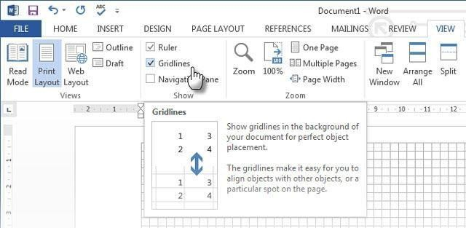
Figure 6-1. Display the Grid
Use the Drawing Canvas. Inserting any shape or “drawing” in a Word document automatically creates a drawing canvas. You will have to resize the canvas to frame your entire flowchart. It is especially useful when using different shapes (as in a flowchart). Also, you can customize the drawing canvas itself to create attractive backdrops for your flowchart.
Now, let’s start the meticulous job of inserting our shapes and connecting them all together. It always helps if you map it out on paper first, and then use Word to give it the finished look. A rough sketch helps you understand the page layout on Word to begin with. The process is simple but putting some planning into using this “planning tool” is a timesaver. All the required symbols can be found on the Insert tab – Shapes. Click the dropdown for Shapes.

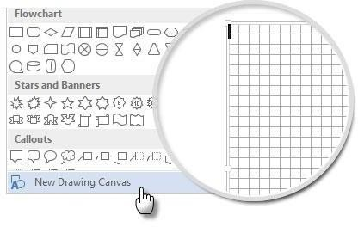
Figure 6-2. Drawing Canvas
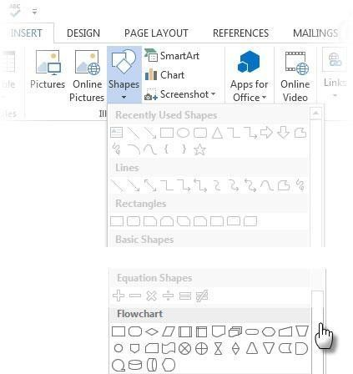

Figure 6-3. Shapes

  - The symbols are neatly organized under the Flowchart group.
  - Select the shape. For instance, the symbol for “Start”.
  - Click in the canvas area, keep the left button pressed while dragging the mouse to add the shape. You can also double click on any shape to automatically add it to the Canvas. Move and resize
  - Add text by clicking the shape and typing in the label.
  - Connect two symbol-shapes with the help of arrows or connectors. Unlike simple arrows,

connectors stay connected to the shapes. The two basic types of connectors available under the Shapes dropdown are elbow and curved.

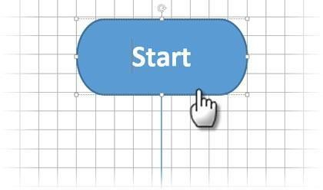
Figure 6-4. Drawing Canvas Example
Note: Connectors work as intended only between shapes placed on the drawing canvas. For instance; you can manually move the connectors to any connection points (represented by tiny blue dots on the shapes). The connection points anchor the connectors in place and you can move the shapes without dislodging the connectors. This gives you a lot of flexibility when modifying your flowchart by moving things around.
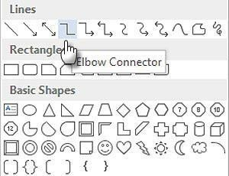
Figure 6-5. Lines or Connector

  - Add a Yes or No to the connectors branching out of Decisions shapes by inserting Text Boxes alongside the connector arrows. You can also use the rotation handle to rotate the text box.
Tips to Align Shapes
There are several ways to do it.

  - The recommended way is to do it right the first time. Use the gridlines and draw them with uniform widths when you are placing them on the canvas.
  - Click on individual shapes and drag them to the new locations. If you have many shapes, this can be very time consuming. The gridlines help you snap them in place.
  - Select all the shapes you want to align. On the Format tab, click the Align dropdown menu. Select Align Selected Objects and use the alignment tool to align the shapes automatically.
Tips to Align a Flowchart
After the flowchart has been laid out, you can neatly align the diagram according to the page.

  - Group all the shapes and connectors. Select all the shapes and connectors. On the Format tab, click the Group dropdown and select Group.
  - From the Align dropdown check if the Align to Margin item is selected. Then, click Align Center and/or Align Middle.
  - Optionally, resize the canvas by dragging the corner or edges

Designing a Flowchart
Flowchart symbols:
Flowcharts use special shapes to represent different types of actions or steps in a process. Lines and arrows show the sequence of the steps, and the relationships among them. These are known as flowchart symbols. Following shapes are most commonly used in flow charts.
Rectangle Shape - Represents a process Oval Shape - Represents the start or end
Diamond Shape - Represents a decision Parallelogram - Represents input/output
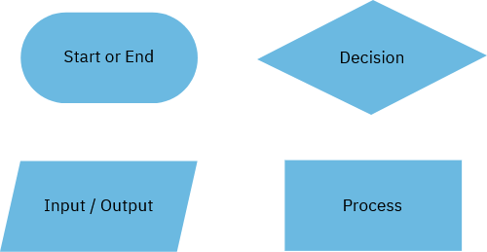

Figure 6-6. Commonly used shapes in flowcharts

Basic Symbols of a Flowchart are given below:
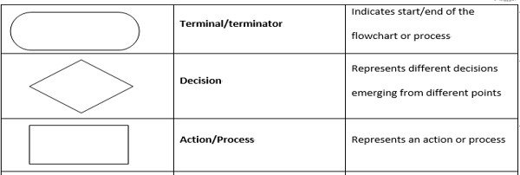
Figure 6-7. Basic Symbols in flowcharts, their name, and representation (a)
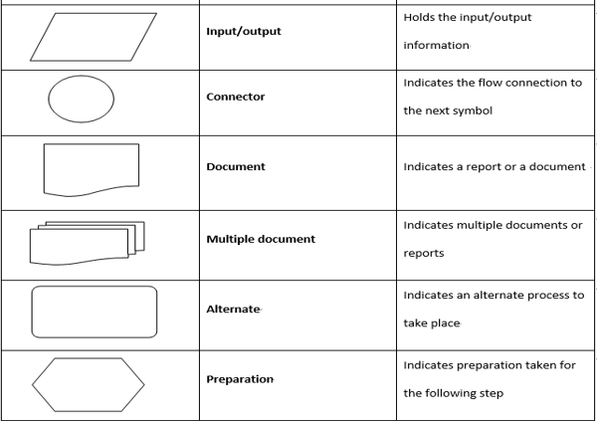

Figure 6-7. Basic Symbols in flowcharts, their name, and representation (b)

Flowchart designing
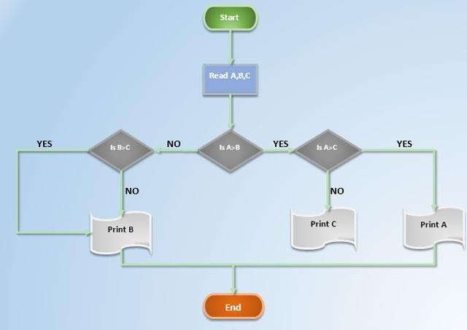
Figure 6-8. Stunning Flowchart
The colorful flowchart you see above is nothing but a more formatted flowchart. Formatting a flowchart should be the final stage after you have inserted, connected, and labelled all the boxes. It is better to do it in bulk rather than putting the flourishes on individual boxes as you go along. So, select multiple shapes and format them together.

I will leave it to your creative eye, and just point you to the basic tools you can access from the Format tab on the Ribbon or the more detailed options available on the side panel. Open the side panel by right-clicking on a shape and selecting Format Shape
You have many options available to design the shapes and the connectors:

  - Shape Styles: A quick way to add color or gradient fills to the shapes.
  - Shape Fills: Use your choice of solid colors or gradients. Don’t use too many color schemes.
  - Shape Outlines: Set the visual properties of the bounding lines. Also, use it to make the connector arrows thicker or thinner.
  - Effects: Give the shapes depth with 3-Dimensions, Shadows etc.
As you can see, there are many options to add a variety of finishing touches to the barebones

flowchart. It is painstaking, but do fuss over it if you want a thoroughly professional look.
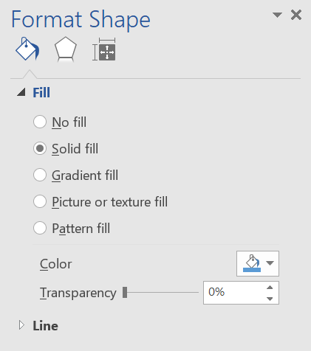

Figure 6-9. Format Shape

Flow Charts in Visio:
Visio customization and settings are similar to Word since both software are developed by Microsoft under the Office domain.
Getting Started:
After opening Visio, click the basic diagram button.

The biggest difference between Word and Visio is that Visio is designed to make flowcharts and drawings where as word is a text editing software. This makes it very easy to maneuver and make changes in Visio according to one’s requirements.
After selecting “Basic Diagram”, a new window appears where all the shapes are neatly arranged on the

left side under the tab of “Basic Shapes”.

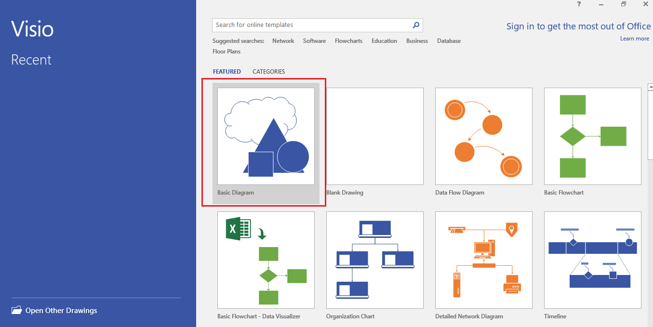

Figure 6-10. Main Window Visio
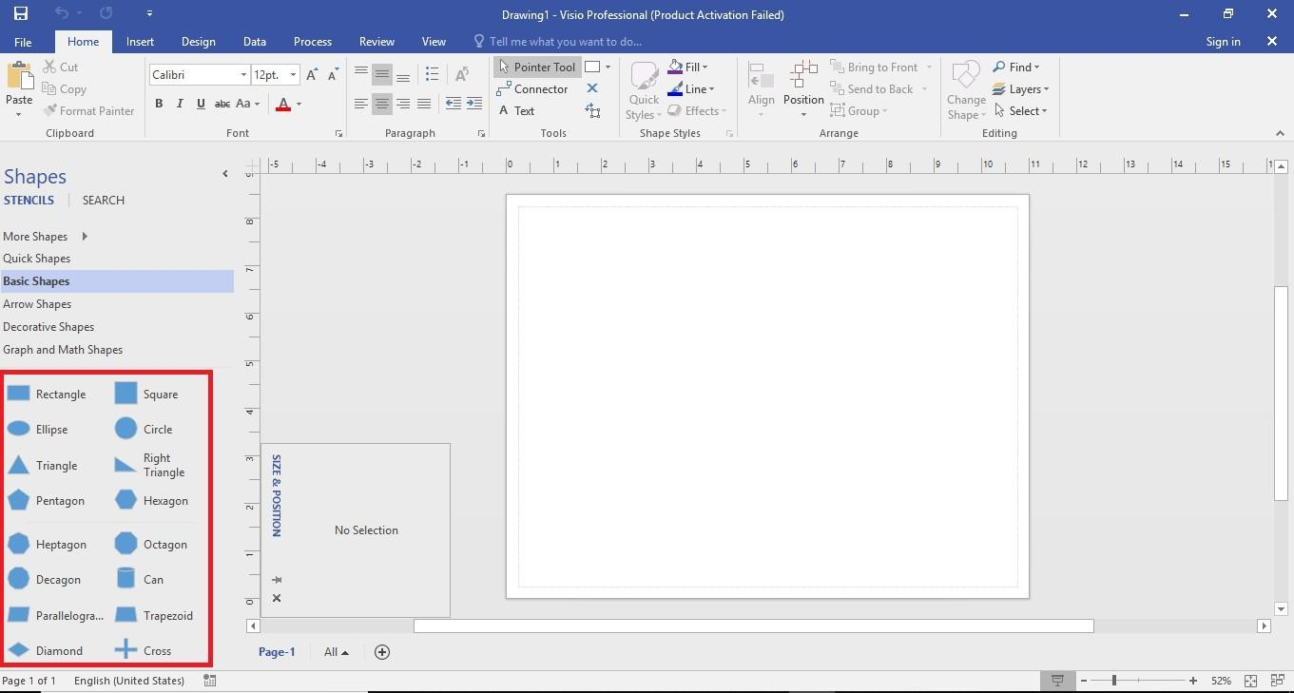
Figure 6-11. Work Space
Display the Grid by using the same method as used in Word. Drop all the shapes in the Work Space.

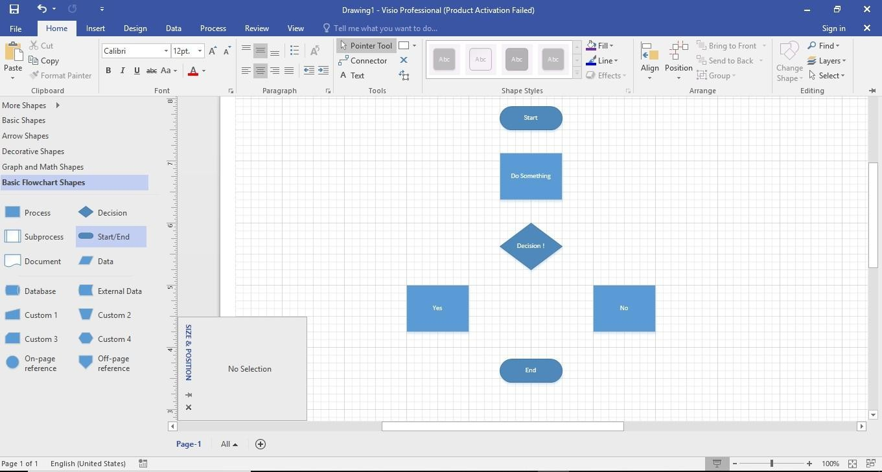
Figure 6-12. Dropping Shapes
Now connect the shapes together using the “Connector” tool in the upper portion of the “Home” tab.
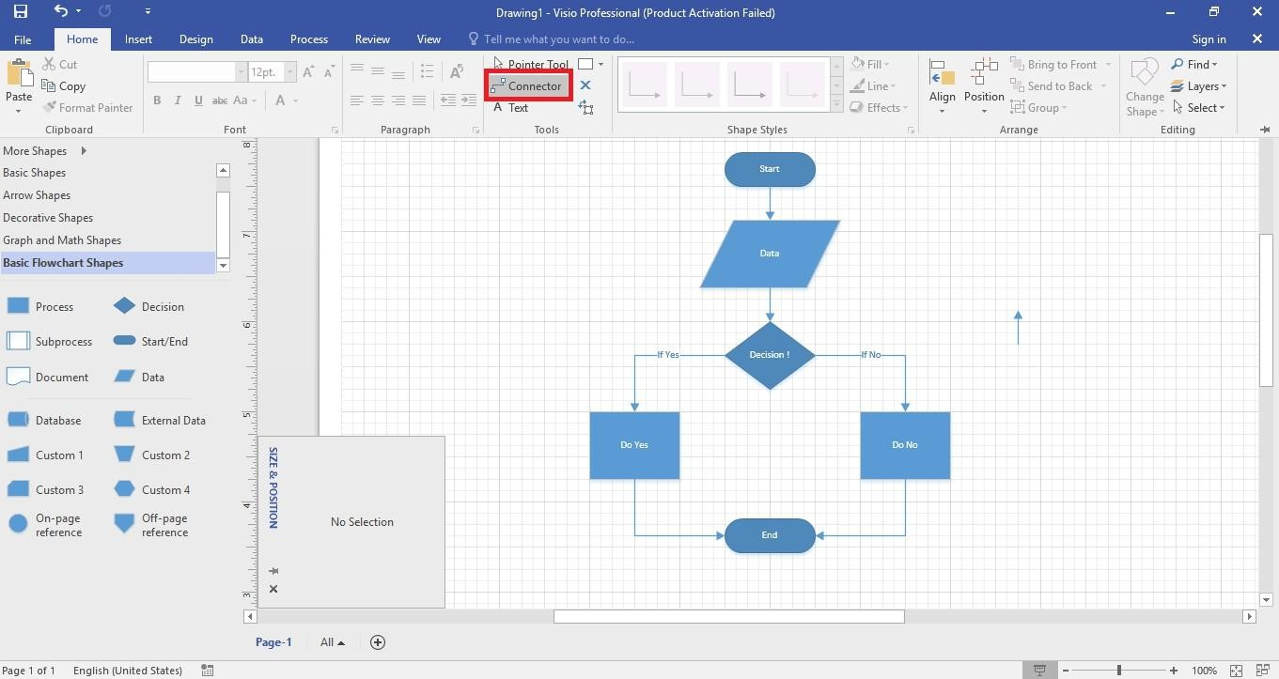
Figure 6-13. Connecting the Shapes
Colors can be added to shapes and formatted as same as in word by using format or simply by

“Styles Option”. Right click the shape you want to edit in the Work Space and select “Styles” to open a variety of editing options.
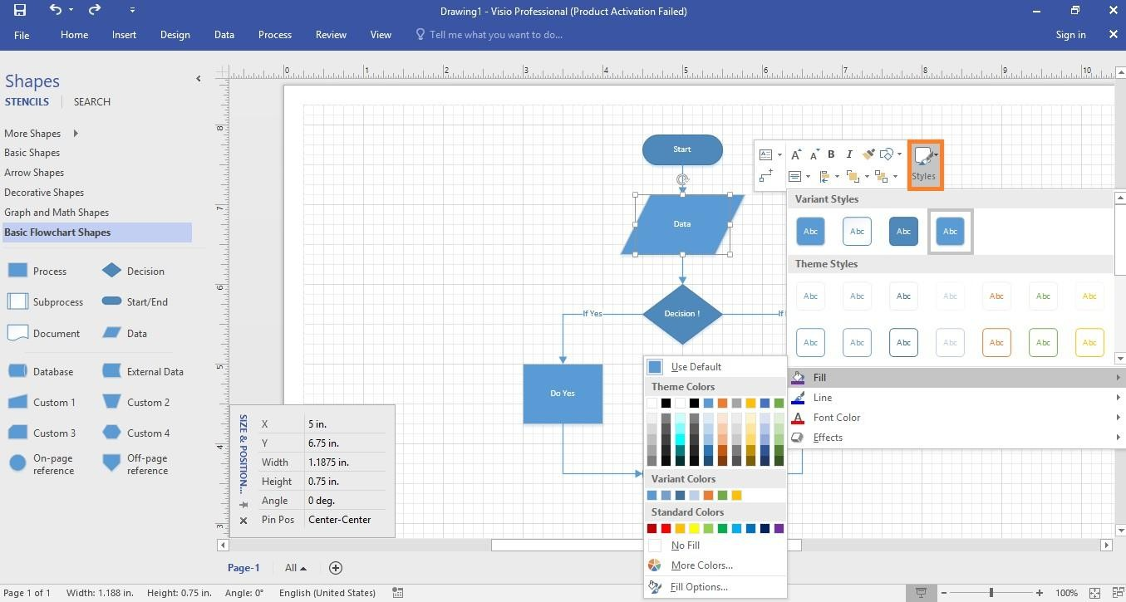
Figure 6-14. Adding Colors and Editing

Activity 01:
Draw the flow chart in MS Word and Visio.

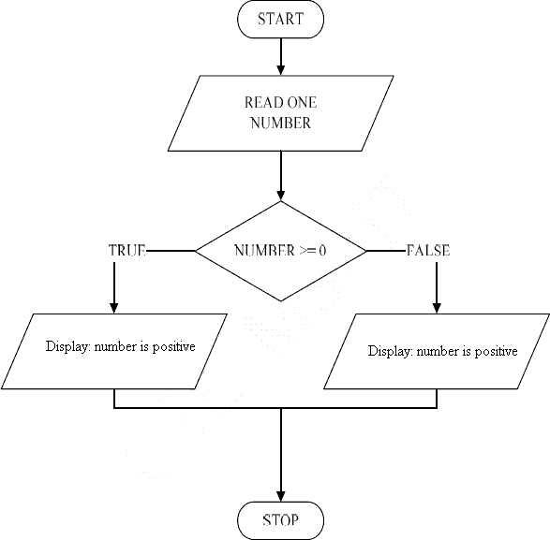
Display: number is negative
Figure 6-15. Flowchart for Activity 1

Activity 02:
Draw the flow chart in MS Word and Visio.
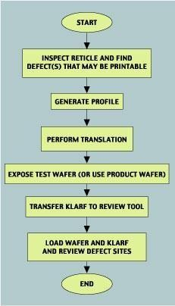
Figure 6-15. Flowchart for Activity 2

Cognitive Questions
Q1. Two students are asked to draw a flowchart that finds the largest of three numbers. Student A uses a diamond shape for every comparison and labels each branch "Yes"/"No". Student B uses plain rectangles for the comparisons and doesn't label the branches. Explain what standard flowchart convention Student B has broken, and why following these conventions matters when someone else has to read your flowchart later. (5)

Q2. You are designing a flowchart for a program that keeps asking the user to enter a number until they enter a valid one (between 1 and 100). Explain which flowchart construct (sequence, decision, or loop) this requires, and sketch in words how the arrows would need to connect back to an earlier step to represent the "keep asking" behavior. (5)

Cognitive Activity
Obtained Marks | /10

Lab Exercise and Summary
Summary should cover Introduction, Procedure, Data Analysis and Evaluation.

Student’s Signature: Date:

Psychomotor Activity 1 — Experimental Setup
S.No | Criteria | Performance | Description | Marks
1 | MS Visio Setup (4) | Level 4 | Opens and configures MS Visio correctly and independently. | 4
1 | MS Visio Setup (4) | Level 3 | Configures MS Visio with minor errors or assistance. | 3
1 | MS Visio Setup (4) | Level 2 | Completes the setup with considerable assistance. | 2
1 | MS Visio Setup (4) | Level 1 | Setup is incomplete and requires substantial assistance. | 1
2 | Diagram/Flowchart File Setup (4) | Level 4 | Correctly creates/selects the required Visio drawing file, page size, and shape stencils. | 4
2 | Diagram/Flowchart File Setup (4) | Level 3 | Diagram/file setup is mostly correct with minor errors or omissions. | 3
2 | Diagram/Flowchart File Setup (4) | Level 2 | Setup is partially completed and requires assistance. | 2
2 | Diagram/Flowchart File Setup (4) | Level 1 | Major errors or omissions are present in the setup. | 1
3 | Parameter Setup (2) | Level 2 | Correctly selects and connects required flowchart shapes (start/end, process, decision, connectors) with proper labels. | 2
3 | Parameter Setup (2) | Level 1 | Selects and connects most required shapes with minor errors. | 1
 | Total Obtained |  |  | /10

If a student is absent:
Criteria | Description | Marks
Absent | Student is absent from the laboratory activity. | 0

Psychomotor Activity 2 — Implementation + Results
S.No | Criteria | Performance | Description | Marks
1 | Implementation (4) | Level 4 | Implements the flowchart correctly and independently using standard flowchart symbols and connectors. | 4
1 | Implementation (4) | Level 3 | Implements the flowchart with minor errors or assistance. | 3
1 | Implementation (4) | Level 2 | Partially implements the flowchart and requires considerable assistance. | 2
1 | Implementation (4) | Level 1 | Implementation is largely incomplete and requires substantial assistance. | 1
2 | Execution/Logic Check (2) | Level 2 | The flowchart's logic runs correctly end-to-end (every path reaches an End) and handles decision branches appropriately. | 2
2 | Execution/Logic Check (2) | Level 1 | Flowchart logic runs with minor errors or assistance. | 1
3 | Results/Output (4) | Level 4 | Obtains a correct, clearly labeled flowchart that accurately represents the required logic. | 4
3 | Results/Output (4) | Level 3 | Obtains a mostly correct flowchart with minor errors. | 3
3 | Results/Output (4) | Level 2 | Obtains a partially correct flowchart with noticeable errors or omissions. | 2
3 | Results/Output (4) | Level 1 | Flowchart is largely incorrect or incomplete. | 1
 | Total Obtained |  |  | /10
If a student is absent:
Criteria | Description | Marks
Absent | Student is absent from the laboratory activity. | 0
Affective Activity — Lab Report + Viva Voce
S.No | Criteria | Performance | Description | Marks
1 | Lab Report  Completeness & Organization  (4) | Level 4 | Report is complete, well-organized, and demonstrates responsible completion of the hardware/software identification exercise. | 4
1 | Lab Report  Completeness & Organization  (4) | Level 3 | Report is complete with minor omissions or organizational issues. | 3
1 | Lab Report  Completeness & Organization  (4) | Level 2 | Report is partially complete with several omissions. | 2
1 | Lab Report  Completeness & Organization  (4) | Level 1 | Report has major omissions or poor organization. | 1
2 | Work/Results & Conclusion (2) | Level 2 | Completed classification and conclusion are correctly presented and discussed. | 2
2 | Work/Results & Conclusion (2) | Level 1 | Presented with minor errors or omissions. | 1
3 | Viva Voce (4) | Level 4 | Design of flow charts in MS Word & design of flow charts in MS Visio, demonstrating strong understanding. | 4
3 | Viva Voce (4) | Level 3 | Explains most concepts correctly with minor difficulty. | 3
3 | Viva Voce (4) | Level 2 | Explains basic aspects with some prompting. | 2
3 | Viva Voce (4) | Level 1 | Demonstrates limited understanding, requires substantial prompting. | 1
3 | Total Obtained |  |  | /10

The student has not submitted the report and has not appeared in the Viva Voce.
Criteria | Description | Marks
Lab Report and Results Not Submitted | Student has not submitted the report and results file. | 0
Absent in Viva Voce | Student is absent from the viva voce. | 0

Instructor’s Signature: Date: _________

Experiment No 7

Pseudocode Writing

Objective:
- After this lab student will have understanding about Pseudocode writing.

Pseudocode
Pseudocode is a detailed description of a computer program. It is written in plain English. It has no syntax like any of the programming language and thus can’t be compiled or interpreted by the computer. For example, cout is used to display content in C++; print in python whereas it is System.out.println in case of java, but as pseudocode, display/output is the word which covers several programming languages.
So that the program written in an informal language and could be understood by any programming background is pseudocode. Hence, we can say that the purpose of writing pseudocode is that it is easier for people to understand than any specific programming language code. There exists no standard for pseudocode syntax, as a program in pseudocode is not an executable program.
Following are the basic rules before writing pseudocode:
- Write only one statement per line.
- Write what you mean, not how to program it
- Give proper indentation to show hierarchy and make code understandable.
- Make the program as simple as possible.
- Conditions and loops must be specified well i.e., begun and ended explicitly.
Example 1:
Write a pseudocode to print sum of two integer numbers:
- Start the program
- Read the first number and save in the variable (Num1)
- Read the second number and save in the variable (Num2)
- Add the two numbers and save the result in variable Sum => Sum=Num1+Num2
- Print the variable Sum
- End the Program
Flow chart:
A flow chart is a type of diagram that represents an algorithm, showing steps by different shapes such as rectangles, diamonds, ovals etc., in an order of steps as per program. Arrows are used connect these shapes. Flow chart were discussed in detail in Lab 6.
Example 2:
Write a pseudocode to find the area of rectangle.
- Begin
- numeric nLength, nBreadth, nArea
- display "ENTER THE LENGTH OF RECTANGLE : "
- accept nLength
- display "ENTER THE BREADTH OF RECTANGLE : "
- accept nBreadth

- nArea=nLength*nBreadth
- display "AREA OF RECTANGLE : " nArea
- end
Example:
Draw a flow chart to find area of rectangle.
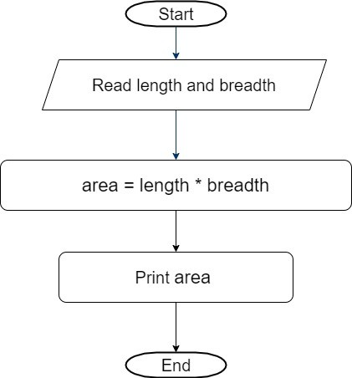
Figure 7-1: Flow chart to find area of rectangle
Activity 1:
Write a pseudocode and draw a flowchart to find the larger of two numbers.

Activity 2.
Write a pseudocode and draw a flowchart for a program that determines if a student passed (Marks
> 40) the exam or failed.

Cognitive Questions
Q1. A classmate writes the following pseudocode to calculate the average of n numbers entered by the user, but it gives the wrong answer every time: START INPUT n FOR i = 1 to n INPUT number sum = sum + number END FOR average = sum / n PRINT average STOP Identify the mistake in this pseudocode and explain why it causes an incorrect result, then rewrite the faulty line correctly. (5)

Q2. Explain the difference between pseudocode and an actual programming language such as C++, using the statement "IF age is 18 or more THEN the person is eligible to vote" as your example — write it once as pseudocode and once as it would look as a C++ if-statement, and explain why pseudocode is still useful even though it cannot be run on a computer. (5)

Cognitive Activity
Obtained Marks | /10

Lab Exercise and Summary
Summary should cover Introduction, Procedure, Data Analysis and Evaluation.

Student’s Signature: Date:

Psychomotor Activity 1 — Experimental Setup
S.No | Criteria | Performance | Description | Marks
1 | Word Processor (for writing pseudocode) Setup (4) | Level 4 | Opens and configures Word Processor (for writing pseudocode) correctly and independently. | 4
1 | Word Processor (for writing pseudocode) Setup (4) | Level 3 | Configures Word Processor (for writing pseudocode) with minor errors or assistance. | 3
1 | Word Processor (for writing pseudocode) Setup (4) | Level 2 | Completes the setup with considerable assistance. | 2
1 | Word Processor (for writing pseudocode) Setup (4) | Level 1 | Setup is incomplete and requires substantial assistance. | 1
2 | Pseudocode Document Setup (4) | Level 4 | Correctly creates/selects the required document/file used to write and organize the pseudocode. | 4
2 | Pseudocode Document Setup (4) | Level 3 | Document setup is mostly correct with minor errors or omissions. | 3
2 | Pseudocode Document Setup (4) | Level 2 | Setup is partially completed and requires assistance. | 2
2 | Pseudocode Document Setup (4) | Level 1 | Major errors or omissions are present in the setup. | 1
3 | Parameter Setup (2) | Level 2 | Correctly uses required pseudocode keywords/structures (START, INPUT, IF, FOR, WHILE, PRINT, STOP). | 2
3 | Parameter Setup (2) | Level 1 | Uses most required pseudocode keywords/structures with minor errors. | 1
 | Total Obtained |  |  | /10

If a student is absent:
Criteria | Description | Marks
Absent | Student is absent from the laboratory activity. | 0

Psychomotor Activity 2 — Implementation + Results
S.No | Criteria | Performance | Description | Marks
1 | Implementation (4) | Level 4 | Writes the pseudocode correctly and independently, using clear sequence, selection, and repetition structures as needed. | 4
1 | Implementation (4) | Level 3 | Writes the pseudocode with minor errors or assistance. | 3
1 | Implementation (4) | Level 2 | Partially writes the pseudocode and requires considerable assistance. | 2
1 | Implementation (4) | Level 1 | Pseudocode is largely incomplete and requires substantial assistance. | 1
2 | Logic Dry-Run (2) | Level 2 | Correctly traces/dry-runs the pseudocode by hand with sample input and reaches the expected result. | 2
2 | Logic Dry-Run (2) | Level 1 | Dry-runs the pseudocode with minor errors or assistance. | 1
3 | Results/Output (4) | Level 4 | Produces correct, logically complete pseudocode that solves the given problem clearly. | 4
3 | Results/Output (4) | Level 3 | Produces mostly correct pseudocode with minor logical errors. | 3
3 | Results/Output (4) | Level 2 | Produces partially correct pseudocode with noticeable errors or omissions. | 2
3 | Results/Output (4) | Level 1 | Pseudocode is largely incorrect or incomplete. | 1
 | Total Obtained |  |  | /10

If a student is absent:
Criteria | Description | Marks
Absent | Student is absent from the laboratory activity. | 0

Affective Activity — Lab Report + Viva Voce
S.No | Criteria | Performance | Description | Marks
1 | Lab Report  Completeness & Organization  (4) | Level 4 | Report is complete, well-organized, and demonstrates responsible completion of the hardware/software identification exercise. | 4
1 | Lab Report  Completeness & Organization  (4) | Level 3 | Report is complete with minor omissions or organizational issues. | 3
1 | Lab Report  Completeness & Organization  (4) | Level 2 | Report is partially complete with several omissions. | 2
1 | Lab Report  Completeness & Organization  (4) | Level 1 | Report has major omissions or poor organization. | 1
2 | Work/Results & Conclusion (2) | Level 2 | Completed classification and conclusion are correctly presented and discussed. | 2
2 | Work/Results & Conclusion (2) | Level 1 | Presented with minor errors or omissions. | 1
3 | Viva Voce (4) | Level 4 | Clearly explains & have understanding about Pseudocode writing, demonstrating strong understanding. | 4
3 | Viva Voce (4) | Level 3 | Explains most concepts correctly with minor difficulty. | 3
3 | Viva Voce (4) | Level 2 | Explains basic aspects with some prompting. | 2
3 | Viva Voce (4) | Level 1 | Demonstrates limited understanding, requires substantial prompting. | 1
3 | Total Obtained |  |  | /10

The student has not submitted the report and has not appeared in the Viva Voce.
Criteria | Description | Marks
Lab Report and Results Not Submitted | Student has not submitted the report and results file. | 0
Absent in Viva Voce | Student is absent from the viva voce. | 0

Instructor’s Signature: Date: _________

Experiment No 8
Introduction to C++ programming language

Objective:
- To get basic understanding of C++ programming language

Setting up Integrated Development Environment (IDE):
Go to start menu-->All Programs-->Microsoft Visual Studio and then click on Microsoft Visual Studio.
  - Create a new project by clicking File->New->Project.
  - From Installed Template choose other language
  - Choose language Visual C++
  - In Visual C++ choose tab Win32
  - Choose project type Win32 Console Application and then click OK
See the image below,
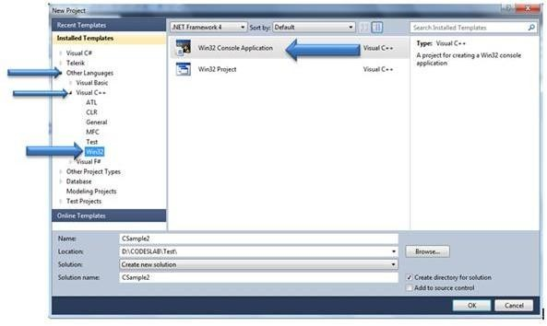
Figure 8-1: Creating New Project in Visual Studio
From the dialog box click on Next button.

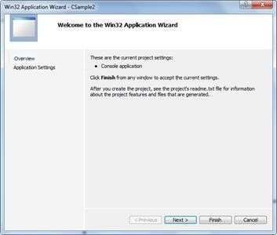
Figure 8-2. Win32 Application Wizard
Next screen is of Application Setting. You need to make sure
  - Application type is set a Console Application
  - In Additional options uncheck the Precompiled Header.
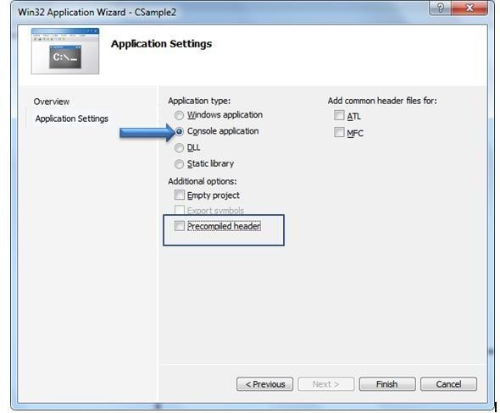

Figure 8-3. Application Setting

After clicking Finish you will find a project has been created with below structure. Open solution explorer to see the structure
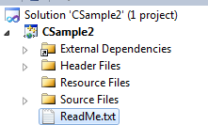

Figure 8-4. Project
To start programming, right click on Source Files and add a new item. You need to make sure below two points,
  - Select C++ File to add
  - But in name change extension to .CPP, default is .C. To work with C language program source file name should be with extension “.C”. In this case I am giving source file name as Sample1.C
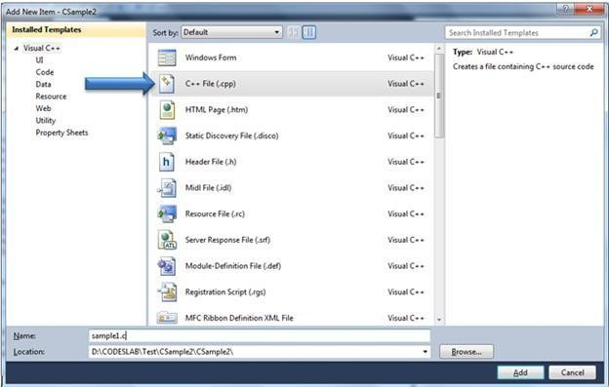
Figure 8-5. Create a .cpp file
Now open Sample1.cpp file.

C++ Program Structure

A C++ program basically has the following form:
  - Preprocessor Commands
  - Functions
  - Variables
  - Statements & Expressions
  - Comments
The following program is written in the C++ programming language.
// Your First C++ Program #include <iostream>
using namespace std; int main() {
cout << "Hello World!"; return 0;
}
Preprocessor Commands:
These commands tell the compiler to do preprocessing before doing actual compilation. Like #include <iostream> is a preprocessor command which tells a C++ compiler to include iostream file before going to actual compilation.
Functions:
Functions are main building blocks of any C++ Program. Every C Program will have one or more functions and there is one mandatory function which is called main() function. This function is prefixed with keyword int which means this function returns an integer value when it exits. This integer value is returned using return statement.
Variables:
Variables are used to hold numbers, strings and complex data for manipulation. You will learn in detail about variables in next topics.
Statements & Expressions:
Expressions combine variables and constants to create new values. Statements are expressions, assignments, function calls, or control flow statements which make up C++ programs.

Comments:
Comments are used to give additional useful information inside a C++ Program. All the comments will be put inside /*...*/ as given in the example above. A comment can span through multiple lines. For single line comments use //.
Note the followings:
C++ is a case sensitive programming language. It means in C++ cout and Cout will have different meaning.
Data types in C++ language
In C++, variable (data) should be declared before it can be used in program. Data types are the keywords, which are used for assigning a type to a variable.
- Primitive Data Types
  - Integer types
  - Floating Type
  - Character types
- User defined data types
We will discuss later about user defined data types.
Variables:
A variable is just a named area of storage that can hold a single value (numeric or character). The C language demands that you declare the name of each variable that you are going to use and its type.
The Programming language C++ has two main variable types.
  - Local Variables
  - Global Variables
We will discuss later about local and global variables.

Syntax for declaration of a variable

data_type variable_name;
For example, if you want to declare a variable of type integer then the syntax will be int number;
Input:
Any programming language input means to feed some data into program. This can be given in the form of file or from command line. C++ programming language provides a set of built-in functions to read given input and feed it to the program as per requirement.

Output:
In any programming language output means to display some data on screen, printer or in any file. C++ programming language provides a set of built-in functions to output required data. Here we will discuss only one input function and one output function just to understand the meaning of input and output.
cout function
This is one of the most frequently used functions in C++ for output.
cin function
This is the function which can be used to to read an input from the command line.
Escape Sequences
Escape Sequence causes the program to escape from the normal interpretation of a string, so that the next character is recognized as having a special meaning. The back slash “\” character is called the “Escape Character”. The escape sequence includes the following:
\n => new line
\t => tab
\b => back space
\r => carriage return
\” => double quotations
\\ => back slash etc.
Operators
There are various types of operators that may be placed in three categories:

Arithmetic | + | - | * | / %
Assignment | = += -= *= /= %=
Relational | < > <= >= == !=
Logical | && , || , !

Consider the following program
/* A program to add 2 integers. Comment statement in C/C++ (0) */ #include<iostream> /* I/O standard library in C++ (1) */ using namespace std;
int main () /* must be first statement in C/C++ program (2) */
{
/* start of body of program */
int integer1; int integer2;
int sum = 0; /* variable declarations (3) */ cout <<"Initialization of 2 integers\n" ;

/*sample of cout (4) */
integer1 = 80; /*sample of assignment statement (5) */
integer2 = 90;
sum = integer1 + integer2;
/*sample of assignment statement. And numerical example (6) */
cout << "sum= \n\n"<< sum ;
/* sample cout statement (7) */
/* sample of escape character \n */

return 0; /* return statement. Remove it if type of main is void (8) */

} /* End of program boundary (9) */

Above program is actually demonstration input statement and “+” arithmetic operator.
Output of the above program will be

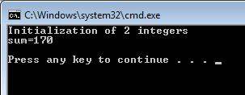
Figure 8-6. Output
Write down a program which initialize 3 integers, G1,G2,G3, then calculate average as real (float). Print your name as string using a simple cout statement, then grades G1,G2,G3 in different line with nice heading, and finally, print the average.
/* solution of the above problem */
#include <iostream> using namespace std; int main ( )
{ /* Start of program body */ int G1; int G2; int G3;
float Av;
cout<<"My name is Yahia \n" ; G1 = 90; G2 = 84; G3 = 80; Av = (G1 + G2 + G3 ) / 3.0;

/* why we put 3.0 and not 3 ?*/
cout <<"math: "<< G1 <<"\n"<<"physics: "<< G2 <<"\n"<<"Computer skill: "<< G3 <<"
\n";
cout << "Average: "<< Av; return 0;
} /* End of program body */

Output of this will be My name is Yahia math: 90
physics: 84
Computer skill: 80
Average: 84.6667

=== Code Execution Successful ===

How to input data from keyboard / user input?
To read input data from keyword, use: cin statement.
You have already learned that cout is used to output (print) values. Now we will use cin to get user input.
cin is a predefined variable that reads data from the keyboard with the extraction operator (>>). In the following example, the user can input a number, which is stored in the variable x. Then we print the value of x:
Example
#include <iostream> using namespace std; int main() {
int x;
cout << "Type a number: "; // Type a number and press enter cin >> x; // Get user input from the keyboard
cout << "Your number is: " << x; return 0;
}

Output:
Type a number: 4567 Your number is: 4567

Good To Know
cout is pronounced "see-out". Used for output, and uses the insertion operator (<<) cin is pronounced "see-in". Used for input, and uses the extraction operator (>>)

String input:

#include <iostream>
#include <string> // use string library
using namespace std;

int main() {
string fullName;
cout << "Type your full name: ";
getline (cin, fullName); // cin>> fullName; will skip the data after space cout << "Your name is: " << fullName;
return 0;
}

Output:

Type your full name: Arslan Rafique Your name is: Arslan Rafique

=== Code Execution Successful ===

Type the following program in C++ Editor and execute it. Mention the Error.
void main(void)
{
cout<< “Hello World”;
}

Activity 02:
Add the following line at the beginning of the above program. Recompile the program. What is the output?
#include<iostream>

Activity 03:
Make the following changes to the program. What Errors are observed?
- Write Void instead of void

- Write void main (void);

- Remove the semi colon ‘;’

- Erase any one of brace ‘{’ or ‘}’

Write five statements by using cout function to print the asterisk pattern:
*****
*****
*****
*****
*****
Steps:
For first line of asterisks, write the following line
cout << "*****";
Copy and paste the line five times and then compile the code.

Activity 05:
Write program that print the following shape on console:
*************
* *
* *
* *
*************
Activity 06:
Write a C++ program to declare two integer and one float variables then initialize them to 10, 15, and 12.6 then prints these values on the screen.
Activity 07:
Declare integer type variables “age”, “phNo” and assign 20 and 0333 value to the variables respectively. Then print the value on console.
Your output should be in the following format Your age is= 20 and your contact no is 333
You are allow only one cout function in your program.

Write a program that get two numbers from user and print its sum on console Solution:
Step 1:

Declare three integer variables num1 and num2 and result in main function. Get input from user using cin function for num1 & num2
Step 2:

Calculate sum of num1 and num2 and store in result variable. Print result using cout statement
Test input:

Enter num1: 12

Enter num2: 4

Result = 16

Activity 08:
Write a program that gets two integer numbers from user. Your program should perform subtraction multiplication and division on both number and display result on console.

Activity 09:
Write program for the following flow chart:
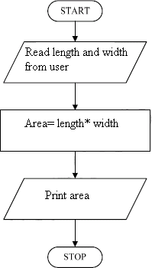
Figure 8-7. Flow chart for Activity 3

Write code from the following pseudocode. This pseudocode is swapping values of two numbers by getting input from user and print on console.
Get two numbers num1 and num2 from user. Store num1 in temp variable.
Store num2 in num1. Store temp in num2. Display num1 and num2.

Cognitive Questions
Q1. A student writes a C++ program to add two numbers but forgets to declare the data type of one variable. The compiler shows the error: "'y' was not declared in this scope." Explain why C++ requires every variable to be declared before use, and state whether this is a syntax error, a logical error, or a run-time error — and how you can tell the difference. (5)

Q2. A different program compiles successfully with no errors, but crashes when the user enters 0 as the divisor in a division operation. Explain why this problem was not caught by the compiler, what category of error this is, and how it differs from the variable-declaration error in the previous question. (5)

Cognitive Activity
Obtained Marks | /10

Lab Exercise and Summary
Summary should cover Introduction, Procedure, Data Analysis and Evaluation.

Student’s Signature: Date:

Psychomotor Activity 1 — Experimental Setup
S.No | Criteria | Performance | Description | Marks
1 | Visual Studio IDE Setup (4) | Level 4 | Opens and configures Visual Studio IDE correctly and independently. | 4
1 | Visual Studio IDE Setup (4) | Level 3 | Configures Visual Studio IDE with minor errors or assistance. | 3
1 | Visual Studio IDE Setup (4) | Level 2 | Completes the setup with considerable assistance. | 2
1 | Visual Studio IDE Setup (4) | Level 1 | Setup is incomplete and requires substantial assistance. | 1
2 | Project/Source File Setup (4) | Level 4 | Correctly creates/selects the required Visual Studio project, source (.cpp) file, and basic program structure. | 4
2 | Project/Source File Setup (4) | Level 3 | Project/file setup is mostly correct with minor errors or omissions. | 3
2 | Project/Source File Setup (4) | Level 2 | Setup is partially completed and requires assistance. | 2
2 | Project/Source File Setup (4) | Level 1 | Major errors or omissions are present in the setup. | 1
3 | Parameter Setup (2) | Level 2 | Correctly declares required variables, data types, and input/output statements. | 2
3 | Parameter Setup (2) | Level 1 | Declares most required variables and data types with minor errors. | 1
 | Total Obtained |  |  | /10

If a student is absent:
Criteria | Description | Marks
Absent | Student is absent from the laboratory activity. | 0

Psychomotor Activity 2 — Implementation + Results
S.No | Criteria | Performance | Description | Marks
1 | Implementation (4) | Level 4 | Implements the required C++ program correctly and independently using appropriate syntax and constructs. | 4
1 | Implementation (4) | Level 3 | Implements the program with minor syntax or logic errors. | 3
1 | Implementation (4) | Level 2 | Partially implements the program and requires considerable assistance. | 2
1 | Implementation (4) | Level 1 | Program implementation is largely incomplete and requires substantial assistance. | 1
2 | Compilation/Execution (2) | Level 2 | Compiles and runs the program correctly and appropriately handles basic compiler errors. | 2
2 | Compilation/Execution (2) | Level 1 | Compiles/runs the program with minor errors or assistance. | 1
3 | Results/Output (4) | Level 4 | Produces correct output for the required test cases and presents results clearly. | 4
3 | Results/Output (4) | Level 3 | Produces mostly correct output with minor errors. | 3
3 | Results/Output (4) | Level 2 | Produces partially correct output with noticeable errors or omissions. | 2
3 | Results/Output (4) | Level 1 | Output is largely incorrect or incomplete. | 1
 | Total Obtained |  |  | /10

If a student is absent:
Criteria | Description | Marks
Absent | Student is absent from the laboratory activity. | 0

Affective Activity — Lab Report + Viva Voce
S.No | Criteria | Performance | Description | Marks
1 | Lab Report  Completeness & Organization  (4) | Level 4 | Report is complete, well-organized, and demonstrates responsible completion of the hardware/software identification exercise. | 4
1 | Lab Report  Completeness & Organization  (4) | Level 3 | Report is complete with minor omissions or organizational issues. | 3
1 | Lab Report  Completeness & Organization  (4) | Level 2 | Report is partially complete with several omissions. | 2
1 | Lab Report  Completeness & Organization  (4) | Level 1 | Report has major omissions or poor organization. | 1
2 | Work/Results & Conclusion (2) | Level 2 | Completed classification and conclusion are correctly presented and discussed. | 2
2 | Work/Results & Conclusion (2) | Level 1 | Presented with minor errors or omissions. | 1
3 | Viva Voce (4) | Level 4 | Clearly explains lab demonstrating strong understanding & get basic understanding of C++ programming language. | 4
3 | Viva Voce (4) | Level 3 | Explains most concepts correctly with minor difficulty. | 3
3 | Viva Voce (4) | Level 2 | Explains basic aspects with some prompting. | 2
3 | Viva Voce (4) | Level 1 | Demonstrates limited understanding, requires substantial prompting. | 1
3 | Total Obtained |  |  | /10

The student has not submitted the report and has not appeared in the Viva Voce.
Criteria | Description | Marks
Lab Report and Results Not Submitted | Student has not submitted the report and results file. | 0
Absent in Viva Voce | Student is absent from the viva voce. | 0

Instructor’s Signature: Date: _________

Experiment No 9

Relational operators, Logical operators and Selection structure (Nested if-else)

Objective:
- To get basic understanding of Relational & logical operators
- One way selection
- Two-way selection
- Compound Statement
- To get basic understanding of nested-if conditions
- Where and when to use ‘nested-if’ and ‘logical-and’.
- To practice how the nested-if and logical operators are used in a C++ program.
- To get basic understanding of nested-if conditions
- To get basic understanding of logical operators.
- Where and when to use ‘nested-if’ and ‘logical-and’.
- To practice how the nested-if and logical operators are used in a C++ program

Introduction
This lab will introduce you the concepts of how to use the Control Structures (selections) such as: if, if-else, if-else-if. Furthermore, you will also learn the relational operators such as >, >=,
<= etc. The relational operators are frequently used in conditions to make number of decisions. There is another important type of operators (logical operators) which are often used with conditions.

One Way Selection
Sometimes, we are only interested to make a decision for example, acquiring absolute value of a number. In this case we just need to convert the negative number to the positive. However, if the number is already positive then we do not need to do anything.
if (number<0)
number= -1 * number;

Two Way Selections
Apart from the one-way selection, we need to tackle both the cases. For example if the marks of a student are greater than 50, then the student is passed otherwise the student is failed.
if (marks>50)
cout << “Passed”;
else
cout << “failed”;

You can use as many if-statements after the else part, for example, consider the following code:
if (marks>90)
cout << “Grade is A”;
else if (marks>85)
cout << “Grade is B”;
else
cout << “ Fail”;
The above statement will output the grade “A” for all students scoring more than 90 marks. However, the grade of the students will be B who have scored more than 85 marks and less than 90, similarly, the remaining students will get F grade. The statement will be executed in a way that first statement will be checked, if the students marks are greater than 90, then the grade will be shown as “A” and the remaining parts will not be executed (The else part). If the students marks are less than 90, then the first statement would be evaluated as false, and the control will be passed to the else if (marks >85) statement.

Compound Statement
In the above statements, we have used only one statement that would be executed after the true of false condition. However, most of the times, we need to execute multiple statements after the condition evaluated as true or false. For example, consider the following statement:

if (marks>90)
cout<< “Grade is A”;
cout << “congratulations, you have performed excellent”;
If the marks are more than 90, the program will display the following output:
Grade is A
Congratulations, you have performed excellent
However, suppose if the marks are less than 90, then guess what you will get:

Nothing ….
Surprisingly. This will not happen; however, for the marks less than 90, the following would be printed on screen:
Congratulations, you have performed excellent
This is due to the fact that C++ considers only one statement as associated with the condition, and the statement
cout<<”congratulations, you have performed excellent”
is not part of the if-statement, and as the if has been evaluated as false therefore the above statement will be executed.
To tackle this situation, we need to do it in the following way.
if (marks>90)
{
cout << “Grade is A”;
cout << “congratulations, you have performed excellent”;
}

Now both statements will be associated with the if-statement. In case the if-statement is false, none of the above statements will be executed.

Nested-if statement
When we want to make decisions based on more than one conditions then one way of achieving this is using nested-if condition. For example, consider the following example. A student is given a scholarship, if and only if his/her percentage is more than 70% and he/she is below 16 years of age. Here, you need to notice that there are two conditions and if both conditions are fulfilled then the student will be given scholarship, otherwise, no scholarship will be awarded. To accomplish such task, you can use the concept of nested-if in the following way.
if (percentage>=70 )
{
if (age <16)
{
cout << “Congratulations! You are eligible for the scholarship”;
}
}

The nested-if statement is executed in the following way, first, the statement (percentage>=70 ) will be evaluated, if the statement is true then the control is passed to the first statement within this if-statement. The first line within this if-statement is again an if-statement, now the statement (age < 16) will be evaluated. Here if this statement is also true, then the student will be given the scholarship. We can use logical-and to solve the same problem as well. This will be discussed in the next section.

Logical-and (&&)
The same problem discussed above can be solved with using logical-and operator (&&) between both conditions. For example, consider the following code:
if (percentage>=70 && age <16)
{
cout << “Congratulations! You are eligible for the scholarship” ;
}
To understand the above statement, revise your concepts. The logical-and is evaluated as true if both values (conditions) are true. if both conditions are true, then the statement will be executed. The difference between using logical-and and nested-if has been explained in the next section.

Similarities and Differences for the use of nested-if and logical-and Scenario 1: Nested-if and Logical-and (&&) are similar
Consider the followings two codes:
Code A:
if (percentage>=70 )

{

if (age <16)

{

cout << “Congratulations! You are eligible for the scholarship” ;

}

}
Code B:
if (percentage>=70 && age <16)
{
cout << “Congratulations! You are eligible for the scholarship” ;
}
In this scenario, both codes will output the same. However, there are certain differences in

using nested-if and logical-and (&&). There are some scenarios where use of nested-if is better, however, there are some other scenarios where the use of logical-and (&&) is better. For example, consider the following case.

Scenario 2: Nested-if is better than Logical-and (&&)
Consider the following code:
if (percentage>=70 )
{
if (age <16)
{
cout << “Congratulations! You are eligible for the scholarship” ; cout << “Your percentage is more than 70” ;
}

However, you probably, will not like to write the above code in the following way.
if (percentage>=70 && age <16)
{
cout<< “Congratulations! You are eligible for the scholarship” ;
}
if (percentage>=70)
{
cout<< “Your percentage is more than 70” ;
}

Scenario 3: Logical-and (&&) is better than nested-if
Consider the following code.
if (percentage>=70 && age <16)
{
cout<< “Congratulations! You are eligible for the scholarship” ;
}
else
{
cout<< “Sorry, you did not get the scholarship” ;
}

You will not like to write it in the following way:
if (percentage>=70 )
{
if (age <16)
{
cout << “Congratulations! You are eligible for the scholarship”;
}
else {
cout << “Sorry, you did not get the scholarship” ;
}
}
else
{
cout << “Sorry, you did not get the scholarship” ;
}
Logical-or (||)
Apart from logical-and (&&), there is another logical operator which is known as logical-or (||). You can refresh your concepts of logical operators by looking into the appendix A available at the end of this lab. In the logical-or (||), the condition is considered as true if any of the conditions are true. For example, re-writing the previous example with logical-or (||) would look like the following
if (percentage>=70 || age <16)
{
cout << “Congratulations! You are eligible for the scholarship” ;
}
The “cout” statement will be executed if any of the conditions is true. For example, either the person has achieved more than 70% marks or his/her age is less than 16, the scholarship will be awarded to that person.

Logical-not (!)
The logical-not (!) is used before any condition and it will reverse the evaluation of the condition. For example, if the condition is true, the logical-not (!) will make it false, if the condition is false, then the logical-not (!) will make it true. Consider the following example. logical-not (!):

if (!(5==5))
cout << “5 is not equal to 5”;
the above statement will be evaluated as false because the condition (5==5) is evaluated as true and logical-not (!) will make it false, as the if-statement is evaluated as false, therefore, the printf- statement will not be executed. Similarly, we have written the previously discussed example by incorporating logical-not (!).
if (percentage>=70 && (!(age <16)))
{
cout << “Congratulations! You are eligible for the scholarship”;
}

Now we have both logical-and and logical-not. You know that logical-and will be evaluated as true if both conditions are true. The first condition would be true when percentage is more than or equal to 70, however, the second condition would be true when the age is more than or equal to 16. Remember, from previous discussion that whenever the inner condition (age<16) is false, the logical-not (!) will make it true. Therefore, the scholarship will be given to only those students whose percentage is greater than or equal to 70 and whose age is more than or equal to 16.

Relational Operator
Table 9-1. Relational Operators

Operator | Description | Example
== | Checks if the value of two operands is equal or not, if yes then condition becomes true. | (A == B) is not true.
!= | Checks if the value of two operands is equal or not, if values are not equal then condition becomes true. | (A! = B) is true.
> | Checks if the value of left operand is greater than the value of right operand, if yes then condition becomes true. | (A > B) is not true.
< | Checks if the value of left operand is less than the value of right operand, if yes then condition becomes true. | (A < B) is true.
>= | Checks if the value of left operand is greater than or equal to the value of right operand, if yes then condition becomes true. | (A >= B) is not true.
<= | Checks if the value of left operand is less than or equal to the value of right operand, if yes then condition becomes true. | (A <= B) is true.

Write a C++ program to find whether the number is zero, positive or negative.
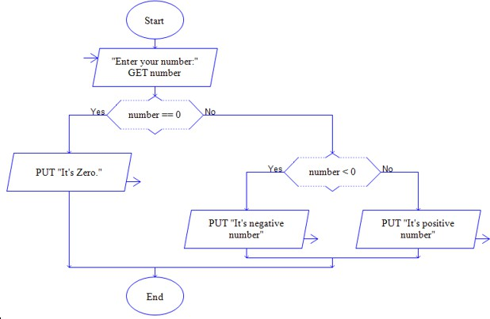
Figure 9-1. Flow chart for Activity 1

Activity 02: -
Write a program that get two numbers from user and check the following conditions.
- if both numbers are equal then print both are equal
- if num1 is greater then num2 then print num1 is greater then num2
- if num2 is greater then num1 then print num2 is greater then num1

Write a C++ program to find whether the given input is a vowel or not using logical operators.

Activity 04: -
Write a C++ program to find the largest of three numbers using relational operators and if else structure.
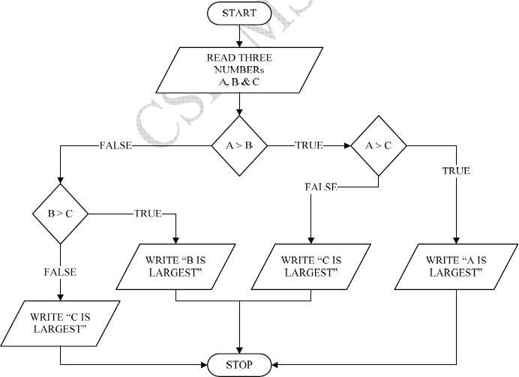
Figure 9-2. Flow chart for Activity 4

Cognitive Questions
Q1. A bank approves a loan only if the applicant is at least 18 years old AND has a monthly income of at least 30,000. Explain how you would write this condition using nested-if versus using the logical-AND (&&) operator, and — referencing the "Nested-if vs Logical-and" scenarios covered in this lab — explain a situation where nested-if is the better choice even though && could technically work. (5)

Q2. Given the values a = 15, b = 10, c = 20, determine the result (true or false) of the expression (a > b) && (c > a) || (b > c), showing the value of each sub-expression step by step before combining them. (5)

Cognitive Activity
Obtained Marks | /10

Lab Exercise and Summary
Summary should cover Introduction, Procedure, Data Analysis and Evaluation.

Student’s Signature: Date:

Psychomotor Activity 1 — Experimental Setup
S.No | Criteria | Performance | Description | Marks
1 | Visual Studio IDE Setup (4) | Level 4 | Opens and configures Visual Studio IDE correctly and independently. | 4
1 | Visual Studio IDE Setup (4) | Level 3 | Configures Visual Studio IDE with minor errors or assistance. | 3
1 | Visual Studio IDE Setup (4) | Level 2 | Completes the setup with considerable assistance. | 2
1 | Visual Studio IDE Setup (4) | Level 1 | Setup is incomplete and requires substantial assistance. | 1
2 | Project/Source File Setup (4) | Level 4 | Correctly creates/selects the required Visual Studio project, source (.cpp) file, and program structure for selection logic. | 4
2 | Project/Source File Setup (4) | Level 3 | Project/file setup is mostly correct with minor errors or omissions. | 3
2 | Project/Source File Setup (4) | Level 2 | Setup is partially completed and requires assistance. | 2
2 | Project/Source File Setup (4) | Level 1 | Major errors or omissions are present in the setup. | 1
3 | Parameter Setup (2) | Level 2 | Correctly defines required variables, relational/logical operators, and condition structures. | 2
3 | Parameter Setup (2) | Level 1 | Defines most required variables and conditions with minor errors. | 1
 | Total Obtained |  |  | /10
If a student is absent:
Criteria | Description | Marks
Absent | Student is absent from the laboratory activity. | 0

Psychomotor Activity 2 — Implementation + Results
S.No | Criteria | Performance | Description | Marks
1 | Implementation (4) | Level 4 | Implements the required selection structure (if, if-else, nested-if, logical operators) correctly and independently. | 4
1 | Implementation (4) | Level 3 | Implements the program with minor syntax or logic errors. | 3
1 | Implementation (4) | Level 2 | Partially implements the program and requires considerable assistance. | 2
1 | Implementation (4) | Level 1 | Program implementation is largely incomplete and requires substantial assistance. | 1
2 | Compilation/Execution (2) | Level 2 | Compiles and runs the program correctly for all required test cases (true/false branches) and handles basic errors. | 2
2 | Compilation/Execution (2) | Level 1 | Compiles/runs the program with minor errors or assistance. | 1
3 | Results/Output (4) | Level 4 | Produces correct output for all required test cases and presents results clearly. | 4
3 | Results/Output (4) | Level 3 | Produces mostly correct output with minor errors. | 3
3 | Results/Output (4) | Level 2 | Produces partially correct output with noticeable errors or omissions. | 2
3 | Results/Output (4) | Level 1 | Output is largely incorrect or incomplete. | 1
 | Total Obtained |  |  | /10

If a student is absent:
Criteria | Description | Marks
Absent | Student is absent from the laboratory activity. | 0

Affective Activity — Lab Report + Viva Voce
S.No | Criteria | Performance | Description | Marks
1 | Lab Report  Completeness & Organization  (4) | Level 4 | Report is complete, well-organized, and demonstrates responsible completion of the hardware/software identification exercise. | 4
1 | Lab Report  Completeness & Organization  (4) | Level 3 | Report is complete with minor omissions or organizational issues. | 3
1 | Lab Report  Completeness & Organization  (4) | Level 2 | Report is partially complete with several omissions. | 2
1 | Lab Report  Completeness & Organization  (4) | Level 1 | Report has major omissions or poor organization. | 1
2 | Work/Results & Conclusion (2) | Level 2 | Completed classification and conclusion are correctly presented and discussed. | 2
2 | Work/Results & Conclusion (2) | Level 1 | Presented with minor errors or omissions. | 1
3 | Viva Voce (4) | Level 4 | Clearly practice how the nested-if and logical operators are used in a C++ program  demonstrating strong understanding. | 4
3 | Viva Voce (4) | Level 3 | Explains most concepts correctly with minor difficulty. | 3
3 | Viva Voce (4) | Level 2 | Explains basic aspects with some prompting. | 2
3 | Viva Voce (4) | Level 1 | Demonstrates limited understanding, requires substantial prompting. | 1
3 | Total Obtained |  |  | /10

The student has not submitted the report and has not appeared in the Viva Voce.
Criteria | Description | Marks
Lab Report and Results Not Submitted | Student has not submitted the report and results file. | 0
Absent in Viva Voce | Student is absent from the viva voce. | 0

Instructor’s Signature: Date: _________

Experiment No 10

Familiarization to Network Simulator Tools

Objective:
- Introduction to network devices
- Overview of computer networks (LAN, MAN, WAN)
- Network topologies (Bus, Ring, star, mesh etc.,)
- Installation of Cisco Packet tracer
- Familiarization to initial interface of Cisco Packet tracer

Computer Networks:
A computer network is defined as the interconnection of two or more computers. Two or more computers are interlinked in order to communicate and share resources e.g., printers, exchange files, or allow electronic communications. The computers on a network may be linked through cables, telephone lines, radio waves, satellites, or infrared light beams.
Some applications of computer networks are as follows:
  - Sharing of resources such as printers
  - Sharing software and databases
  - Communication between one or more computers to exchange data and information.
  - Sharing information over long distances through network

Network Devices:
Network devices are components used to connect computers or other electronic devices together so that they can information and resources. Network Devices, or networking hardware, are physical devices that are required for communication and interaction between hardware on a computer network.

Here is the common network devices list:
  - Hub
  - Switch
  - Router
  - Bridge
  - Gateway
  - Modem
  - Repeater
  - Access Point

Hub
A hub is a common connection point for devices in a network with multiple ports. A hub is the simplest in the family of network connecting devices because it connects LAN components with identical protocols.

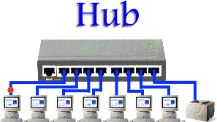

Figure 10-1. Hub

Switch

Switches generally have a more intelligent role than hubs. A switch is a multiport device that improves network efficiency. The switch maintains limited routing information about nodes in the internal network, and it allows connections to systems like hubs or routers. Strands of LANs are usually connected using switches. Generally, switches can read the hardware addresses of incoming packets to transmit them to the appropriate destination.
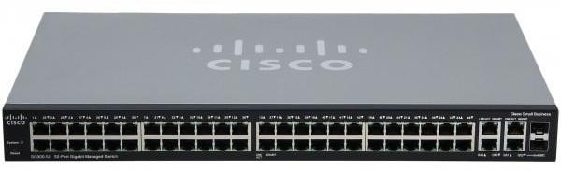
Figure 10-2. Switch

Router

Routers are intelligent devices, and they store information about the networks they’re connected to. Router is a physical or virtual appliance that passes information between two or more packet-switched computer networks. A router inspects a given data packet's destination Internet Protocol address (IP address), calculates the best way for it to reach its destination and then forwards it accordingly.
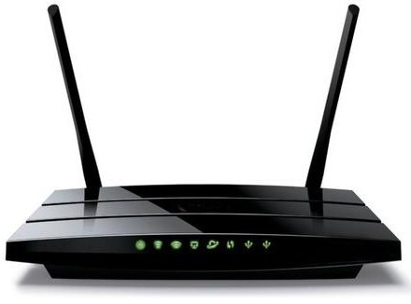

Figure 10-3. Router

Bridge

Bridges are used to divide large busy networks into multiple smaller and interconnected networks to improve performance. They are used to connect two or more hosts or network segments together. The basic role of bridges in network architecture is storing and forwarding frames between the different segments that the bridge connects.

Gateway

A gateway is a network node used in telecommunications that connects two networks with different transmission protocols together. Gateways serve as an entry and exit point for a

network, as all data must pass through or communicate with the gateway prior to being routed.
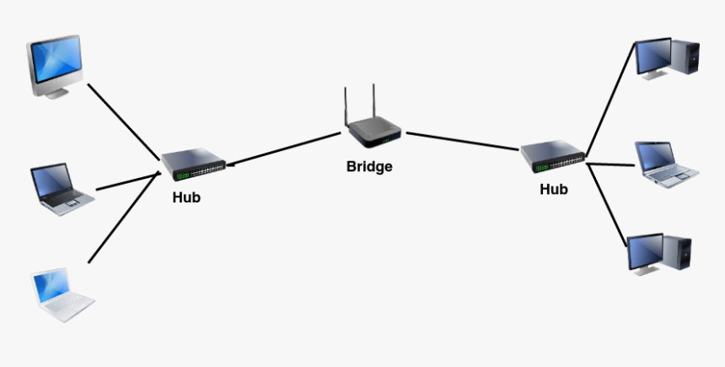
Figure 10-4. Bridge
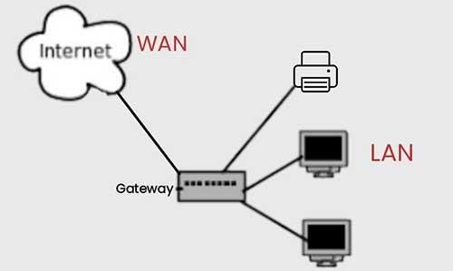

Figure 10-5. Gateway

Modem

Modems (modulators-demodulators) are used to transmit digital signals over analog telephone lines. Thus, digital signals are converted by the modem into analog signals of different frequencies and transmitted to a modem at the receiving location. The receiving modem performs the reverse transformation and provides a digital output to a device connected to a modem, usually a computer.

Repeater

Repeater is an electronic device that amplifies the signal it receives. You can think of repeater as a device, which receives a signal and retransmits it at a higher level or higher power so that the signal can cover longer distances, more than 100 meters for standard LAN cables. Repeaters work on the Physical layer.

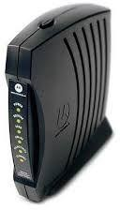

Figure 10-6. Modem
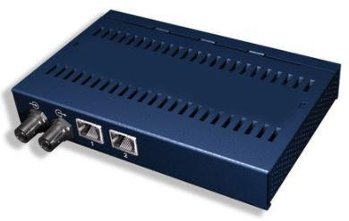

Figure 10-7. Repeater

Access Point

An access point is a device that creates a wireless local area network, or WLAN, usually in an office or large building. An access point connects to a wired router, switch, or hub via an Ethernet cable, and projects a Wi-Fi signal to a designated area.
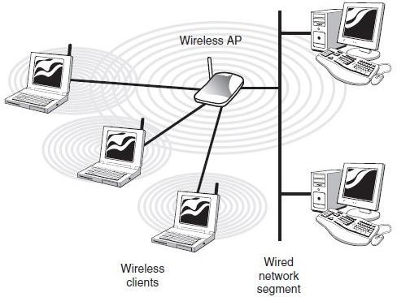
Figure 10-8. Access Point

Types of Networks
- LAN
- WAN
- MAN LAN
A local area network (LAN) is a collection of devices connected together in one physical location, such as a building, office, or home. A LAN can be small or large, ranging from a home network with one user to an enterprise network with thousands of users and devices in an office or school.
A LAN is a computer network that consists of access points, cables, routers, and switches that enable devices to connect to web servers and internal servers within a single building, campus, or home network, and to other LANs via Wide Area Networks (WAN) or Metropolitan Area Network (MAN).
Devices on a LAN, typically personal computers and workstations, can share files and be accessed by each other over a single Internet connection.
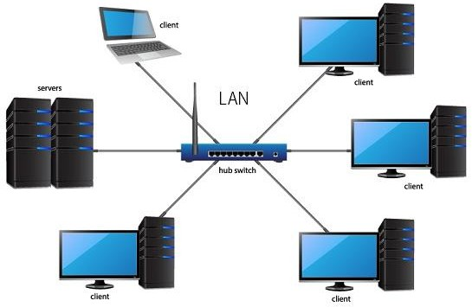

Figure 10-9. LAN
WAN
In its simplest form, a wide-area network (WAN) is a collection of local-area networks (LANs) or other networks that communicate with one another. A WAN is essentially a network of networks, with the Internet the worlds largest WAN.
WANs typically are used by corporations or organizations to facilitate the exchange of data between their computers in dispersed offices. Across all industries, most large corporations with facilities at multiple locations use WANs, and even small businesses with just two remote sites increasingly use WANs.
The main components for a WAN are routers, switches and modems.

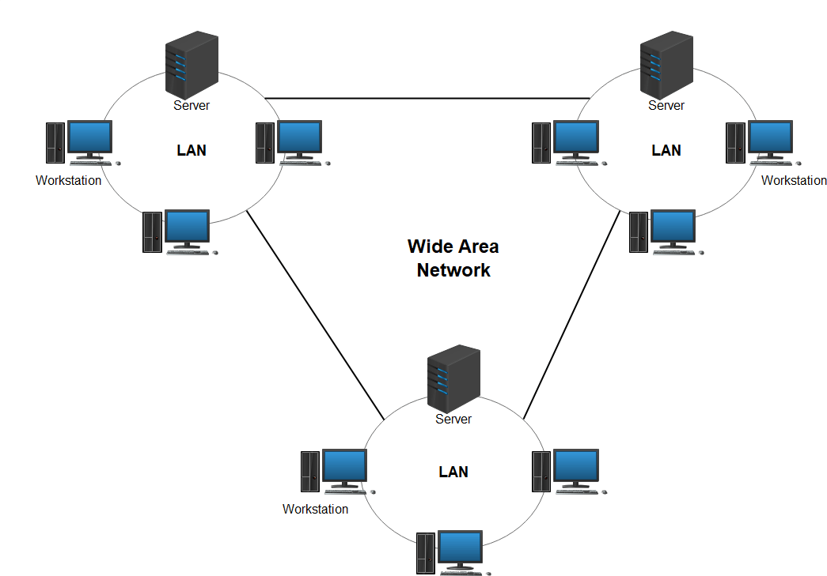

Figure 10-10. WAN
MAN
A metropolitan area network (MAN) is a computer network that connects computers within a metropolitan area, which could be a single large city, multiple cities and towns, or any given large area with multiple buildings. A MAN is larger than a local area network (LAN) but smaller than a wide area network (WAN).
Like WANs, a MAN is made up of interconnected LANs. Because MANs are smaller, they are usually more efficient than WANs, since data does not have to travel over large distances
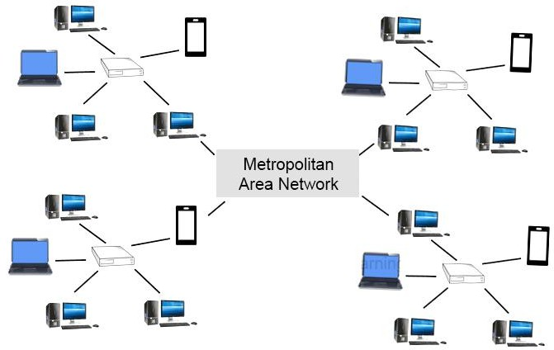

Figure 10-11. MAN

Network Topologies
Network topology describes the physical and logical relationship of nodes in a network, the schematic arrangement of the links and nodes, or some hybrid combinations. Most common network topologies are described below.
Bus Topology

Bus topology is the kind of network topology where every node, i.e. every device on the network, is connected to a solo main cable line. In a bus topology, one computer in the network works as a server and other computers behave as clients. The purpose of the server is to exchange data between client computers.
Data is transmitted in a single route, from one point to the other. We cannot transmit data in both ways.
An example of bus topology is connecting two floors through a single line. Ethernet networks also use a bus topology.
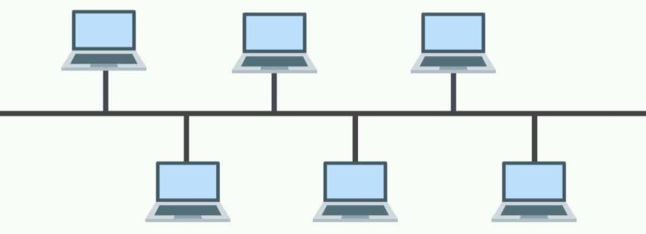
Figure 10-12. Bus Topology
Simple layout and cheap but vulnerable to failure and only suitable for low traffic volumes. Not used for office networks today, but can still be found within some consumer products.
Ring Topology
In networks with ring topology, computers are connected to each other in a circular format. Every device in the network will have two neighbors and no more or no less. Ring topologies were commonly used in the past but you would be hard-pressed to find an enterprise still using them today.
The first node is connected to the last node to link the loop together. In this format packets need to travel through all network nodes on the way to their destination. Easy to manage and with a low risk of collision but reliant on all nodes being powered up and in full working order. Rarely used today.
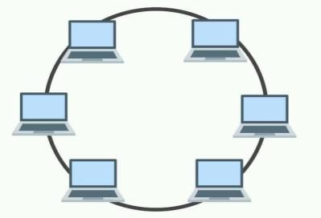
Figure 7-13. Ring Topology

Star Topology
A star topology is a topology where every node in the network is connected to one central switch. Every device in the network is directly connected to the switch and indirectly connected to every other node.
The relationship between these elements is that the central network hub is a server and other devices are treated as clients. The central node has the responsibility of managing data transmissions across the whole network and acts as a repeater.
With star topologies, computers are connected with a coaxial cable, twisted pair, or optical fiber cable.
All devices are connected to a central switch, which makes it easy to add new nodes without rebooting all currently connected devices. This topology makes efficient use of cable and is easy to administer. On the other hand, the health of the switch is vital. This topology requires monitoring and maintenance. However, it is a commonly encountered topology.
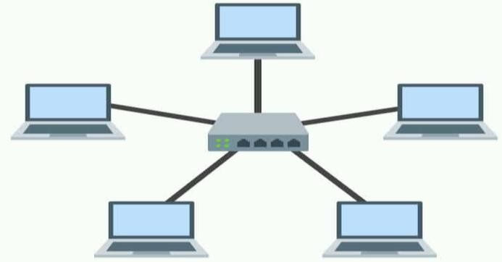
Figure 10-14. Star Topology
Mesh Topology
A mesh topology is a point-to-point connection where nodes are interconnected. In this form of topology, data is transmitted via two methods: routing and flooding. Routing is where nodes use routing logic to work out the shortest distance to the packet’s destination. In contrast, flooding is where data is sent to all nodes within the network. Flooding doesn’t require any form of routing logic to work.
Each node is connected to every other mode with a direct link. This topology creates a very reliable network, but requires a large amount of cable and is difficult to administer. Wi-Fi networks make this topology more feasible.
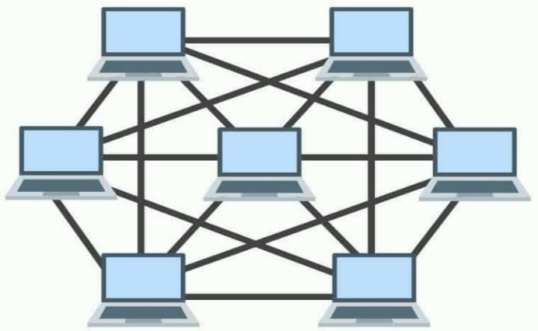
Figure 10-15. Mesh Topology

Tree Topology
A tree topology network is a structure that is shaped like a tree with its many branches. Tree topologies have a root node that is connected to another node hierarchy. The hierarchy is parent-child where there is only one mutual connection between two connected nodes. This form of topology is used within wide area networks to sustain lots of spread-out devices.
A hierarchical layout that links together groups of nodes. Creates parent-child dependencies between root nodes and regular nodes. This layout can be vulnerable to failure if a root node has a problem. This topology is complicated and difficult to manage and it uses a lot of cable.
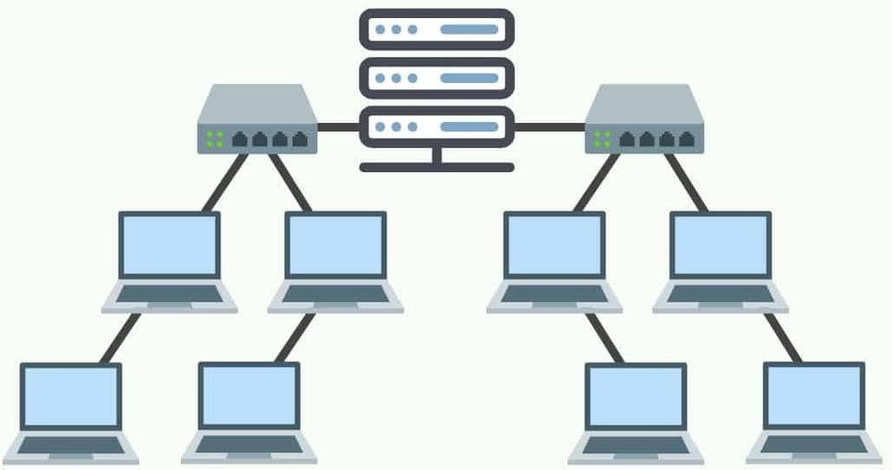
Figure 10-16. Tree Topology
Hybrid Topology

When a topology is composed of two or more different topologies it is referred to as a hybrid topology. Hybrid topologies are most-commonly encountered in larger enterprises where individual departments have network topologies that different from another topology in the organization. Connecting these topologies together will result in a hybrid topology. As a consequence, the capabilities and vulnerabilities depend on the types of topologies that are tied together.
Combines two or more of the standard topologies. This can be a good solution to create quickly link together different existing networks into a unified system.
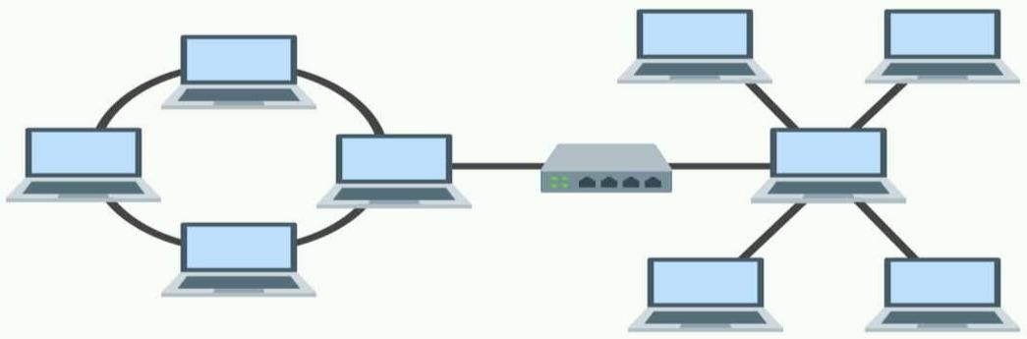
Figure 10-17. Hybrid Topology

Cisco Packet Tracer
Cisco Packet Tracer is a dominant network simulation tool built by Cisco Systems. You can make a simple or complex network inside the Packet tracer to create, plan, configure, and test your network scenarios in a virtual ecosystem.
Installation of Cisco Packet Tracer on Windows

Step 1: Visit the official website of Netacad using any web browser. Press the login button and select log In option. Next screen will appear, click on the sign-up option. On next screen you will be asked for email and password and other simple details, fill them and click on Register. Next, login screen will appear again so fill in the Email id than password and click login button.

Figure 10-18. Cisco Packet Tracer Log in Page
Step 2: After logging-in Dashboard will initialize, now click on Resources and choose Download Packet Tracer Option. On the next web page choose the operating system to download the packet tracer. Downloading will start automatically.
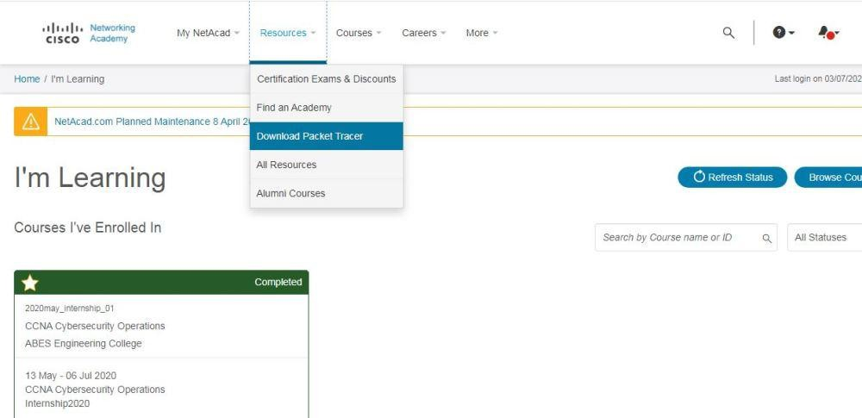
Figure 10-19. Cisco Packet Tracer Download Page

Step 3: Go to downloads and check for the executable file of packet tracer in your system and run it. A screen of License Agreement will appear, Click on I accept the license.
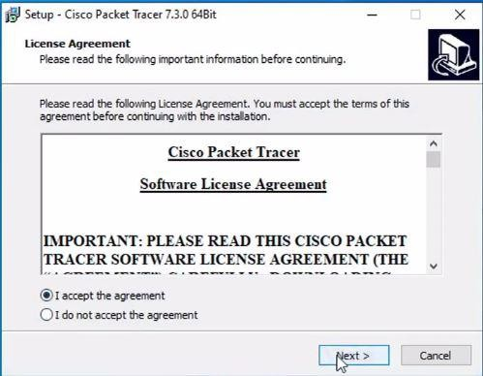
Figure 10-20. Cisco Packet Tracer License Agreement Page Step 4: Choose the installing location which has sufficient space.
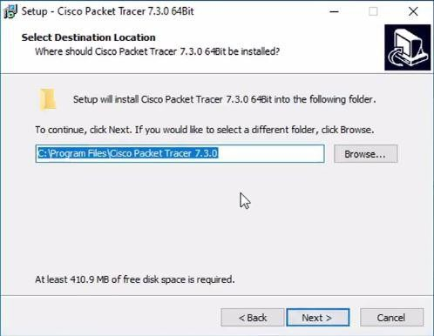

Figure 10-21. Cisco Packet Tracer Select Destination Page

Step 5: Select the start menu folder and click the Next button.
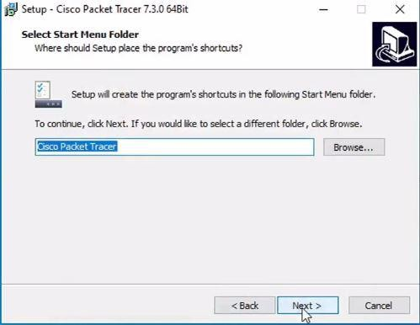
Figure 10-22. Cisco Packet Tracer Menu Folder Selection Page Step 6: Check the box for creating a desktop icon and click on the Next button.
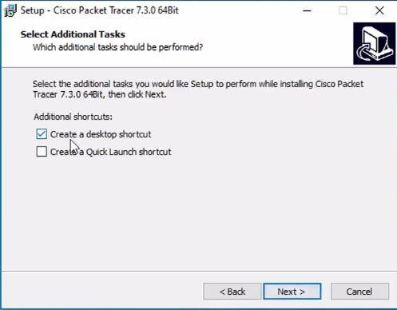
Figure 10-23. Cisco Packet Tracer Select Additional Tasks Page

Step 7: Now packet tracer is ready to install so click on the Install button.
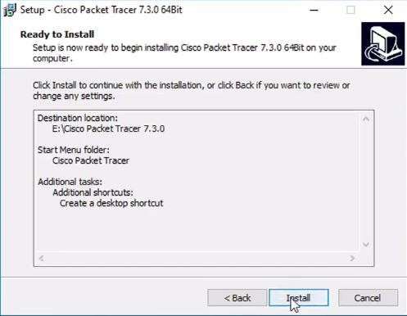
Figure 10-24. Cisco Packet Tracer Installation Page Step 8: The installation process will start and will hardly take a minute.
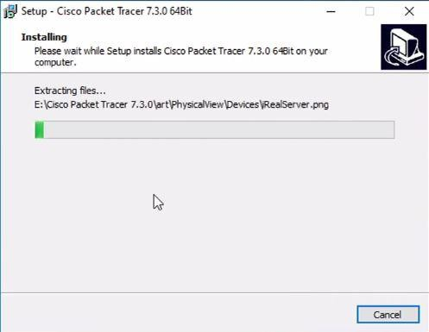
Figure 10-25. Cisco Packet Tracer Installing Page

Step 9: Click on the Finish button to complete the installation.
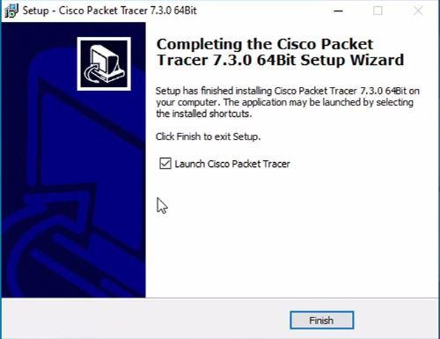
Figure 10-26. Cisco Packet Tracer Setup Wizard Page Step 10: An icon is created on the desktop so run it.


Figure 10-27. Cisco Packet Tracer Icon Step 11: Interface is initialized and the software is ready to use.
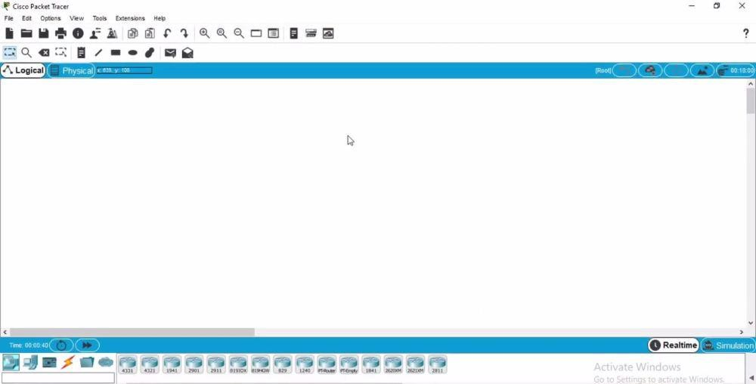
Figure 10-28. Cisco Packet Tracer Initial Page

Packet Tracer Interface Overview
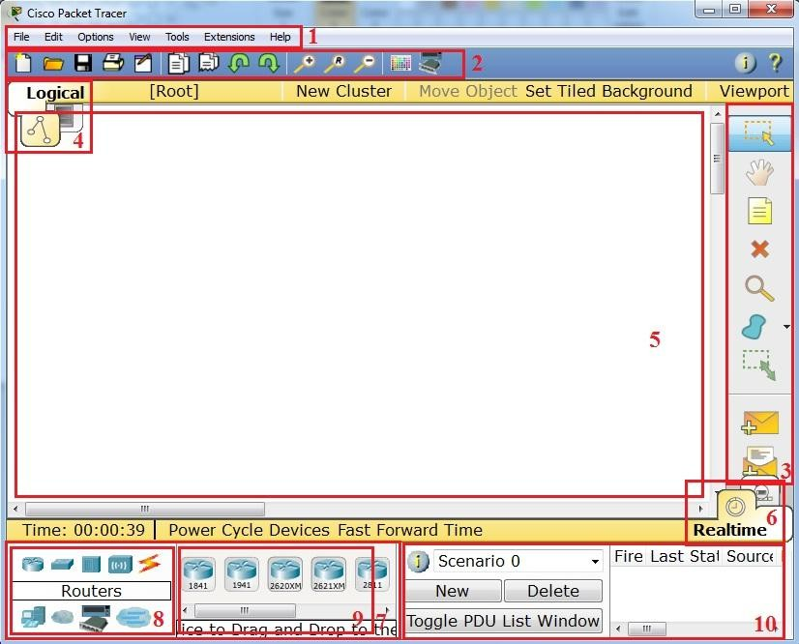
When you open Packet Tracer, by default you will be presented with the following interface:

Figure 10-29. Cisco Packet Tracer initial interface
This initial interface contains ten components. If you are unsure of what a particular interface item does, move your mouse over the item and a help balloon will explain the item.
Following table describes the components in the initial interface.
Table 10-1. Components of initial Interface of Packet Tracer
1 | Menu Bar | Contains File, Edit, Options, View, Tools, Extensions, and Help menus. It provides basic commands such as Open, Save, Save as, Print etc.
2 | Main Tool Bar | Provides shortcut icons to the File and Edit menu commands. also provides buttons for Copy, Paste, Undo, Redo, Zoom, the Drawing Palette, and the Custom Devices Dialog.  On the right, you will also find the Network Information button.

3 | Common Tools Bar | This bar provides access to these commonly used workspace tools: Select, Move Layout, Place Note, Delete, Inspect, Resize Shape, Add Simple PDU, and Add Complex PDU.
4 | Logical/Physical Workspace and Navigation Bar | You can toggle between the Physical Workspace and the Logical Workspace with the tabs on this bar. (see fig 7-19)  In Logical Workspace, this bar also allows you to go back to a previous level in a cluster, create a New Cluster, Move Object, Set Tiled Background, and Viewport.  In Physical Workspace, this bar allows you to navigate through physical locations, create a New City, create a New Building, create a New Closet, Move Object, apply a Grid to the background, Set Background, and go to the Working Closet.
5 | Workspace | This area is where you will create your network, watch simulations, and view many kinds of information and statistics.
6 | Realtime/Simulation Bar | You can toggle between Realtime Mode and Simulation Mode with the tabs on this bar. (see fig 7-20)  This bar also provides buttons to Power Cycle Devices and Fast Forward Time as well as the Play Control buttons and the Event List toggle button in Simulation Mode.  It contains a clock that displays the relative Time in Real-time Mode and Simulation Mode.
7 | Network Component Box | This box is where you choose devices and connections to put into the workspace.  It contains the Device-Type Selection Box and the Device-Specific Selection Box.
8 | Device-Type Selection Box | This box contains the type of devices and connections available in Packet Tracer.  The Device-Specific Selection Box will change depending on which type of device you choose.

9 | Device-Specific Selection Box | This box is where you choose specifically which devices you want to put in your network and which connections to make.
10 | User Created Packet Window* | This window manages the packets you put in the network during simulation scenarios.
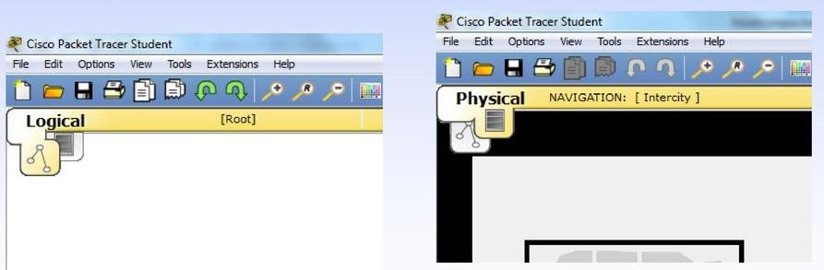
Figure 10-30. Logical and Physical Workspace in Packet Tracer
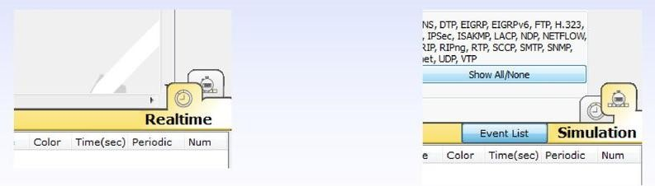
Figure 10-31. Modes of Operations in Packet Tracer

Activity 01:-
Implement a simple network including 2 PC`s and a Hub and send packet from one PC to another PC.

Activity 02:-
Implement a simple network including 2 PC`s and a Switch and send packet from one PC to another PC.

Cognitive Questions
Q1. In a Bus topology, if the single main cable breaks, every device on the network loses connectivity. In a Star topology, if one device's cable breaks, only that device is affected. Explain why this difference exists, referencing the role of the central connecting device (hub/switch) in a Star topology, and state one topology you would recommend for a computer lab and why. (5)

Q2. In Packet Tracer, two PCs on the same network cannot ping each other. List three possible causes you would check first (for example, cabling, IP addressing, or device power state), and explain how you would confirm which one is the actual problem using the tool. (5)

Cognitive Activity
Obtained Marks | /10

Lab Exercise and Summary
Summary should cover Introduction, Procedure, Data Analysis and Evaluation.

Student’s Signature: Date:

Psychomotor Activity 1 — Experimental Setup
S.No | Criteria | Performance | Description | Marks
1 | Cisco Packet Tracer Setup (4) | Level 4 | Opens and configures Cisco Packet Tracer correctly and independently. | 4
1 | Cisco Packet Tracer Setup (4) | Level 3 | Configures Cisco Packet Tracer with minor errors or assistance. | 3
1 | Cisco Packet Tracer Setup (4) | Level 2 | Completes the setup with considerable assistance. | 2
1 | Cisco Packet Tracer Setup (4) | Level 1 | Setup is incomplete and requires substantial assistance. | 1
2 | Network Topology Setup (4) | Level 4 | Correctly creates/selects the required devices (PCs, switch/router) and builds the network topology in Packet Tracer. | 4
2 | Network Topology Setup (4) | Level 3 | Topology setup is mostly correct with minor errors or omissions. | 3
2 | Network Topology Setup (4) | Level 2 | Setup is partially completed and requires assistance. | 2
2 | Network Topology Setup (4) | Level 1 | Major errors or omissions are present in the setup. | 1
3 | Parameter Setup (2) | Level 2 | Correctly configures required IP addresses, subnet masks, and cabling/connections. | 2
3 | Parameter Setup (2) | Level 1 | Configures most required addressing and connections with minor errors. | 1
 | Total Obtained |  |  | /10

If a student is absent:
Criteria | Description | Marks
Absent | Student is absent from the laboratory activity. | 0

Psychomotor Activity 2 — Implementation + Results
S.No | Criteria | Performance | Description | Marks
1 | Implementation (4) | Level 4 | Implements the required network topology correctly and independently, with correct device connections and addressing. | 4
1 | Implementation (4) | Level 3 | Implements the topology with minor errors or assistance. | 3
1 | Implementation (4) | Level 2 | Partially implements the topology and requires considerable assistance. | 2
1 | Implementation (4) | Level 1 | Implementation is largely incomplete and requires substantial assistance. | 1
2 | Execution/Connectivity Test (2) | Level 2 | Correctly tests connectivity (e.g., ping) between devices and appropriately troubleshoots basic errors. | 2
2 | Execution/Connectivity Test (2) | Level 1 | Tests connectivity with minor errors or assistance. | 1
3 | Results/Output (4) | Level 4 | Obtains correct results and clearly demonstrates successful communication between all required devices. | 4
3 | Results/Output (4) | Level 3 | Obtains mostly correct results with minor connectivity errors. | 3
3 | Results/Output (4) | Level 2 | Obtains partially correct results with noticeable errors or omissions. | 2
3 | Results/Output (4) | Level 1 | Results are largely incorrect or incomplete. | 1
 | Total Obtained |  |  | /10

If a student is absent:
Criteria | Description | Marks
Absent | Student is absent from the laboratory activity. | 0

Affective Activity — Lab Report + Viva Voce
S.No | Criteria | Performance | Description | Marks
1 | Lab Report  Completeness & Organization  (4) | Level 4 | Report is complete, well-organized, and demonstrates responsible completion of the hardware/software identification exercise. | 4
1 | Lab Report  Completeness & Organization  (4) | Level 3 | Report is complete with minor omissions or organizational issues. | 3
1 | Lab Report  Completeness & Organization  (4) | Level 2 | Report is partially complete with several omissions. | 2
1 | Lab Report  Completeness & Organization  (4) | Level 1 | Report has major omissions or poor organization. | 1
2 | Work/Results & Conclusion (2) | Level 2 | Completed classification and conclusion are correctly presented and discussed. | 2
2 | Work/Results & Conclusion (2) | Level 1 | Presented with minor errors or omissions. | 1
3 | Viva Voce (4) | Level 4 | Clearly explains topologies & Familiarization to initial interface of Cisco Packet tracer. | 4
3 | Viva Voce (4) | Level 3 | Explains most concepts correctly with minor difficulty. | 3
3 | Viva Voce (4) | Level 2 | Explains basic aspects with some prompting. | 2
3 | Viva Voce (4) | Level 1 | Demonstrates limited understanding, requires substantial prompting. | 1
3 | Total Obtained |  |  | /10

The student has not submitted the report and has not appeared in the Viva Voce.
Criteria | Description | Marks
Lab Report and Results Not Submitted | Student has not submitted the report and results file. | 0
Absent in Viva Voce | Student is absent from the viva voce. | 0

Instructor’s Signature: Date: _________

Experiment No 11

Introduction to Microsoft Access Database

Objective:
- To create tables and forms
- To handle relationships in database
- To make queries (Update, create etc.)

Microsoft Access (MS Access)
Microsoft Access (MS Access) is a popular relational database management system (RDBMS) developed by Microsoft. It is part of the Microsoft Office suite of productivity software and is designed to help users efficiently store, manage, and manipulate structured data. MS Access is known for its user-friendly interface, making it accessible to both beginners and experienced users. Here are some of its inner features:
  - Tables: MS Access allows users to create tables for data storage. Tables are organized into rows (records) and columns (fields), where each column represents a specific type of data. Users can define data types, enforce data validation rules, and establish relationships between tables.
  - Queries: Queries in MS Access are used to retrieve and manipulate data from tables. Users can create queries using a visual query builder or by writing SQL (Structured Query Language) code. Queries enable users to filter, sort, calculate, and summarize data from one or more tables.
  - Forms: Forms provide a user-friendly interface for entering and displaying data. MS Access includes form design tools that allow users to customize the layout and appearance of forms. Forms can be used to input data into tables and display data from queries and tables.
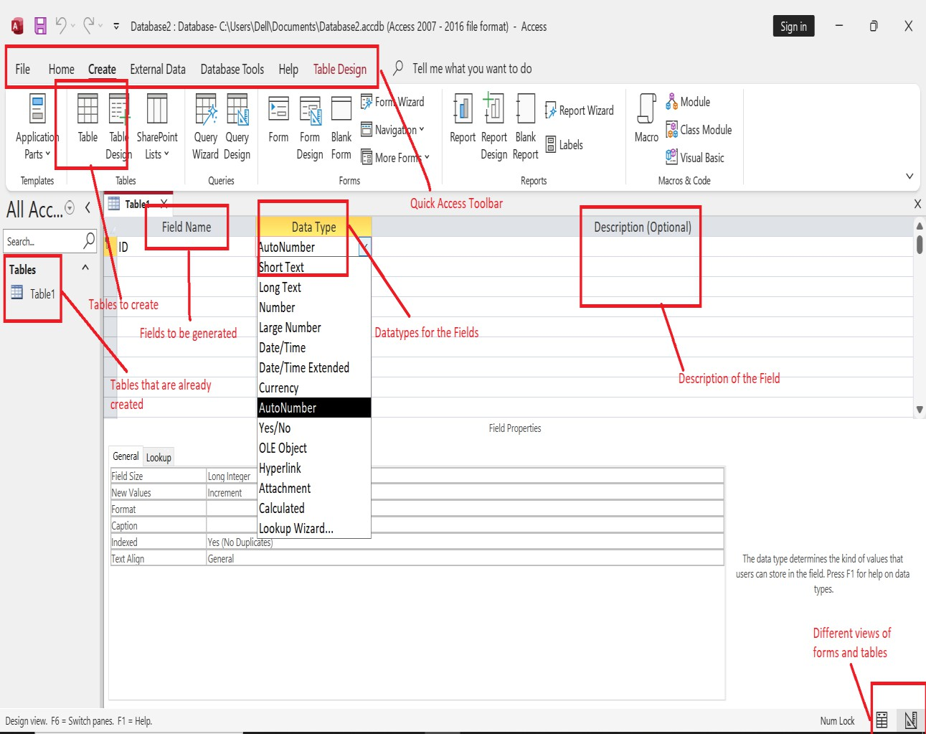
Figure 11-1. MS Access Front Page Tabs Overview (Table and Relationship)

Objects:

MS Access uses “objects" to help the user list and organize information, as well as prepare specially designed reports. When you create a database, Access offers you Tables, Queries, Forms, Reports, Macros, and Modules. Databases in Access are composed of many objects but the following are the major objects.
  - Tables
  - Queries
  - Forms
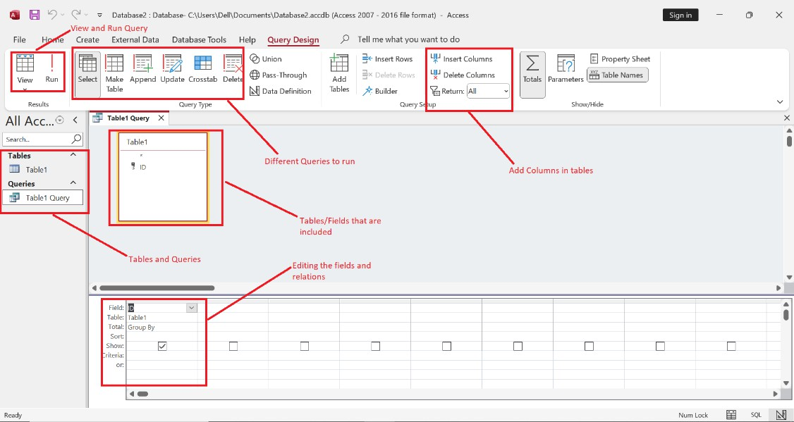
Figure 11-2. Table and Queries in Database

Datatypes

Every field in a table has properties and these properties define the field's characteristics and behavior. The most important property for a field is its data type. A field's data type determines what kind of data it can store. MS Access supports different types of data, each with a specific purpose.
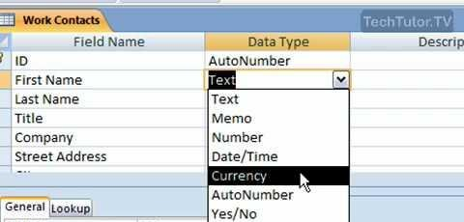
Figure 11-3. Datatypes

Tables

When you create a database, you store your data in tables. Because other database objects depend so heavily on tables, you should always start your design of a database by creating all of its tables and then creating any other object.

Let us now go to the Create tab.
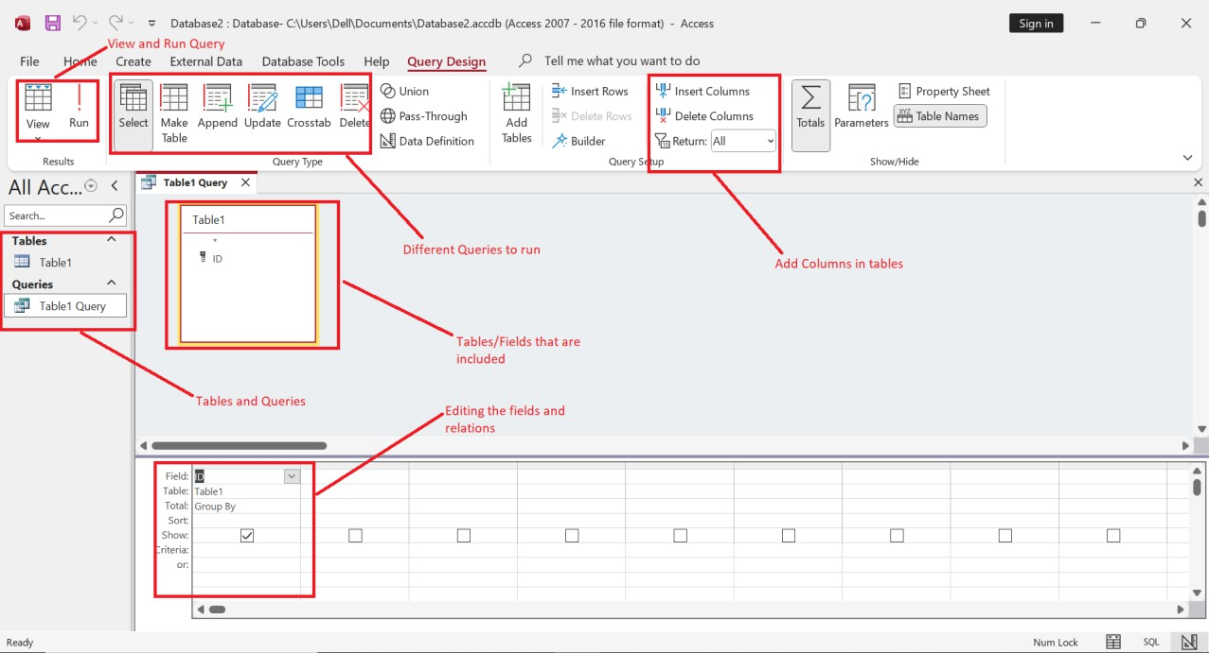

Figure 11-4. View for creating tables and queries

Relationships
Defining Relationships
A relationship works by matching data in key columns usually columns with the same name in both the tables. In most cases, the relationship matches the primary key from one table, which provides a unique identifier for each row, with an entry in the foreign key in the other table. There are three types of relationships between tables. The type of relationship that is created depends on how the related columns are defined.

Let us now look into the three types of relationships:

One-to-Many Relationships
A one-to-many relationship is the most common type of relationship. In this type of relationship, a row in table A can have many matching rows in table B, but a row in table B can have only one matching row in table A.

For example, the Customers and Orders tables have a one-to-many relationship: each customer can place many orders, but each order comes from only one customer.

Many-to-Many Relationships

In a many-to-many relationship, a row in table A can have many matching rows in table B, and vice versa.

You create such a relationship by defining a third table, called a junction table, whose primary key consists of the foreign keys from both table A and table B.

For example, the Customers table and the Cookies table have a many-to-many relationship that is defined by a one-to-many relationship from each of these tables to the Orders table.
One-to-One Relationships

In a one-to-one relationship, a row in table A can have no more than one matching row in table B, and vice versa. A one-to-one relationship is created if both the related columns are primary keys or have unique constraints.
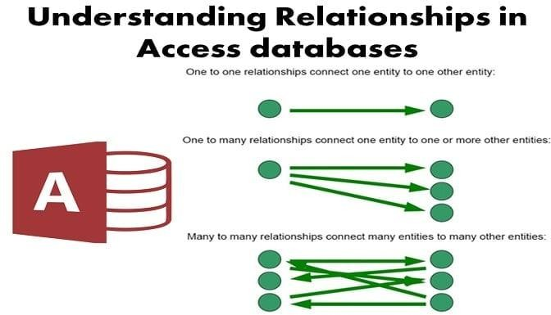
Figure 11-5. Relationships in Access database

Forms

Forms in Access are like display cases in stores that make it easier to view or get the items that you want. Since forms are objects through which you or other users can add, edit, or display the data stored in your Access desktop database, the design of your form is an important aspect. There's a lot you can do design-wise with forms in Microsoft Access. You can create two basic types of forms.

Creating Forms
There are a few methods you can use to create forms in Access. For this, open your Database and go to the Create tab. In the Forms group, in the upper right-hand corner you will see the Form Wizard button.

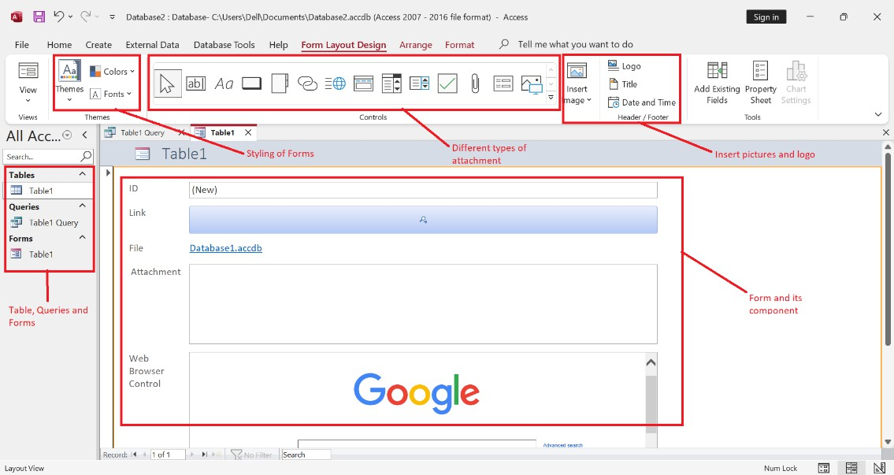
Figure 11-6. Creation of Forms in MS Access (a)
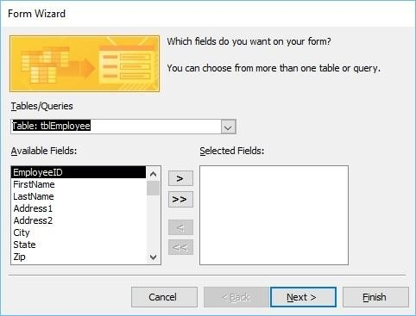
Figure 11-7. Creation of Forms in MS Access (Form Wizard)

Queries

Queries are powerful tools used to retrieve, manipulate, and analyze data from one or more tables in a database. Queries allow you to ask specific questions about your data and return the results in a meaningful way. Here's an overview of queries in MS Access:
Types of Queries:
Select Query: This type of query is used to retrieve data from one or more tables based on specified criteria. You can select specific fields to include in the result set and apply sorting to the data.
SELECT field_1 FROM table_1 WHERE criterion_1;

SELECT Last_Name FROM Contacts
WHERE First_Name = 'Mary';
Action Query: Action queries are used to perform actions on the data, such as adding, updating, or deleting records. There are four main types of action queries:
INSERT INTO tblEmployees (FirstName, LastName, JobTitle) VALUES (“Tom”, “Cruise”, “Drama Teacher”)
INSERT INTO CUSTOMERS VALUES
(1, 'Ramesh', 32, 'Ahmedabad', 2000.00 ),
(2, 'Khilan', 25, 'Delhi', 1500); CREATE DATABASE database_name;
Append Query: Adds records from one table to another.
Update Query: Modifies existing records based on specified criteria.
UPDATE table_name
SET column1 = value1, column2 = value2. columnN=valueN
[ WHERE CONDITION ];
UPDATE CUSTOMERS SET ADDRESS = 'Pune' WHERE ID = 6;
Delete Query: Removes records based on specified criteria. DELETE FROM table_name WHERE {CONDITION}; DELETE FROM CUSTOMERS WHERE ID = 6;
Make-Table Query: Creates a new table based on the results of a select query.
CREATE TABLE table_name( column1 datatype,
column2 datatype, column3 datatype,
.....
columnN datatype,
PRIMARY KEY( one or more columns )
);

CREATE TABLE CUSTOMERS( ID INT NOT NULL,
NAME VARCHAR (20) NOT NULL, AGE INT NOT NULL, ADDRESS CHAR (25) ,
SALARY DECIMAL (18, 2), PRIMARY KEY (ID)
);
Parameter Query: Parameter queries allow you to prompt the user for input when the query is run. This input is then used as criteria in the query, making it dynamic and flexible.
Crosstab Query: Crosstab queries are used to summarize data by displaying it in a matrix format. They are helpful for creating pivot-table-like reports.
Totals Query: Totals queries are used to perform aggregate functions like sum, average, count, etc., on data within a table. They group data based on specified criteria and calculate totals for each group.
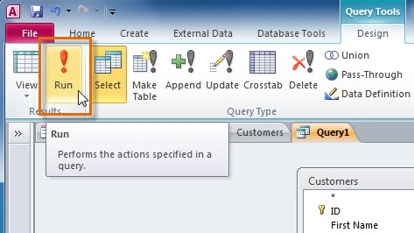
Figure 11-8. Query Tools in MS Access Query Design View:
Queries in MS Access are created and edited using the Query Design View. In this view, you can visually design your query by selecting tables, specifying criteria, and choosing fields to include in the result set. The Query Design View provides a graphical interface for building complex queries.

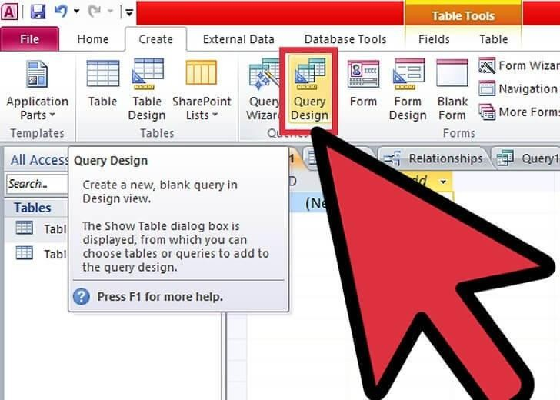
Figure 11-9. Query Design View
Note:
For further help you can follow the following links https://www.accessallinone.com/ms-access-and-structured-query-language-sql/ https://www.tutorialspoint.com/ms_access/ms_access_query_data.htm https://www.tutorialspoint.com/sql/sql-syntax.htm

Activity 01:-
You are tasked with creating a basic employee management database using Microsoft Access. Follow the steps below:
- Create a new database named "EmployeeDatabase."
- Design a table called "EmployeeTable" with fields for EmployeeID (AutoNumber, Primary Key), FirstName, LastName, BirthDate, Department, and Position.
- Populate the "EmployeeTable" with sample data.
- Create a form named "EmployeeForm" that allows users to input and view employee information.
- Arrange the fields on the form for a user-friendly layout, add labels for clarity.
- Test your form by entering and viewing data.

Activity 02:-
Enhance your Microsoft Access Employee Database using queries and create a clear report to visualize specific employee details using following requirements:
- Improve your Microsoft Access Employee Database using queries.
- Create a query called "EmployeeQuery" for specific details in the "EmployeeTable."
- Experiment with different ways to get the information you want using the "EmployeeQuery."
- Enhance the query by calculating the age of each employee.
- View the query results in a clear and organized report, "EmployeeReport."

Cognitive Questions
Q1. You are designing a database for a university with a Students table and a Courses table, where each student can enroll in several courses. Explain why you should not simply add columns like Course1, Course2, Course3 to the Students table, and describe instead how a relationship (using a common field such as Student ID) between two tables solves this problem. (5)

Q2. A student stores phone numbers using the Number data type in an Access table, and every phone number starting with 0 loses its leading zero when saved (e.g., 0301-1234567 becomes 301-1234567). Explain why this happens and which data type should have been used instead, and why. (5)

Cognitive Activity
Obtained Marks | /10

Lab Exercise and Summary
Summary should cover Introduction, Procedure, Data Analysis and Evaluation.

Student’s Signature: Date:

Psychomotor Activity 1 — Experimental Setup
S.No | Criteria | Performance | Description | Marks
1 | MS Access Setup (4) | Level 4 | Opens and configures MS Access correctly and independently. | 4
1 | MS Access Setup (4) | Level 3 | Configures MS Access with minor errors or assistance. | 3
1 | MS Access Setup (4) | Level 2 | Completes the setup with considerable assistance. | 2
1 | MS Access Setup (4) | Level 1 | Setup is incomplete and requires substantial assistance. | 1
2 | Database/Table Setup (4) | Level 4 | Correctly creates/selects the required database file, tables, fields, and data types. | 4
2 | Database/Table Setup (4) | Level 3 | Database/table setup is mostly correct with minor errors or omissions. | 3
2 | Database/Table Setup (4) | Level 2 | Setup is partially completed and requires assistance. | 2
2 | Database/Table Setup (4) | Level 1 | Major errors or omissions are present in the setup. | 1
3 | Parameter Setup (2) | Level 2 | Correctly defines required primary keys, relationships, and field properties. | 2
3 | Parameter Setup (2) | Level 1 | Defines most required keys and relationships with minor errors. | 1
 | Total Obtained |  |  | /10

If a student is absent:
Criteria | Description | Marks
Absent | Student is absent from the laboratory activity. | 0

Psychomotor Activity 2 — Implementation + Results
S.No | Criteria | Performance | Description | Marks
1 | Implementation (4) | Level 4 | Implements the required tables, relationships, forms, and/or queries correctly and independently. | 4
1 | Implementation (4) | Level 3 | Implements the database objects with minor errors or assistance. | 3
1 | Implementation (4) | Level 2 | Partially implements the database objects and requires considerable assistance. | 2
1 | Implementation (4) | Level 1 | Implementation is largely incomplete and requires substantial assistance. | 1
2 | Execution/Query Run (2) | Level 2 | Correctly runs required queries/forms and appropriately handles basic errors. | 2
2 | Execution/Query Run (2) | Level 1 | Runs queries/forms with minor errors or assistance. | 1
3 | Results/Output (4) | Level 4 | Obtains correct results and clearly presents the required tables, relationships, and/or query output. | 4
3 | Results/Output (4) | Level 3 | Obtains mostly correct results with minor errors. | 3
3 | Results/Output (4) | Level 2 | Obtains partially correct results with noticeable errors or omissions. | 2
3 | Results/Output (4) | Level 1 | Results are largely incorrect or incomplete. | 1
 | Total Obtained |  |  | /10

If a student is absent:
Criteria | Description | Marks
Absent | Student is absent from the laboratory activity. | 0
Affective Activity — Lab Report + Viva Voce
S.No | Criteria | Performance | Description | Marks
1 | Lab Report  Completeness & Organization  (4) | Level 4 | Report is complete, well-organized, and demonstrates responsible completion of the hardware/software identification exercise. | 4
1 | Lab Report  Completeness & Organization  (4) | Level 3 | Report is complete with minor omissions or organizational issues. | 3
1 | Lab Report  Completeness & Organization  (4) | Level 2 | Report is partially complete with several omissions. | 2
1 | Lab Report  Completeness & Organization  (4) | Level 1 | Report has major omissions or poor organization. | 1
2 | Work/Results & Conclusion (2) | Level 2 | Completed classification and conclusion are correctly presented and discussed. | 2
2 | Work/Results & Conclusion (2) | Level 1 | Presented with minor errors or omissions. | 1
3 | Viva Voce (4) | Level 4 | Clearly handle relationships in database  to make queries (Update, create etc.)  , demonstrating strong understanding. | 4
3 | Viva Voce (4) | Level 3 | Explains most concepts correctly with minor difficulty. | 3
3 | Viva Voce (4) | Level 2 | Explains basic aspects with some prompting. | 2
3 | Viva Voce (4) | Level 1 | Demonstrates limited understanding, requires substantial prompting. | 1
3 | Total Obtained |  |  | /10

The student has not submitted the report and has not appeared in the Viva Voce.
Criteria | Description | Marks
Lab Report and Results Not Submitted | Student has not submitted the report and results file. | 0
Absent in Viva Voce | Student is absent from the viva voce. | 0

Instructor’s Signature: Date: _________

Experiment No 12

Information Security

After this lab student will have understanding about:
- BitLocker for drive
- Firewall

Encrypting a Drive Using BitLocker
Step 1: Access BitLocker Settings Open Control Panel:
Press Windows Key + S and type Control Panel.

Click on the Control Panel app from the search results.
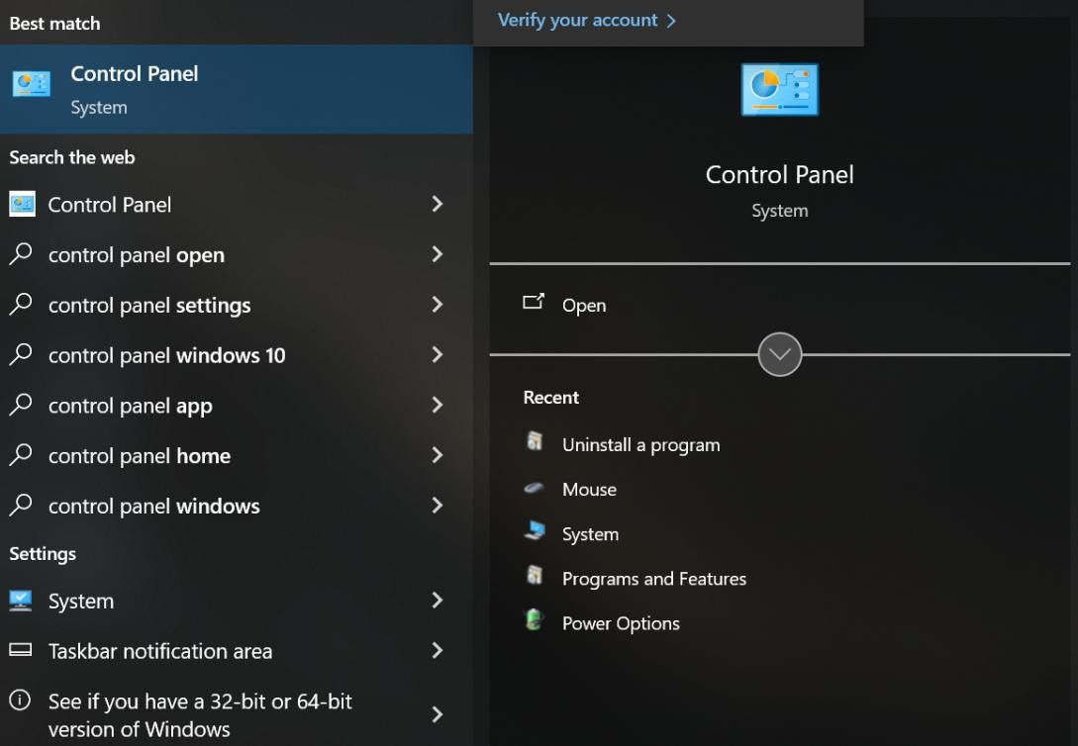
Figure 12-1. Open Control Panel Navigate to BitLocker Settings:
In Control Panel, select System and Security. Click on BitLocker Drive Encryption.
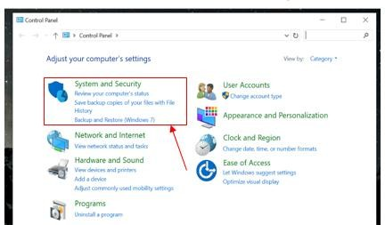
Figure 12-2. System and Security Settings

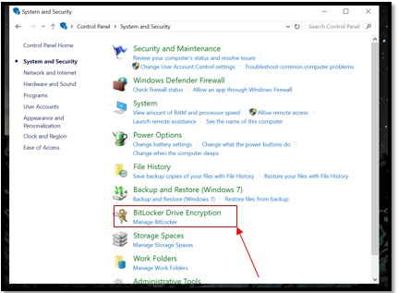
Figure 12-3. BitLocker Drive Encryption Step 2: Turn On BitLocker
Select the Drive to Encrypt:

In the BitLocker Drive Encryption window, you’ll see a list of drives. Find the drive you want to encrypt.
Click on Turn on BitLocker next to the selected drive.
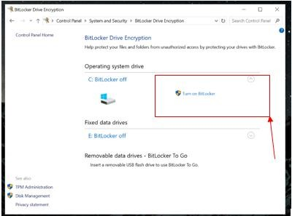

Figure 12-4. BitLocker Drive Selection for Encryption

Choose How to Unlock the Drive:
You’ll be prompted to choose how you want to unlock the drive. You can use a password, a smart card, or other options depending on your version of Windows.
For this lab, select Use a password to unlock the drive and enter a strong password.
Step 3: Backup Your Recovery Key Backup the Recovery Key:
You’ll need to back up the recovery key that allows you to access the drive if you forget the password. Options include saving it to a file, printing it, or saving it to your Microsoft account.
Select the backup option you prefer and follow the instructions to complete the backup.
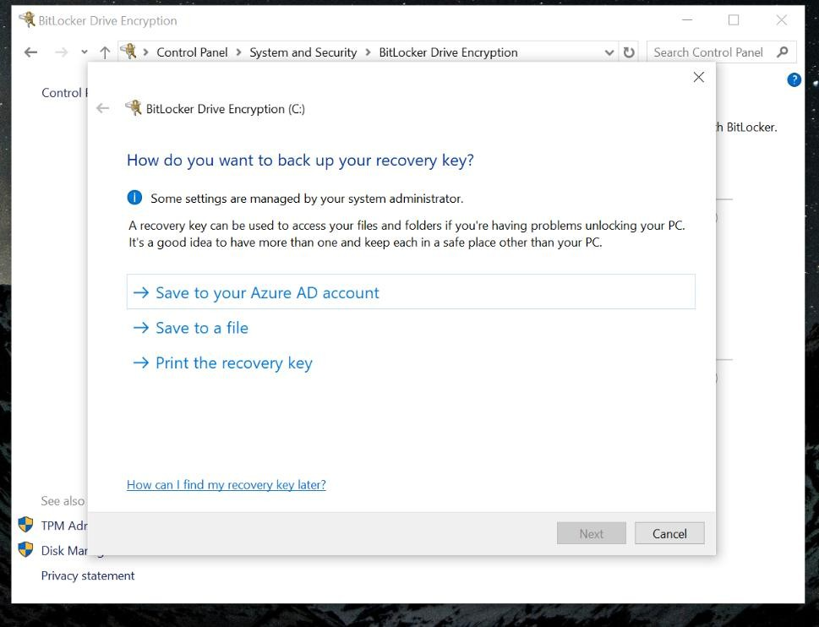
Figure 12-5. BitLocker Recovery Key Backup Option Step 4: Choose How Much of Your Drive to Encrypt
Select Encryption Mode:
You will be asked to choose between encrypting used disk space only (faster) or encrypting the entire drive (slower but more secure).
Choose the option that suits your needs.
Step 5: Start Encryption Begin Encryption Process:
After choosing your settings, click Start Encrypting to begin the encryption process.
This process may take some time depending on the size of the drive and the amount of data.

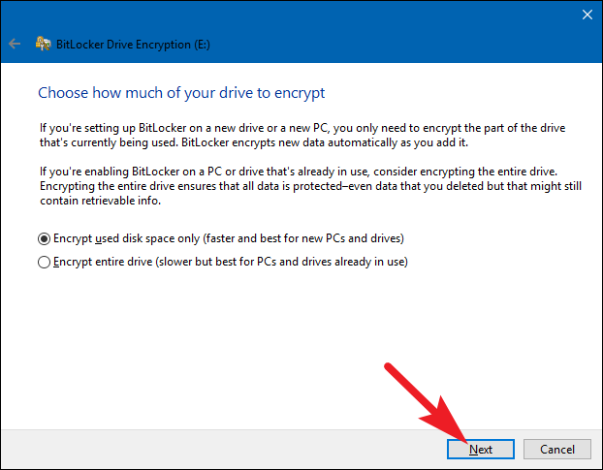
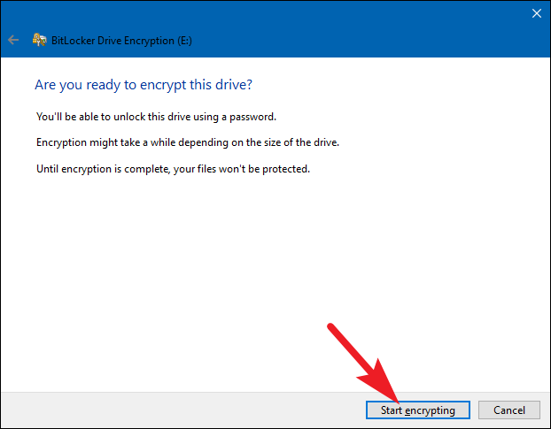
Figure 12-6. Select Encryption Mode (Step 4)
Figure 12-7. Start Encrypting (Step 5) Wait for Encryption to Complete:

You can monitor the progress on the BitLocker Drive Encryption window. You may use your computer during this time, but avoid shutting it down or disconnecting the drive.
Step 6: Verify Encryption Status Check Encryption Status:
Once encryption is complete, the BitLocker Drive Encryption window will show the drive as BitLocker On.
Ensure that the drive is listed as encrypted and that you can see the lock icon on the drive in File Explorer.
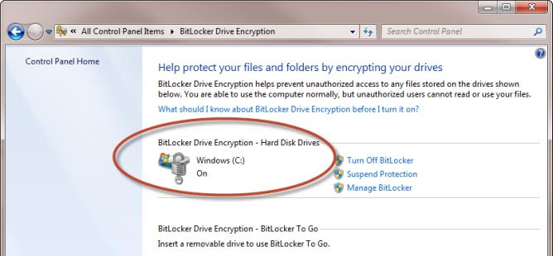
Figure 12-8. Check Encryption Status

Managing Windows Firewall Settings
Step 1: Open Windows Security Access Windows Security:
Press Windows Key + S to open the search bar.
Type Windows Security and click on the Windows Security app from the search results.
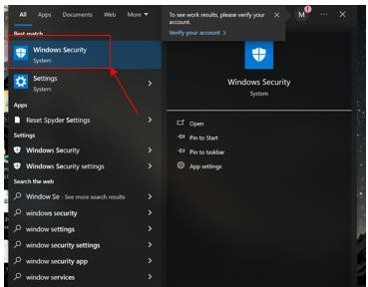

Figure 12-9. Open Windows Security Navigate to Firewall & Network Protection:
In the Windows Security window, click on Firewall & network protection. Step 2: Turn Firewall on or off.
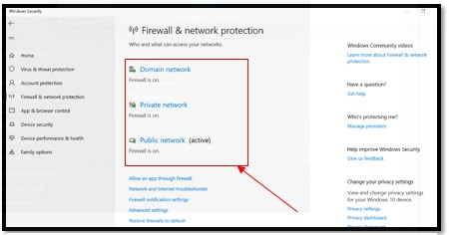
Figure 12-10. Open Firewall & Network Protection to make Firewall On or Off

Windows Firewall overview:

Windows Firewall is a security feature that helps to protect your device by filtering network traffic that enters and exits your device. This traffic can be filtered based on several criteria, including source and destination IP address, IP protocol, or source and destination port number. Windows Firewall can be configured to block or allow network traffic based on the services and applications that are installed on your device. This allows you to restrict network traffic to only those applications and services that are explicitly allowed to communicate on the network.
Windows Firewall is a host-based firewall that is included with the operating system and enabled by default on all Windows editions. Windows Firewall supports Internet Protocol security (IPsec), which you can use to require authentication from any device that is attempting to communicate with your device. When authentication is required, devices that can't be authenticated as a trusted device can't communicate with your device. You can use IPsec to require that certain network traffic is encrypted to prevent it from being read by network packet analyzers that could be attached to the network by a malicious user. Windows Firewall also works with Network Location Awareness so that it can apply security settings appropriate to the types of networks to which the device is connected. For example, Windows Firewall can apply the public network profile when the device is connected a coffee shop wi-fi, and the private network profile when the device is connected to the home network. This allows you to apply more restrictive settings to public networks to help keep your device secure. Practical applications Windows Firewall offers several benefits to address your organization's network security challenges:
- Reduced risk of network security threats: By reducing the attack surface of a device, Windows Firewall provides an additional layer of defense to the defense-in-depth model. This increases manageability and decreases the likelihood of a successful attack.
- Protection of sensitive data and intellectual property: Windows Firewall integrates with IPsec to provide a simple way to enforce authenticated, end-to-end network communications. This allows for scalable, tiered access to trusted network resources, helping to enforce data integrity and, if necessary, protect data confidentiality.
- Extended value of existing investments: Windows Firewall is a host-based firewall included with the operating system, so no additional hardware or software is required. It's also designed to complement existing non-Microsoft network security solutions through a documented API Concepts. The default behavior of Windows Firewall is to:
  - block all incoming traffic, unless solicited or matching a rule.
  - allow all outgoing traffic, unless matching a rule Firewall rules Firewall rules identify allowed or blocked network traffic, and the conditions for

this to happen. The rules offer an extensive selection of conditions to identify traffic, including:
  - Application, service or program name
  - Source and destination IP addresses
  - Can make use dynamic values, like default gateway, DHCP servers, DNS servers and local subnets
  - Protocol name or type. For transport layer protocols, TCP and UDP, you can specify ports or port ranges. For custom protocols, you can use a number between 0 and 255 representing the IP protocol
  - Interface type
  - ICMP/ICMPv6 traffic type and code Firewall profiles Windows Firewall offers three network profiles: domain, private and public. The network profiles are used to assign rules. For example, you can allow a specific application to communicate on a private network, but not on a public network.
- Domain network: The domain network profile is automatically applied to a device that is joined to an Active Directory domain, when it detects the availability of a domain controller. This network profile cannot be set manually. Tip Another option to detect the domain network is to configure the policy settings in the NetworkListManager Policy CSP, which applies to Microsoft Entra joined devices too.
- Private network: The private network profile is designed for private networks such as a home network. It can be set manually on a network interface by an administrator.
- Public network: The public network profile is designed with higher security in mind for public networks, like Wi Fi hotspots, coffee shops, airports, hotels, etc. It's the default profile for unidentified networks. Tip Use the PowerShell cmdlet Get-NetConnectionProfile to retrieve the active network category (NetworkCategory). Use the PowerShell cmdlet Set-NetConnectionProfile to switch the category between private and public.
- Disable Windows Firewall: Microsoft recommends that you don't disable Windows Firewall because you lose other benefits, such as the ability to use Internet Protocol security (IPsec) connection security rules, network protection from attacks that employ network fingerprinting, Windows Service Hardening, and boot time filters. Non-Microsoft firewall software can programmatically disable only the rule types of Windows Firewall that need to be disabled for compatibility. You shouldn't disable the firewall yourself for this purpose. If disabling Windows Firewall is required, don't disable it by stopping the Windows Firewall service (in the Services snap-in, the display name is Windows Defender Firewall and the service name is MpsSvc). Stopping the Windows Firewall service isn't supported by Microsoft and can cause problems, including:
- Start menu can stop working
- Modern applications can fail to install or update

- Activation of Windows via phone fails
- Application or OS incompatibilities that depend on Windows Firewall. The proper method to disable the Windows Firewall is to disable the Windows Firewall Profiles and leave the service running. See Manage Windows Firewall with the command line for detailed steps.

Activities
Write a report on these following questions and also perform these activities.
  - What is BitLocker Drive Encryption, and how does it enhance the security of data on a Windows device?
  - Explain the steps you would take to enable BitLocker. What options do you need to configure, and why are they important?
  - What is the role of the Windows Firewall in protecting a computer, and how does it contribute to network security?
  - Perform a Windows Firewall in computer turn on and off and show the steps to the instructors and write a detailed step by step report on this.

Cognitive Questions
Q1. A laptop with BitLocker-encrypted drive is stolen. The thief removes the hard drive and connects it to another computer, but still cannot read any files without the recovery key. Explain how BitLocker protects data "at rest" like this, and why this protection is different from (and stronger than) just having a Windows login password. (5)

Q2. A student installs a new game, and Windows Firewall blocks it from connecting online. Explain what a firewall rule actually does, and describe the safer way to fix this (allowing that one specific app through the firewall) versus the risky shortcut of turning the firewall off completely — including why the risky shortcut is a bad security habit even if it "solves" the immediate problem. (5)

Cognitive Activity
Obtained Marks | /10

Lab Exercise and Summary
Summary should cover Introduction, Procedure, Data Analysis and Evaluation.

Student’s Signature: Date:

Psychomotor Activity 1 — Experimental Setup
S.No | Criteria | Performance | Description | Marks
1 | Windows Security Tools (BitLocker / Firewall) Setup (4) | Level 4 | Opens and configures Windows Security Tools (BitLocker / Firewall) correctly and independently. | 4
1 | Windows Security Tools (BitLocker / Firewall) Setup (4) | Level 3 | Configures Windows Security Tools (BitLocker / Firewall) with minor errors or assistance. | 3
1 | Windows Security Tools (BitLocker / Firewall) Setup (4) | Level 2 | Completes the setup with considerable assistance. | 2
1 | Windows Security Tools (BitLocker / Firewall) Setup (4) | Level 1 | Setup is incomplete and requires substantial assistance. | 1
2 | Security Configuration Setup (4) | Level 4 | Correctly locates and prepares the required Windows security settings (BitLocker/Firewall) for configuration. | 4
2 | Security Configuration Setup (4) | Level 3 | Configuration setup is mostly correct with minor errors or omissions. | 3
2 | Security Configuration Setup (4) | Level 2 | Setup is partially completed and requires assistance. | 2
2 | Security Configuration Setup (4) | Level 1 | Major errors or omissions are present in the setup. | 1
3 | Parameter Setup (2) | Level 2 | Correctly configures required security parameters (encryption options, firewall rules/exceptions). | 2
3 | Parameter Setup (2) | Level 1 | Configures most required security parameters with minor errors. | 1
 | Total Obtained |  |  | /10

If a student is absent:
Criteria | Description | Marks
Absent | Student is absent from the laboratory activity. | 0

Psychomotor Activity 2 — Implementation + Results
S.No | Criteria | Performance | Description | Marks
1 | Implementation (4) | Level 4 | Implements the required security configuration correctly and independently, following safe practice. | 4
1 | Implementation (4) | Level 3 | Implements the configuration with minor errors or assistance. | 3
1 | Implementation (4) | Level 2 | Partially implements the configuration and requires considerable assistance. | 2
1 | Implementation (4) | Level 1 | Implementation is largely incomplete and requires substantial assistance. | 1
2 | Execution/Verification (2) | Level 2 | Correctly verifies that the security setting is active/working (e.g., drive encrypted, rule applied) and handles basic errors. | 2
2 | Execution/Verification (2) | Level 1 | Verifies the setting with minor errors or assistance. | 1
3 | Results/Output (4) | Level 4 | Obtains correct results and clearly demonstrates the required security configuration is active and working as intended. | 4
3 | Results/Output (4) | Level 3 | Obtains mostly correct results with minor errors. | 3
3 | Results/Output (4) | Level 2 | Obtains partially correct results with noticeable errors or omissions. | 2
3 | Results/Output (4) | Level 1 | Results are largely incorrect or incomplete. | 1
 | Total Obtained |  |  | /10
If a student is absent:
Criteria | Description | Marks
Absent | Student is absent from the laboratory activity. | 0

Affective Activity — Lab Report + Viva Voce
S.No | Criteria | Performance | Description | Marks
1 | Lab Report  Completeness & Organization  (4) | Level 4 | Report is complete, well-organized, and demonstrates responsible completion of the hardware/software identification exercise. | 4
1 | Lab Report  Completeness & Organization  (4) | Level 3 | Report is complete with minor omissions or organizational issues. | 3
1 | Lab Report  Completeness & Organization  (4) | Level 2 | Report is partially complete with several omissions. | 2
1 | Lab Report  Completeness & Organization  (4) | Level 1 | Report has major omissions or poor organization. | 1
2 | Work/Results & Conclusion (2) | Level 2 | Completed classification and conclusion are correctly presented and discussed. | 2
2 | Work/Results & Conclusion (2) | Level 1 | Presented with minor errors or omissions. | 1
3 | Viva Voce (4) | Level 4 | Clearly explains have understanding about BitLocker for drive, Firewall  , demonstrating strong understanding. | 4
3 | Viva Voce (4) | Level 3 | Explains most concepts correctly with minor difficulty. | 3
3 | Viva Voce (4) | Level 2 | Explains basic aspects with some prompting. | 2
3 | Viva Voce (4) | Level 1 | Demonstrates limited understanding, requires substantial prompting. | 1
3 | Total Obtained |  |  | /10

The student has not submitted the report and has not appeared in the Viva Voce.
Criteria | Description | Marks
Lab Report and Results Not Submitted | Student has not submitted the report and results file. | 0
Absent in Viva Voce | Student is absent from the viva voce. | 0

Instructor’s Signature: Date: _________

Experiment No 13-14
Open Ended Lab
Why is an Open-Ended Lab considered a project?
An open-ended lab is considered a project because it requires students to apply the theoretical concepts learned throughout the Application of Information and Technologies course to develop a practical solution for a real-world problem. Unlike conventional laboratory exercises, where students follow predefined steps and obtain expected results, an open-ended lab allows students to identify a problem, plan an appropriate solution, select suitable application software, develop the required documents, analyze data, and present their work effectively.
From a technical perspective, an open-ended lab in Application of Information and Technologies involves the practical use of Microsoft Word for professional documentation, Microsoft Excel for data organization, calculations, charts, and analysis, Microsoft PowerPoint for effective presentations, Microsoft Access for database creation and management, and internet-based resources for information gathering and communication. Students are expected to integrate these applications to produce a complete ICT-based project.
Academically, open-ended labs support problem-based learning and outcome-based education as required by PEC. They improve students’ design thinking, teamwork, troubleshooting skills, creativity, and practical understanding of digital systems. Since students are not only following fixed instructions but also making design decisions, testing their solution, and preparing a report, the open-ended lab fulfills the characteristics of a project.
Therefore, an open-ended lab is justified as a project because it includes problem identification, project planning, document preparation, spreadsheet development or database management, data analysis, report writing, and final project demonstration using information technology applications.
General Instructions
Students must follow the instructions given below:
- The project should be completed in a group of maximum three students.
- Each group must select a unique project title or application.
- Students are not allowed to copy another group’s project.
- Plagiarism in reports, presentations, or digital content is strictly prohibited.
- The project must be completed within the given timeline.
- Each group must demonstrate the project to the concerned instructor.
- The project should utilize concepts and tools covered in the Application of Information and Technologies course.
- Proper documentation, and referencing must be included in the final submission.

Project Objectives
The objectives of this open-ended lab project are:
  - To apply information technology concepts to solve a real-world problem.
  - To develop practical skills in using modern digital tools and applications.
  - To enhance students' problem-solving, analytical, and decision-making abilities.
  - To improve teamwork, communication, and project management skills.
  - To develop professional reports, presentations, and supporting documentation.
  - To prepare students for technology-driven academic and professional environments.

Project Deliverables
Each group must submit the following deliverables:
- A completed and fully functional project.
- A project report submitted to the supervisor.
- A live demonstration of the completed project.

Possible Application Areas
Students may design their projects from, but not limited to, the following areas:
- Education Sector
- Library
- Hospitals
- Business and E-Commerce
- Inventory Management
- Traffic Sector

OPEN ENDED LAB (PROJECT) ASSESSMENT
1 | Project Title
2 | Lab | CPEG1611- Applications of Information and Communication Technologies Lab | Semester | Fall/Spring 20___
3 | Student Name & Registration No. | Student 1 | Student 2 | Student 3
4 | Instructor Name  & Signature

Project Demonstration

Assessment Criteria | Very Poor  0-1 | Poor  2 | Satisfactory  3 | Good  4 | Excellent  5 | Score (S1) | Score (S2) | Score (S3)
Design Evaluation and Testing | No or very poor design prototype and demonstration. | Design prototype is not working and no testing of design has been done | Design prototype is partially functional and little testing of design has been done. | Design prototype is functional and some testing of design has been done. | Design prototype is fully functional and design has been exhaustively tested.
Usage of software/ hardware tools in design and evaluation | No or very poor software / hardware tools usage in project design and results evaluation | Insignificant evidence of software / hardware tools usage in project design and results evaluation | Little evidence of ability to select appropriate software / hardware tools, in project design and results evaluation | Some evidence of skills to use software / hardware tools in project design and results evaluation | Clear evidence of skills to use software / hardware tools in project design and results evaluation

Project Report

Assessment Criteria | Very Poor  0-1 | Poor  2 | Satisfactory  3 | Good  4 | Excellent  5 | Score (S1) | Score (S2) | Score (S3)
Literature Survey,  Problem Analysis and Design Procedure | No or very poor literature survey done. No problem analysis performed. No worthwhile design procedure exists. | Insufficient literature survey Problem analysis part is skipped or does not contribute to creating an effective design. Does not follow any design procedure. | Partial literature survey. Problem Analyses performed is haphazard and design parameter selection is spontaneous. Little use of design procedure. | Adequate literature survey. Problem analysis performed correctly. Project demonstrates some use of design process. | Clear and complete literature survey, effective problem analyses is performed to choose design parameters. Project demonstrates effective use of design process.
Language, Grammar and References | A lot of spelling and grammatical mistakes with poor English. The list of references is clearly inadequate. Table of content missing. | Frequent spellings and grammatical errors. The list of references should be expanded. | Occasional spellings and grammatical errors. The list of references appears reasonable but citation does not follow standard format. | Very few spellings and grammatical errors.  Organization is good.  The list of references appears reasonable and citation follow standard format. | Almost no spelling or grammatical mistake.  Excellent organization. A comprehensive list of references is cited using the standard format.

Viva Voce

Assessment Criteria | Very Poor  0-1 | Poor  2 | Satisfactory  3 | Good  4 | Excellent  5 | Score (S1) | Score (S2) | Score (S3)
Knowledge of Project Implementation details (Q/A) | No or very poor knowledge of implementation and design process. | Poor knowledge of implementation and design with wrong/no answers | Satisfactory knowledge of implementation, vague answers | Adequate knowledge of project implementation with majority of correct answers | Exceptional knowledge of implementation and overall design with clear and spontaneous answers.

